UNITED STATES

SECURITIES AND EXCHANGE COMMISSION
Washington, D.C. 20549

SCHEDULE TO

(Rule 13a-4)

Tender Offer Statement Under Section 14(d)(1) or 13(e)(1)

of the Securities Exchange Act of 1934

REGENXBIO Inc.

(Name of Subject Company (Issuer) and Filing Person (Offeror))

Options to Purchase Common Stock, Par Value $0.0001 per share

(Title of Class of Securities)

75901B107

(CUSIP Number of Class of Securities)

Curran Simpson

President and Chief Executive Officer

REGENXBIO Inc.

9804 Medical Center Drive

Rockville, Maryland 20850

(240) 552-8181
(Name, Address, and Telephone Number of Person Authorized to Receive Notices and Communications on Behalf of Filing Person)

 | With Copies to:
Patrick J. Christmas | Kerry Shannon Burke
Executive Vice President, Chief Strategy and Legal Officer | Matthew C. Franker
REGENXBIO Inc. | Covington & Burling LLP
9804 Medical Center Drive | One CityCenter
Rockville, Maryland 20850 | 850 Tenth Street N.W.
(240) 552-8181 | Washington, D.C. 20001
 | (202) 662-6000

- Check the box if the filing relates solely to preliminary communications made before the commencement of a tender offer. Check the appropriate boxes below to designate any transactions to which the statement relates:

- third party tender offer subject to Rule 14d-1.

- Issuer tender offer subject to Rule 13e-4.

- going-private transaction subject to Rule 13e-3.

- amendment to Schedule 13D under Rule 13d-2.

Check the following box if the filing is a final amendment reporting the results of the tender offer: ☐

If applicable, check the appropriate box(es) below to designate the appropriate rule provision(s) relied upon:

- Rule 13e-4(i) (Cross-Border Issuer Tender Offer)

- Rule 14d-1(d) (Cross-Border Third-Party Tender Offer)

Item 1. Summary Term Sheet.

The information set forth under “Summary Term Sheet” and in the Offer to Exchange Eligible Options for Replacement Options, dated June 3, 2026 (the “Offer to Exchange”), attached hereto as Exhibit (a)(1)(A), is incorporated herein by reference.

Item 2. Subject Company Information.

- Name and Address.

REGENXBIO Inc., a Delaware corporation (the “Company”), is the issuer of the securities subject to the Offer to Exchange. The Company’s principal executive offices are located at 9804 Medical Center Drive, Rockville, MD 20850 and the telephone number of its principal executive offices is (240) 552-8181.

- Securities.

This Tender Offer Statement on Schedule TO relates to an offer by the Company to certain non-executive employee optionholders (“Eligible Holders”), subject to specified conditions, to exchange some or all of their eligible outstanding options to purchase shares of common stock, par value $0.0001 per share (the “Common Stock”), for replacement options to purchase shares of the Company’s Common Stock (the “Option Exchange”). Executive officers, employees having the title President or Executive Vice President, and members of the Company’s board of directors are not eligible to participate in this offer.

An outstanding option is eligible for exchange (an “Eligible Option”) if it is held by an Eligible Holder, was granted under the Company’s 2015 Equity Incentive Plan (the “2015 Equity Plan”), has a grant date prior to July 1, 2024 (or, if the Option Exchange is extended, the date that is two years prior to the end of the Option Exchange) and has an exercise price per share equal to or greater than $18.00. As of May 27, 2026, there were Eligible Options to purchase 2,915,945 shares of Common Stock outstanding.

Pursuant to the Offer to Exchange, in exchange for the tender and cancellation of Eligible Options, the Company will grant replacement options (each, a “Replacement Option”) under the Company's 2025 Equity Incentive Plan (the “2025 Equity Plan”). The total number of shares of Common Stock underlying a Replacement Option with respect to an exchanged Eligible Option will be determined by dividing the number of shares of Common Stock underlying the exchanged Eligible Option by the applicable exchange ratio and rounding down to the nearest whole share, subject to the terms and conditions described in the Offer to Exchange and in the related accompanying Terms of Election, the form of which is attached hereto as Exhibit (a)(1)(E).

The information set forth in the Offer to Exchange under “Summary Term Sheet,” Section 1 (“Eligibility; Number of Options; Offer Expiration Date”), Section 5 (“Acceptance of Options for Exchange; Grant of Replacement Options”) and Section 7 (“Price Range of Common Stock Underlying the Options”) of the Offering Memorandum for the Offer to Exchange Eligible Options for Replacement Options contained in the Offer to Exchange (the “Offering Memorandum”) are incorporated herein by reference.

- Trading Market and Price.

The information set forth under Section 7 (“Price Range of Common Stock Underlying the Options”) of the Offering Memorandum is incorporated herein by reference.

Item 3. Identity and Background of Filing Person.

- Name and Address.

The Company is both the filing person and the subject company. The information set forth under Item 2(a) above and under Section 10 (“Interests of Directors, Officers and Affiliates; Transactions and Arrangements Concerning our Securities”) of the Offering Memorandum is incorporated herein by reference.

The address of each executive officer and director of the Company is:

REGENXBIO Inc.

9804 Medical Center Drive

Rockville, MD 20850

The executive officers and directors of the Company are set forth below:

Executive Officers |  | Title
Curran Simpson |  | President, Chief Executive Officer and Director
Mitchell Chan |  | Executive Vice President, Chief Financial Officer and Treasurer
Steve Pakola, M.D. |  | Executive Vice President, Chief Medical Officer
Patrick J. Christmas |  | Executive Vice President, Chief Strategy and Legal Officer
Craig Malzahn |  | Executive Vice President, Product Development and Chief Technology Officer
Non-employee Directors |  | Chairman of the Board
Kenneth T. Mills |  | Chairman of the Board
Jean Bennett, M.D., Ph.D. |  | Director
Allan M. Fox |  | Director
Alexandra Glucksmann, Ph.D. |  | Director
A.N. “Jerry” Karabelas, Ph.D. |  | Director
George Migausky |  | Director
David C. Stump, M.D. |  | Director
Daniel Tassé |  | Director
Jennifer Zachary |  | Director

Item 4. Terms of the Transaction.

- Material Terms.

The information set forth in the Offer to Exchange under “Summary Term Sheet” and the information set forth in the Offering Memorandum under Section 1 (“Eligibility; Number of Options; Offer Expiration Date”), Section 3 (“Procedures for Electing to Exchange Options”), Section 4 (“Withdrawal Rights”), Section 5 (“Acceptance of Options for Exchange; Grant of Replacement Options”), Section 6 (“Conditions of this Offer”), Section 9 (“Information Concerning REGENXBIO”), Section 11 (“Status of Options Acquired by Us in this Offer; Accounting Consequences of this Offer”), Section 12 (“Agreements; Legal Matters; Regulatory Approvals”), Section 13 (“Material U.S. Federal Income Tax Consequences”) and Section 14 (“Extension of Offer; Termination; Amendment”) are incorporated herein by reference.

- Purchases.

The information set forth under Section 10 (“Interests of Directors, Officers and Affiliates; Transactions and Arrangements Concerning our Securities”) of the Offering Memorandum is incorporated herein by reference.

Item 5. Past Contacts, Transactions, Negotiations and Agreements.

- Agreements Involving the Subject Company’s Securities.

The information set forth under Section 10 (“Interests of Directors, Officers and Affiliates; Transactions and Arrangements Concerning our Securities”) of the Offering Memorandum is incorporated herein by reference. The documents incorporated herein by reference as Exhibits (d)(1) through (d)(7) also contain information regarding agreements relating to securities of the Company.

Item 6. Purposes of the Transaction and Plans or Proposals.

- Purposes.

The information set forth under Section 2 (“Purpose of this Offer”) of the Offering Memorandum is incorporated herein by reference.

- Use of Securities Acquired.

The information set forth under Section 5 (“Acceptance of Options for Exchange; Grant of Replacement Options”) and Section 11 (“Status of Options Acquired by Us in this Offer; Accounting Consequences of this Offer”) of the Offering Memorandum is incorporated herein by reference.

- Plans.

The information set forth under Section 2 (“Purpose of this Offer”) of the Offering Memorandum is incorporated herein by reference.

Item 7. Source and Amount of Funds or Other Consideration.

- Source of Funds.

The information set forth under Section 8 (“Source and Amount of Consideration; Terms of Replacement Options”) and Section 15 (“Fees and Expenses”) of the Offering Memorandum is incorporated herein by reference.

- Conditions.

The information set forth under Section 6 (“Conditions of this Offer”) of the Offering Memorandum is incorporated herein by reference.

- Borrowed Funds. Not applicable.

Item 8. Interest in Securities of the Subject Company.

- Securities Ownership.

The information set forth under Section 10 (“Interests of Directors, Officers and Affiliates; Transactions and Arrangements Concerning our Securities”) of the Offering Memorandum is incorporated herein by reference.

- Securities Transactions.

The information set forth under Section 10 (“Interests of Directors, Officers and Affiliates; Transactions and Arrangements Concerning our Securities”) of the Offering Memorandum is incorporated herein by reference.

Item 9. Persons/Assets, Retained, Employed, Compensated or Used.

- Solicitations or recommendations.

Not applicable.

Item 10. Financial Statements.

- Financial Information.

The information set forth under Section 9 (“Information Concerning REGENXBIO”) and Section 16 (“Additional Information”) of the Offering Memorandum is incorporated herein by reference.

- Pro Forma Information.

Not applicable.

Item 11. Additional Information.

- Agreements, Regulatory Requirements and Legal Proceedings.

  - The information set forth under Section 10 (“Interests of Directors, Officers and Affiliates; Transactions and Arrangements Concerning our Securities”) of the Offering Memorandum is incorporated herein by reference.

  - The information set forth under Section 12 (“Agreements; Legal Matters; Regulatory Approvals”) of the Offering Memorandum is incorporated herein by reference.

  - Not applicable.

  - Not applicable.

  - Not applicable.

- Other Material Information. Not applicable.

Item 12. Exhibits

 | Exhibit |  |  |  |  |  |  |  |  | Description
 | Number
 | (a)(1)(A) |  | Offer to Exchange Eligible Options for Replacement Options, dated June 3, 2026
(a)(1)(B) |  |  | Communication to Employees from Chief People Officer, sent on June 3, 2026
(a)(1)(C) |  |  | Form of Announcement Email
(a)(1)(D) |  |  | Terms of Election
(a)(1)(E) |  |  | Form of Confirmation Email
(a)(1)(F) |  |  | Form of Reminder Email
(a)(1)(G) |  |  | Screenshots of Option Exchange Website
(a)(1)(H) |  |  | Option Exchange Frequently Asked Questions
(a)(1)(I) |  |  | Employee Presentation

- Not applicable

(d)(1) | 2015 Equity Incentive Plan (incorporated by reference to Exhibit 10.3 of the Registration Statement on Form S-1/A (File No. 333-206430) filed with the SEC
 | on September 15, 2015)
(d)(2) | Form of Restricted Stock Unit Award Agreement for the 2015 Equity Incentive Plan (incorporated by reference to Exhibit 10.4 of the Annual Report on
 | Form 10-K (File No. 001-37553) filed with the SEC on March 1, 2021)
(d)(3) | Form of Stock Option Award Agreement for the 2015 Equity Incentive Plan (incorporated by reference to Exhibit 10.5 of the Annual Report on Form 10-K
 | (File No. 001-37553) filed with the SEC on March 1, 2021)
(d)(4) | REGENXBIO Inc. 2025 Equity Incentive Plan (incorporated by reference to Exhibit 99.1 of the Registration Statement on Form S-8 (File No. 333-288040)
 | filed with the SEC on June 13, 2025)
(d)(5) | Form of Restricted Stock Unit Award Agreement for the 2025 Equity Incentive Plan (incorporated by reference to Exhibit 10.2 of the Quarterly Report on
 | Form 10-Q (File No. 001-37553) filed with the SEC on August 7, 2025)
(d)(6) | Form of Stock Option Award Agreement for the 2025 Equity Incentive Plan (incorporated by reference to Exhibit 10.3 of the Quarterly Report on Form 10-Q
 | (File No. 001-37553) filed with the SEC on August 7, 2025)
(d)(7) | 2015 Employee Stock Purchase Plan (incorporated by reference to Exhibit 10.4 of the Registration Statement on Form S-1/A (File No. 333-206430) filed
 | with the SEC on September 8, 2015)

- Not applicable

- Not applicable

- Filing Fee Table

Item 13. Information Required by Schedule 13E-3.

Not applicable.

SIGNATURES

After due inquiry and to the best of my knowledge and belief, I certify that the information set forth in this statement is true, complete and correct.

 |  |  | REGENXBIO INC.
Date: | June 3, 2026 | By: /s/ Curran Simpson
 |  |  | President and Chief Executive Officer

Table of Contents

Exhibit (a)(1)(A)

OFFER TO EXCHANGE ELIGIBLE OPTIONS FOR REPLACEMENT OPTIONS


REGENXBIO INC.

THIS OFFER AND WITHDRAWAL RIGHTS EXPIRE AT 11:59 P.M., EASTERN TIME, ON JULY 1, 2026

UNLESS THIS OFFER IS EXTENDED

Unless the context requires otherwise, references in this Offer to Exchange to “REGENXBIO,” the “Company,” “we,” “us” and “our” refer to REGENXBIO Inc.

REGENXBIO is offering eligible non-executive employees the opportunity to exchange certain outstanding stock options to purchase shares of our common stock for new options to purchase fewer shares of our common stock (the “Replacement Options”), calculated in accordance with specified exchange ratios. We expect to grant the Replacement Options on the date on which we cancel the options accepted for exchange, which will be the first business day following the completion of this offer. We are making this offer (the “Offer”) upon the terms, and subject to the conditions, set forth in this Offer to Exchange Eligible Options for Replacement Options (this “Offer to Exchange”) and in the related Terms of Election (the “Terms of Election” and, together with this Offer to Exchange, as they may be amended from time to time, the “Option Exchange”). Our shareholders approved the Option Exchange at our annual meeting of shareholders held on May 29, 2026.

Eligibility. Only Eligible Options may be exchanged in the Option Exchange. For these purposes, “Eligible Options” are those options that:

- were granted pursuant to our 2015 Equity Incentive Plan (the “2015 Equity Plan”);

- have a grant date on or prior to July 1, 2024 (or, if the Option Exchange is extended, the date that is two years prior to the end of the Option Exchange); and

- have an exercise price equal to or greater than $18.00 per share.

Options that do not satisfy these conditions are not eligible to participate in the Option Exchange.

You are eligible to participate in the Option Exchange (an “Eligible Holder”) if you:

- are an employee of REGENXBIO or any of our subsidiaries on the date the Offer to Exchange commences and the date the Replacement Options are granted, and have not been notified by REGENXBIO that your employment is being terminated as of the Replacement Option Grant Date (as defined below);

- are not an executive officer of REGENXBIO and do not have the title of president or executive vice president (collectively, an “Executive Employee”) and are not a consultant, an advisor, or a member of REGENXBIO's Board of Directors; and

- hold Eligible Options as of the commencement of the Offer.

The outstanding options that you hold under the 2015 Equity Plan give you the right to purchase shares of our common stock once those options vest by paying the applicable exercise price (and satisfying any applicable tax withholding obligations).

Exchange Ratios. We established the exchange ratios described below in order to result in a fair value of the Replacement Options that will be generally equal, on an aggregate basis, to the fair value of the Eligible Options that participants surrender. The

1

Table of Contents

exchange ratios in the Option Exchange represent the number of shares of common stock underlying an Eligible Option that an employee must surrender in order to receive one share underlying a Replacement Option and vary based on the fair value of the Eligible Options within the relevant grouping.

The exchange ratios for the Option Exchange were determined using a Black-Scholes option pricing model which takes into account, among other things, the volatility of our stock, interest rates and the expected terms of our stock options. The Board of Directors approved the Option Exchange and recommended that our shareholders do the same based on its belief that the Replacement Options granted in the Option Exchange will provide a better incentive and motivation to employees than the Eligible Options they currently hold (which are “underwater,” meaning the Eligible Options have an exercise price that is greater than the market price for our stock), while balancing the interests of our shareholders by reducing our total number of shares of common stock underlying outstanding options, thereby reducing potential future dilution to existing shareholders, maximizing the retentive and incentive value of shares authorized for issuance under our equity incentive plans, and minimizing the accounting expense of the grants of Replacement Options. If we were to exchange the options on a one-for-one basis, but reduce the exercise price to the lower current fair market value of our common stock, the fair value of the Replacement Options and the associated accounting expense would be significantly greater than the current fair value of the Eligible Options. Accordingly, the Replacement Options will cover fewer shares than the Eligible Options they replace to achieve the same relative fair value for accounting purposes.

The number of shares of our common stock subject to each Replacement Option, calculated according to the exchange ratios, will be rounded down to the nearest whole share on a grant-by-grant basis. Replacement Options to purchase fractional shares will not be granted and you will not receive any cash for fractional shares. As set forth in the table below, the applicable exchange ratios will vary based on the grant date and exercise price of the Eligible Option.

 |  |  | Exercise Price Range |  | Number of |  | Exchange Ratio
 | Grant Date Range |  | Exercise Price Range |  | Outstanding Eligible Options |  | (Eligible Options to
 | Grant Date Range |  | per Share |  | (as of May 27, 2026) |  | Replacement Options)
 | Granted in 2017 and 2018 |  | $18.00 and above | 294,071 |  |  | 7.0 to 1
 | Granted in 2019 and 2020 |  | $20.00 to $29.99 | 30,287 |  |  | 3.25 to 1
 |  |  | $30.00 to $39.99 | 365,196 |  |  | 4.5 to 1
 |  |  | $40.00 and above | 349,534 |  |  | 7.0 to 1
 | Granted in 2021 to date |  | $18.00 to $19.99 | 605,043 |  |  | 1.25 to 1
 |  |  | $20.00 to $29.99 | 543,488 |  |  | 1.50 to 1
 |  |  | $30.00 to $39.99 | 438,159 |  |  | 2.25 to 1
 |  |  | $40.00 and above |  | 290,167 |  | 3.50 to 1
 | Totals |  |  | 2,915,945

If you are eligible to participate in the Option Exchange, you can exchange your Eligible Options on a grant-by-grant basis, i.e., based on the original grant date and exercise price of the Eligible Option (referred to herein as a “separate option grant”). No partial exchanges of separate option grants will be permitted; however, you can choose to exchange one or more of your eligible separate option grants without having to exchange all of your eligible separate option grants. If you have previously exercised a portion of an eligible separate option grant, only the portion of the eligible separate option grant which has not yet been exercised will be eligible to be exchanged.

There are two types of stock options – incentive stock options and non-qualified stock options – and the tax treatment of each type is different. Some of your Eligible Option grants may consist entirely of one of these two types of options and some of your Eligible Option grants may consist of a mix of both types due to the application of certain limits on incentive stock options under U.S. tax laws. This “split” is determined automatically at the time of grant and is reflected in your Morgan Stanley at Work Shareworks (“Shareworks”) account and will also be reflected on the Option Exchange website. For this reason, you may see two awards listed as of any given grant date, one representing the portion of the grant that qualifies as incentive stock options and the other representing the portion of the grant treated as non-qualified stock options, although both awards are technically part of the same “grant” with the same grant date. For purposes of the Option Exchange, this “split” based on the tax status of the option will be disregarded. As a result, both portions of an Eligible Option grant will be treated as one “grant” for purposes of the Option Exchange. On the Option Exchange website, you will see one election box for both the incentive stock option and non-qualified stock option components of an Eligible Option grant, and you must exchange all or none of such grant. See Section 13 of this Offer to Exchange entitled “Material U.S. Federal Income Tax Consequences” for further information.

All Eligible Options that we accept pursuant to the Option Exchange will be cancelled on the first business day following the expiration date of this Offer (the “Offer Expiration Date”), currently scheduled for 11:59 p.m., Eastern Time, on July 1, 2026, and

2

Table of Contents

Eligible Options elected for exchange will no longer be exercisable after that time. We expect to grant the Replacement Options on the first business day following the Offer Expiration Date, with the date of grant for the Replacement Options referred to in this Offer to Exchange as the “Replacement Option Grant Date.” The Replacement Options will have a per share exercise price equal to the per share closing price of our common stock on the Nasdaq Global Select Market (“Nasdaq”) on the Replacement Option Grant Date.

If you do not want to participate in the Option Exchange, no action by you is needed and you are not required to visit the Option Exchange website. If you choose not to participate in the Option Exchange, you will continue to hold your Eligible Options on the same terms and conditions and pursuant to the 2015 Equity Plan and the option agreements under which they were originally granted.

Terms of Replacement Options. We will grant the Replacement Options, under the 2025 Equity Incentive Plan (the “2025 Equity Incentive Plan”), on the Replacement Option Grant Date. In order to be granted a Replacement Option, you must remain continuously employed by REGENXBIO or any of our subsidiaries through the Replacement Option Grant Date and have not been notified by REGENXBIO that your employment is being terminated, as of the Replacement Option Grant Date.

The Replacement Options:

- will have a per share exercise price equal to the per share closing price of our common stock on Nasdaq on the Replacement Option Grant Date;

- will vest as follows: 50% of the Replacement Options will vest one year after the Replacement Option Grant Date, and the remaining 50% of the Replacement Options will vest two years after the Replacement Option Grant Date, in each case, subject to your continued service to REGENXBIO or any of our subsidiaries through the applicable vesting date;

- will expire eight years after the Replacement Option Grant Date;

- will be granted as non-qualified stock options, even if your surrendered Eligible Options were incentive stock options; and

- will have the terms and be subject to the conditions as provided for in the 2025 Equity Plan and applicable option award agreement.

Although our Board of Directors has approved the Offer, neither we nor our Board of Directors make any recommendation as to whether you should elect to exchange or refrain from electing to exchange all or any of your Eligible Options. You must make your own decision regarding whether to elect to exchange all or any of your Eligible Options.

The Offer is not conditioned upon a minimum aggregate number of Eligible Options being surrendered for exchange. This Offer is subject to certain conditions which we describe in Section 6 of this Offer to Exchange entitled “Conditions of this Offer.”

If the market price of our common stock exceeds $18.00 on the Replacement Option Grant Date, the Replacement Options that you receive in exchange for your Eligible Options may have a higher exercise price than some or all of your surrendered Eligible Options.

Our common stock is listed on Nasdaq under the symbol “RGNX.” On June 2, 2026, the closing price of our common stock on Nasdaq was $6.52 per share. We recommend that you obtain current market quotations for our common stock before deciding whether to elect to exchange your Eligible Options.

As of May 27, 2026, there were Eligible Options to purchase an aggregate of 2,915,945 shares of common stock outstanding under our 2015 Equity Plan, which, if exercised in full, would represent approximately 5.6% of our total common stock outstanding as of such date, which was 51,698,833 shares.

Please see the section below entitled “Risk Factors” for a discussion of risks and uncertainties that you should consider before surrendering your Eligible Options for exchange in the Option Exchange.

3

Table of Contents

IMPORTANT

If you wish to participate in this Offer, you must submit your election electronically via the Option Exchange website at www.myoptionexchange.com on or before 11:59 p.m., Eastern Time, on July 1, 2026 (or such later time and date as may apply if the Offer is extended). Election submissions or changes that are received after this deadline will not be accepted. In order to participate in this Offer and submit your election, you will be required to acknowledge your agreement to all of the terms and conditions of the Offer to Exchange as set forth in the Offer documents. If you do not wish to participate in this Offer, no action by you is needed and you are not required to visit the Option Exchange website.

Your delivery of all documents regarding the Option Exchange, including elections, is at your risk. Upon submission of an election via the Option Exchange

website, a confirmation statement will be generated by the Option Exchange website at the time that you complete and submit your election. You should print and keep

a copy of the confirmation statement for your records. The printed confirmation statement will provide evidence that you submitted your election. If you do not receive

a confirmation, it is your responsibility to confirm that we have received your election. Only responses that are properly completed and actually received by us by

11:59 p.m. Eastern Time on the Offer Expiration Date through the Option Exchange website at www.myoptionexchange.com will be accepted. Responses submitted by

any other means, including hand delivery, interoffice, email, U.S. mail (or other post) and Federal Express (or similar delivery service), are not permitted. You should

direct questions about this Offer and requests for additional copies of this Offer to Exchange and the other Offer documents by emailing REGENXBIO at

optionexchange@regenxbio.com.

We are not disseminating this Offer to Exchange in any jurisdiction in which this Offer would not be in compliance with the laws of that jurisdiction.

THIS OFFER TO EXCHANGE HAS NOT BEEN APPROVED OR DISAPPROVED BY THE U.S. SECURITIES AND EXCHANGE COMMISSION (THE “SEC”) OR ANY STATE OR FOREIGN SECURITIES COMMISSION NOR HAS THE SEC OR ANY STATE OR FOREIGN SECURITIES COMMISSION PASSED UPON THE FAIRNESS OR MERITS OF THIS OFFER OR UPON THE ACCURACY OR ADEQUACY OF THE INFORMATION CONTAINED IN THIS OFFER TO EXCHANGE. ANY REPRESENTATION TO THE CONTRARY IS A CRIMINAL OFFENSE.

REGENXBIO HAS NOT AUTHORIZED ANY PERSON TO MAKE ANY RECOMMENDATION ON OUR BEHALF AS TO WHETHER YOU SHOULD ELECT TO EXCHANGE OR REFRAIN FROM ELECTING TO EXCHANGE YOUR ELIGIBLE OPTIONS PURSUANT TO THIS OFFER. YOU SHOULD RELY ONLY ON THE INFORMATION CONTAINED IN THIS DOCUMENT OR OTHER INFORMATION TO WHICH WE HAVE REFERRED YOU. REGENXBIO HAS NOT AUTHORIZED ANYONE TO GIVE YOU ANY INFORMATION OR TO MAKE ANY REPRESENTATION IN CONNECTION WITH THIS OFFER OTHER THAN THE INFORMATION AND REPRESENTATIONS CONTAINED IN THIS DOCUMENT OR IN THE RELATED TERMS OF ELECTION. IF ANYONE MAKES ANY RECOMMENDATION OR REPRESENTATION TO YOU OR GIVES YOU ANY INFORMATION, YOU MUST NOT RELY UPON THAT RECOMMENDATION, REPRESENTATION OR INFORMATION AS HAVING BEEN AUTHORIZED BY REGENXBIO.

NOTHING IN THIS DOCUMENT SHALL BE CONSTRUED TO GIVE ANY PERSON THE RIGHT TO REMAIN IN THE EMPLOYMENT OR SERVICE OF REGENXBIO OR ANY OF OUR SUBSIDIARIES OR TO AFFECT OUR RIGHT TO TERMINATE THE EMPLOYMENT OR SERVICE OF ANY PERSON AT ANY TIME WITH OR WITHOUT CAUSE TO THE EXTENT PERMITTED UNDER LAW. NOTHING IN THIS DOCUMENT SHOULD BE CONSIDERED A CONTRACT OR GUARANTEE OF WAGES OR COMPENSATION.

REGENXBIO RESERVES THE RIGHT TO AMEND OR TERMINATE THE 2025 EQUITY PLAN AT ANY TIME, AND THE GRANT OF A REPLACEMENT OPTION UNDER THE 2025 EQUITY PLAN OR THIS OFFER DOES NOT IN ANY WAY OBLIGATE REGENXBIO TO GRANT ADDITIONAL OPTIONS OR OFFER FURTHER OPPORTUNITIES TO PARTICIPATE IN ANY OPTION EXCHANGE IN ANY FUTURE YEAR. THE GRANT OF AN OPTION AND ANY FUTURE OPTIONS GRANTED UNDER THE 2025 EQUITY PLAN OR IN RELATION TO THIS OFFER IS WHOLLY DISCRETIONARY IN NATURE AND IS NOT TO BE CONSIDERED PART OF ANY NORMAL OR EXPECTED COMPENSATION FOR ANY PURPOSE, INCLUDING WITHOUT LIMITATION, CALCULATING ANY SEVERANCE, RESIGNATION, REDUNDANCY, TERMINATION, BONUS, PENSION OR RETIREMENT PAYMENTS, WELFARE BENEFITS OR SIMILAR PAY OR BENEFITS, OTHER THAN TO THE EXTENT REQUIRED BY LOCAL LAW.

4

Table of Contents

SUMMARY TERM SHEET

The following are answers to some of the questions that you may have about this Offer to Exchange. We urge you to read carefully the following questions and answers, as well as the remainder of this Offer to Exchange. Where applicable, we have included section references to the remainder of this Offer to Exchange where you can find a more complete description of the topics in this question and answer summary. We suggest that you consult with your personal financial, legal and/or tax advisors before deciding whether to participate in this Offer to Exchange. Please review this summary term sheet and questions and answers, and the remainder of this Offer to Exchange and the Terms of Election to ensure that you are making an informed decision regarding your participation in this Offer.

For your ease of use, the questions and answers in this Summary Term Sheet have been separated into three sections, (i) option exchange design questions, (ii) administrative and timing questions and (iii) other important questions.

Option Exchange Design Questions

What is the Option Exchange?

The Option Exchange is being offered by REGENXBIO to allow eligible employees of REGENXBIO to exchange their outstanding stock options that were granted under the 2015 Equity Plan that have exercise prices equal to or greater than $18.00 for new options covering a lesser amount of shares, which we refer to as “Replacement Options.” The number of shares subject to Replacement Options that will be granted in exchange for existing Eligible Options will be determined by the exchange ratios described below. The Replacement Options will be granted on the date on which we cancel the Eligible Options accepted for exchange, which we expect will be on the first business day following the expiration date of this Offer. The Replacement Options will have an exercise price equal to the closing price of our common stock on Nasdaq on the date the Replacement Options are granted, which we refer to as the “Replacement Option Grant Date.” The Replacement Options will be subject to the terms and conditions as provided for in our 2025 Equity Plan. Each Replacement Option will expire eight years after the Replacement Option Grant Date.

Replacement Options will vest as follows: 50% of the Replacement Options will vest one year after the Replacement Option Grant Date, and the remaining 50% of the Replacement Options will vest two years after the Replacement Option Grant Date, in each case, subject to continued service to REGENXBIO or any of our subsidiaries through the applicable vesting date.

Why are we making this Offer?

An objective of our equity incentive programs has been, and continues to be, to align the interests of equity incentive plan participants with those of our shareholders, and we believe that the Option Exchange is an important component in our efforts to achieve that goal. We are implementing the Option Exchange using exchange ratios designed to result in potential grants of Replacement Options with a fair value that, in the aggregate, will be approximately equal to the fair value of the Eligible Options that are surrendered in the Option Exchange.

A significant majority of our employees’ options have exercise prices that exceed, in some cases significantly, the current trading price of our common stock, which remains below historical levels. We face significant competition for experienced and talented personnel in our industry, and stock options are an important part of our incentive compensation. We believe that significantly underwater stock options are less effective as performance incentives because they provide less perceived value to employee option holders, as stock options cannot be sold and only provide value to the holder when there is a positive spread between the exercise price and the current stock price.

As of March 31, 2026, we had a total of 11,579,090 shares of common stock subject to outstanding stock options under our 2015 Equity Plan and 2025 Equity Plan, with a range in exercise prices from $5.92 per share to $75.30 per share. As a result, we have developed a significant stock option “overhang” consisting of outstanding but unexercised options, many of which are underwater and therefore not serving their intended purposes of motivating and retaining employees. Pursuant to the Option Exchange, participants will receive new stock options covering a smaller number of shares than are covered by the surrendered stock options. As of March 31, 2026, if all Eligible Options were exchanged in the Option Exchange, we estimate that the net reduction in overhang of outstanding options would be 14.0% of our stock option overhang as of March 31, 2026, and 2.4% of our fully diluted share count, based on 67,829,507 fully diluted shares outstanding as of March 31, 2026 (assuming exercise of all outstanding stock options, vesting of all outstanding restricted stock units and performance stock units, and exercise of all outstanding warrants). Surrendered Eligible Options will be cancelled and will become available for future issuance under the 2025 Equity Plan.

The Option Exchange is voluntary and will allow Eligible Holders to choose whether to keep their Eligible Options at existing exercise prices and terms or to exchange those options for Replacement Options with new exercise prices and vesting terms. We

5

Table of Contents

intend the Option Exchange to enable Eligible Holders to recognize value from their options, but this cannot be guaranteed considering the unpredictability of the stock market and vesting terms contingent upon continued service to REGENXBIO. (See Section 2 of the Offer to Exchange entitled “Purpose of this Offer” for additional information.)

Subject to the limitations set forth in Sections 6 and 14 of the Offer to Exchange entitled “Conditions of this Offer” and “Extension of Offer; Termination; Amendment,” respectively, we reserve the right, before the Offer Expiration Date, to terminate or amend this Offer to Exchange and to postpone our acceptance and cancellation of any Eligible Options elected for exchange if at any time on or after the date of commencement of the Offer to Exchange and prior to the Offer Expiration Date certain events have occurred.

How does the Option Exchange work?

We are offering eligible employees the opportunity to exchange their outstanding options that were issued under the 2015 Equity Plan, have been outstanding for at least two years (as of the Offer Expiration Date (defined below)), and have exercise prices equal to or greater than $18.00 for a predetermined number of Replacement Options, rounded down to the nearest whole share, based on the exchange ratios described in the table below. The outstanding options that you hold give you the right to purchase our shares of common stock once you exercise those options by paying the applicable exercise price of those options (and satisfying any applicable tax withholding obligations). Thus, when we use the term “options” in this Offer to Exchange, we refer to the actual options you hold to purchase our shares of common stock and not the shares of common stock underlying those options.

Replacement Options will be granted with a per share exercise price equal to the per share closing price of our common stock on Nasdaq on the Replacement Option Grant Date, which we expect to be the first business day following the Offer Expiration Date. Participating in the Option Exchange requires an eligible employee to make a voluntary election to tender Eligible Options on or before 11:59 p.m., Eastern Time, on July 1, 2026 (the “Offer Expiration Date”), unless this Offer is extended, after which time such election will be irrevocable.

The exchange ratios in the Option Exchange represent the number of shares of common stock underlying an Eligible Option that an employee must surrender in order to receive one share of common stock underlying a Replacement Option, and vary based on the grant date and exercise price of the Eligible Options and the fair value of the Eligible Options within the relevant grouping. The exchange ratios for the Option Exchange were determined using a Black-Scholes option pricing model and are based on, among other things, the volatility of our stock, interest rates and the expected terms of our stock options. The exchange ratios were set to result in an aggregate fair value of the Replacement Options approximately equal to the aggregate current fair value of the Eligible Options they replace, in order to balance the compensatory goals of the Option Exchange and the interests of our shareholders, including reducing our total number of shares of common stock underlying outstanding options, reducing potential dilution to our shareholders, maximizing the retentive and incentive value of shares authorized for issuance under our equity incentive plans, and minimizing the accounting expense of the grants of Replacement Options. The number of shares of common stock underlying each Replacement Option will be calculated according to the exchange ratios and will be rounded down to the nearest whole share on a grant-by-grant basis (based on the grant date of the Eligible Option). Replacement Options to purchase fractional shares will not be granted and cash will not be paid for any fractional shares. As set forth in the table below, the applicable exchange ratios will vary based on the grant date and exercise price of the Eligible Option.

 |  |  | Exercise Price Range |  | Number of |  | Exchange Ratio
 | Grant Date Range |  | Exercise Price Range |  | Outstanding Eligible Options |  | (Eligible Options to
 | Grant Date Range |  | per Share |  | (as of May 27, 2026) |  | Replacement Options)
 | Granted in 2017 and 2018 |  | $18.00 and above | 294,071 |  |  | 7.0 to 1
 | Granted in 2019 and 2020 |  | $20.00 to $29.99 | 30,287 |  |  | 3.25 to 1
 |  |  | $30.00 to $39.99 | 365,196 |  |  | 4.5 to 1
 |  |  | $40.00 and above | 349,534 |  |  | 7.0 to 1
 | Granted in 2021 to date |  | $18.00 to $19.99 | 605,043 |  |  | 1.25 to 1
 |  |  | $20.00 to $29.99 | 543,488 |  |  | 1.50 to 1
 |  |  | $30.00 to $39.99 | 438,159 |  |  | 2.25 to 1
 |  |  | $40.00 and above |  | 290,167 |  | 3.50 to 1
 | Totals |  |  | 2,915,945

The per share exercise price of the Replacement Options will be the per share closing price of our common stock on Nasdaq on the Replacement Option Grant Date.

6

Table of Contents

Unless prevented by law or applicable regulations, Eligible Options accepted for exchange will be cancelled, and Replacement Options will be granted under the 2025 Equity Plan.

Example

To illustrate how the exchange ratios work, assume that:

- You are a non-executive employee of REGENXBIO as of the Offer commencement date and remain a non-executive employee through the Offer Expiration Date and have not been notified by REGENXBIO that your employment is being terminated as of the Replacement Option Grant Date.

- You have seven outstanding option grants, each to purchase 1,000 shares of common stock, with the following per share exercise prices and hypothetical grant dates:

o$15.65 (hypothetical grant date of January 1, 2017);

o$28.40 (hypothetical grant date of March 1, 2018);

o$38.99 (hypothetical grant date of January 2, 2020);

o$34.31 (hypothetical grant date of January 3, 2022);

o$14.19 (hypothetical grant date of November 1, 2023);

o$18.34 (hypothetical grant date of January 2, 2024); and

o$7.86 (hypothetical grant date of January 2, 2025).

oEach option vests as to 25% of the shares subject to the option on the first anniversary of the vesting commencement date, and as to the remainder in 36 equal monthly installments thereafter, subject to continued service.

oSolely for purposes of illustration, the Replacement Option Grant Date is June 2, 2026.

If you elect to participate in the Offer:

- You may elect to exchange four of your seven existing option grants (the 2018 grant with an exercise price of $28.40, the 2020 grant with an exercise price of $38.99, the 2022 grant with an exercise price of $34.31 and the 2024 grant with an exercise price of $18.34) for Replacement Options.

- Your election to exchange can cover zero options or all 1,000 options of each separate option grant (i.e., with the same exercise price and grant date). You cannot elect to exchange less than the full outstanding amount of a separate option grant. For example, you cannot elect to exchange 500 options in the grants that are eligible for the exchange, since each of the eligible grants have 1,000 options outstanding. Instead, you can elect to exchange either all options with that exercise price and grant date, or none. If you have previously exercised a portion of an eligible separate option grant, only the portion of the Eligible Option grant which has not yet been exercised will be eligible to be exchanged.

- You cannot elect to exchange your existing option grants with a per share exercise price of less than $18.00 (and for the option grant with a per share exercise price of $7.86, also because the options have been outstanding for less than two years).

- 50% of the Replacement Options will vest one year after the Replacement Option Grant Date, and the remaining 50% of the Replacement Options will vest two years after the Replacement Option Grant Date, in each case, subject to your continued service to REGENXBIO or any of our subsidiaries through the applicable vesting date.

- The Replacement Options would have an exercise price per share of $6.52, which was the closing price of our common stock on Nasdaq on June 2, 2026.

7

Table of Contents

Under these facts, the table below shows the number of shares of common stock subject to each Replacement Option you would receive were you to participate in the Offer and elect to exchange the existing Eligible Options with per share exercise prices of $28.40, $38.99, $34.31 and $18.34.

 | Grant Date of Eligible Option |  | Exercise Price of | Cancelled Shares Subject |  |  | Exchange Ratio |  | Shares Subject to
 | Grant Date of Eligible Option |  | Eligible Option |  | to Eligible Option |  | Exchange Ratio |  | Replacement Option
 | March 1, 2018 | $28.40 |  | 1,000 |  |  | 7.0 to 1 | 142
 | January 2, 2020 | $38.99 |  | 1,000 |  |  | 4.5 to 1 | 222
 | January 3, 2022 | $34.31 |  | 1,000 |  |  | 2.25 to 1 | 444
 | January 2, 2024 | $18.34 |  |  | 1,000 |  | 1.25 to 1 |  | 800
 | Totals |  |  |  | 4,000 |  |  |  | 1,608

Which options are eligible for this Offer?

Options eligible for exchange are those held by employees who are not Executive Employees that were issued under the 2015 Equity Plan and have been outstanding for at least two years as of Offer Expiration Date and have exercise prices equal to or greater $18.00. Executive Employees and members of the REGENXBIO Board of Directors, advisors and consultants are not eligible to participate in the Offer. If you are eligible to participate in the Option Exchange, the Option Exchange website will indicate which of your stock options are eligible for exchange.

Eligible Options that expire pursuant to their terms prior to the completion of the Option Exchange will be forfeited prior to the Offer Expiration Date and will not be eligible to be exchanged for Replacement Options.

Who is eligible to participate in this Offer?

You are eligible to participate in the Offer if you:

- are an employee of REGENXBIO or any of our subsidiaries on the date the Offer to Exchange commences and the date the Replacement Options are granted, and have not been notified by REGENXBIO that your employment is being terminated as of the Replacement Option Grant Date;

- are not an Executive Employee, a consultant, an advisor, or a member of REGENXBIO's Board of Directors; and

- hold Eligible Options as of the commencement of the Offer.

What if I leave REGENXBIO before the Offer Expiration Date?

If you are no longer employed with REGENXBIO or any of our subsidiaries, whether voluntarily, involuntarily, or for any other reason, or have been notified by REGENXBIO that your employment is being terminated, before the Offer Expiration Date, you will not be able to participate in this Offer.

ACCORDINGLY, IF YOU ARE NOT AN ELIGIBLE EMPLOYEE OF REGENXBIO AS DESCRIBED ABOVE ON THE OFFER EXPIRATION DATE, EVEN IF YOU HAD ELECTED TO PARTICIPATE IN THIS OFFER AND HAD TENDERED SOME OR ALL OF YOUR OPTIONS FOR EXCHANGE, YOUR TENDER WILL AUTOMATICALLY BE DEEMED WITHDRAWN AND YOU WILL NOT PARTICIPATE IN THIS OFFER, AND YOU WILL RETAIN YOUR OUTSTANDING OPTION(S) IN ACCORDANCE WITH THEIR CURRENT TERMS AND CONDITIONS. IN THE CASE OF A TERMINATION OF YOUR SERVICE, YOU MAY BE ENTITLED TO EXERCISE YOUR OUTSTANDING OPTION(S) BY PAYING THE CURRENT EXERCISE PRICE DURING A LIMITED PERIOD OF TIME FOLLOWING THE TERMINATION OF SERVICE IN ACCORDANCE WITH THEIR TERMS TO THE EXTENT THAT THEY ARE VESTED AS OF SUCH TERMINATION OF SERVICE. See Section 1 of the Offer to Exchange entitled “Eligibility; Number of Options; Offer Expiration Date” and Section 5 of the Offer to Exchange entitled “Acceptance of Options for Exchange; Grant of Replacement Options” for additional information.

Why aren’t the exchange ratios set at one-for-one?

The exchange ratios were set to result in an aggregate fair value of the Replacement Options approximately equal to the aggregate current fair value of the Eligible Options they replace in order to balance the compensatory goals of the Option Exchange and the interests of our shareholders, including reducing our total number of shares of common stock underlying outstanding options, reducing potential dilution to our shareholders, maximizing the retentive and incentive value of shares authorized for issuance under

8

Table of Contents

our equity incentive plans, and minimizing the accounting expense of the grants of Replacement Options. If we were to exchange the options on a one-for-one basis, but reduce the exercise price to the lower current fair market value of our common stock, the fair value of the Replacement Options and the associated accounting expense would be greater than the current fair value of the Eligible Options. Accordingly, the higher-value Replacement Options will cover fewer shares than the lower-value Eligible Options they replace to achieve the same relative fair value for accounting purposes.

If I participate, what will happen to my exchanged options?

Eligible Options that you elect to exchange will be cancelled on the Offer Expiration Date, which is currently scheduled for 11:59 p.m., Eastern Time, on July 1, 2026, unless this Offer is extended. Eligible Options cancelled in the Option Exchange will become available for future issuance under the 2025 Equity Plan.

If I elect to exchange some of my Eligible Options, do I have to elect to exchange all of my Eligible Options?

No. You may elect to exchange your Eligible Options on a grant-by-grant basis (determined based on options having the same grant date and exercise price). If you elect to exchange any portion of an eligible separate option grant in the Offer, you must elect to exchange the entire eligible separate option grant. No partial exchanges of separate option grants will be permitted.

There are two types of stock options – incentive stock options and non-qualified stock options – and the tax treatment of each type is different. Some of your Eligible Option grants may consist entirely of one of these two types of options and some of your Eligible Option grants may consist of a mix of both types due to the application of certain limits on incentive stock options under U.S. tax laws. This “split” is determined automatically at the time of grant and is reflected in your Shareworks account and will also be reflected on the Option Exchange website. For this reason, you may see two awards listed as of any given grant date, one representing the portion of the grant that qualifies as incentive stock options and the other representing the portion of the grant treated as non-qualified stock options, although both awards are technically part of the same “grant” with the same grant date. For purposes of the Option Exchange, this “split” based on the tax status of the option will be disregarded. As a result, both portions of an Eligible Option grant will be treated as one “grant” for purposes of the Option Exchange. On the Option Exchange website, you will see one election box for both the incentive stock option and non-qualified stock option components of an Eligible Option grant, and you must exchange all or none of such grant. See Section 13 of this Offer to Exchange entitled “Material U.S. Federal Income Tax Consequences” for further information.

What happens to Eligible Options that I choose not to exchange or that you do not accept for exchange?

Eligible Options that you choose not to exchange or that we do not accept for exchange will remain outstanding and will retain their existing terms, exercise prices and vesting schedules.

Will I receive non-qualified stock options or incentive stock options if I participate in this Offer?

All Replacement Options issued in the Option Exchange will be granted as non-qualified stock options, even if your exchanged option was an incentive stock option. See Section 13 of the Offer to Exchange entitled “Material U.S. Federal Income Tax Consequences” for additional information.

What are the conditions to this Offer?

This Offer is subject to the conditions described in Section 6. This Offer is not conditioned upon a minimum aggregate number of options being elected for exchange. (See Section 6 of the Offer to Exchange entitled “Conditions of this Offer” for additional information.)

Administrative and Timing Questions

How do I participate in this Offer?

If you choose to participate in the Option Exchange, you must take the following action on or before 11:59 p.m., Eastern Time, on the Offer Expiration Date:

- Click on the link to the Option Exchange website in the announcement email you received from Infinite Equity on June 3, 2026, announcing the Option Exchange, or go to the Option Exchange website at www.myoptionexchange.com. Log in to

9

Table of Contents

the Option Exchange using the login instructions provided to you in the announcement email (or if you previously logged into the Option Exchange website, your updated login credentials).

- After logging in to the Option Exchange website, review the information and proceed through to the “Election Form” page. You will be provided with personalized information regarding each Eligible Option grant you hold, including:

  - the grant date of the Eligible Option grant;

  - the per share exercise price of the Eligible Option grant;

  - the total number of outstanding and vested shares of our common stock subject to the Eligible Option grant as of July 1, 2026 (assuming vesting in accordance with the applicable vesting schedule, and no exercise or early termination occurs, through such date);

  - the applicable exchange ratio based on the grant date and exercise price of the Eligible Option grant;

  - the hypothetical number of shares of our common stock subject to the Replacement Option that would be granted in exchange for the tendered Eligible Option grant if the election is made and the Option Exchange proceeds; and

  - the expiration of the Replacement Option grant.

- On the “Election Form” page, make your selection next to each of your Eligible Option grants to indicate which Eligible Option grants you choose to tender in the Option Exchange by selecting “Exchange” or choose not to tender in the Option Exchange by selecting “Do Not Exchange.” If you do not select the “Exchange” choice with respect to an Eligible Option, your election with respect to that Eligible Option will default to “Do Not Exchange.” In that event, the Eligible Option will not be exchanged.

- Proceed through the Option Exchange website by following the instructions provided. Review your election and confirm that you are satisfied with your election. After reviewing, acknowledging and agreeing to the terms and conditions stated on the Confirm Elections page and in the Option Exchange documents, submit your election. If you do not acknowledge and agree to the terms and conditions, you will not be permitted to submit your election.

- Upon submitting your election, a confirmation statement will be generated by the Option Exchange website. Please print and keep a copy of the confirmation statement for your records. A copy of the confirmation statement will also be sent to your email. At this point, you will have completed the election process via the Option Exchange website.

It is your responsibility to confirm that we have received your correct election before the deadline. If you do not receive a confirmation, we recommend that you confirm that we have received your election by emailing optionexchange@regenxbio.com. We must receive your properly completed and submitted election by the Offer Expiration Date of the Option Exchange, currently expected to be 11:59 p.m., Eastern Time, on July 1, 2026. If you are unable to submit your election via the Option Exchange website as a result of technical failures of the Option Exchange website such as the Option Exchange website being unavailable or the Option Exchange website not enabling you to submit your election, please email optionexchange@regenxbio.com.

If you wish to exchange any portion of an individual Eligible Option grant in the Option Exchange, you must exchange the entire individual Eligible Option grant. No partial exchanges of an Eligible Option grant will be permitted. As discussed above, some of your Eligible Option grants may consist of both incentive stock options and non-qualified stock options due to the application of certain limits on incentive stock options under U.S. tax law. For this reason, you may see two awards listed as of any given grant date, one representing the portion of the grant that qualifies as incentive stock options and the other representing the portion of the grant that qualifies as non-qualified stock options. For purposes of the Option Exchange, this “split” based on the tax status of the option will be disregarded. As a result, both portions of an Eligible Option grant will be treated as one “grant” for purposes of the Option Exchange. On the Option Exchange website, you will see one election box for both the incentive stock option and non-qualified components of an Eligible Option, and you must exchange all or none of such grant.

If you hold more than one Eligible Option grant, however, you may choose to exchange one or more of such individual Eligible Option grants, on a grant-by-grant basis, without having to exchange all of your Eligible Option grants. If you are eligible to participate in the Option Exchange, the Option Exchange website will list all of your Eligible Option grants.

How do I find out the details about my existing options?

Certain information regarding your Eligible Options will be provided to you on the Option Exchange website. To access the Option Exchange website, see the instructions immediately above under “How do I participate in this Offer?”

10

Table of Contents

If you believe there is an error with respect to your personalized information presented on the Option Exchange website, or if you are unable to submit your election via the Option Exchange website as a result of technical failures of the Option Exchange website such as the Option Exchange website being unavailable or the Option Exchange website not enabling you to submit your election, please email optionexchange@regenxbio.com.

For further details about your existing options, you should refer to the 2015 Equity Plan and the option award agreement for your Eligible Options, which are available in your account on the Shareworks website.

What will happen if I do not submit my election by the deadline?

If you do not submit your election by the deadline, then you will not be permitted to participate in this Offer, and all options currently held by you will remain in effect at their original exercise price and subject to their original terms and conditions.

Please note that if you do not wish to participate in this Offer, no action by you is needed and you are not required to visit the Option Exchange website. (See “Risk Factors” for additional information.)

IF YOU FAIL TO PROPERLY SUBMIT YOUR ELECTION BY THE DEADLINE, YOU WILL NOT BE PERMITTED TO PARTICIPATE IN THIS OFFER.

During what period of time can I withdraw or change my previous elections?

You can withdraw or change your previously submitted election to exchange or not exchange Eligible Options at any time on or before 11:59 p.m., Eastern Time, on the Offer Expiration Date, which is scheduled to occur on July 1, 2026, unless extended by us. If this Offer is extended beyond July 1, 2026, you can withdraw or change your election at any time until the extended expiration date of this Offer.

Election Changes and Withdrawals via the Option Exchange Website:

Participation in this Offer is voluntary. If you choose to participate in this Offer, you must do the following on or before the Offer Expiration Date, which is expected to be 11:59 p.m., Eastern Time, on July 1, 2026.

- Log in to the Option Exchange website at www.myoptionexchange.com.

- After logging in to the Option Exchange website, review the information and proceed through to the “Election Form” page. You will be provided with personalized information regarding each Eligible Option grant you hold, including:

  - the grant date of the Eligible Option grant;

  - the per share exercise price of the Eligible Option grant;

  - the total number of outstanding and vested shares of our common stock subject to the Eligible Option grant as of July 1, 2026 (assuming vesting in accordance with the applicable vesting schedule, and no exercise or early termination occurs, through such date);

  - the applicable exchange ratio based on the grant date and exercise price of the Eligible Option grant;

  - the hypothetical number of shares of our common stock subject to the Replacement Option that would be granted in exchange for the tendered Eligible Option grant if the election is made and the Option Exchange proceeds; and

  - the expiration of the Replacement Option grant.

- On the “Election Form” page, change your selection next to each of your Eligible Option grants to indicate which Eligible Option grants you choose to tender in the Option Exchange by selecting “Exchange” or choose not to tender in the Option Exchange by selecting “Do Not Exchange.” If you do not select the “Exchange” choice with respect to an Eligible Option, your election with respect to that Eligible Option will default to “Do Not Exchange.” In that event, the Eligible Option will not be exchanged.

- Proceed through the Option Exchange website by following the instructions provided. Review your election and confirm that you are satisfied with your election. After reviewing, acknowledging and agreeing to the terms and conditions stated on the Confirm Elections page and in the Option Exchange documents, submit your election. If you do not acknowledge and agree to the terms and conditions, you will not be permitted to submit your election.

11

Table of Contents

- Upon submitting your election, a confirmation statement will be generated by the Option Exchange website. Please print and keep a copy of the confirmation statement for your records. A copy of the confirmation statement will also be sent to your email. At this point, you will have completed the process for changing your previous election or withdrawing from participation in the Option Exchange via the Option Exchange website.

It is your responsibility to confirm that we have received your correct election before the deadline. If you do not receive a confirmation, we recommend that you confirm that we have received your election by emailing optionexchange@regenxbio.com. In all cases, the last election submitted and received prior to the deadline will be final and irrevocable. (See Section 4 of the Offer to Exchange entitled “Withdrawal Rights” for additional information.)

AFTER THE DEADLINE TO WITHDRAW OR CHANGE YOUR ELECTION HAS OCCURRED, YOU WILL NOT BE PERMITTED TO WITHDRAW OR CHANGE YOUR ELECTION.

Can I exchange the remaining portion of an Eligible Option grant that I have already partially exercised?

Yes, any unexercised portion of an eligible separate option grant can be exchanged. If you have previously exercised a portion of an Eligible Option grant, only the portion of that option grant that has not yet been exercised will be eligible to be exchanged. The Replacement Option will only replace the portion of Eligible Option grant that is cancelled upon the expiration of this Offer.

Can I select which of my Eligible Options to exchange?

Yes. You can exchange your Eligible Options on a grant-by-grant basis, determined based on the grant date and current exercise price of the Eligible Option. However, no partial exchanges of eligible separate option grants will be permitted.

Can I exchange both vested and unvested Eligible Options?

Yes. You can exchange Eligible Options, whether or not they are vested. The vesting schedule for Replacement Options is described below.

What will my new option exercise price be?

The per share exercise price of the Replacement Options will be the per share closing price of our common stock on Nasdaq on the Replacement Option Grant Date, which is expected to occur on the first business day following the Offer Expiration Date. IF THE MARKET PRICE OF OUR COMMON STOCK INCREASES BEFORE THE REPLACEMENT OPTION GRANT DATE, THE REPLACEMENT OPTIONS THAT YOU RECEIVE IN EXCHANGE FOR YOUR ELIGIBLE OPTIONS MAY HAVE A HIGHER EXERCISE PRICE THAN SOME OR ALL OF YOUR ELIGIBLE OPTIONS. (See Section 1 of the Offer to Exchange entitled “Eligibility; Number of Options; Offer Expiration Date,” Section 2 of the Offer to Exchange entitled “Purpose of this Offer” and “Risk Factors” for additional information.)

When will the Replacement Options be granted?

We expect to grant the Replacement Options on the first business day following the Offer Expiration Date, which is the date we cancel options elected for exchange. The Offer Expiration Date is currently scheduled for July 1, 2026. If this Offer is extended beyond July 1, 2026, then we expect that the Replacement Options will be granted promptly following the expiration of the extended Offer. (See Section 8 of the Offer to Exchange entitled “Source and Amount of Consideration; Terms of Replacement Options” for additional information.)

When will the Replacement Options vest?

Replacement Options will vest as follows: 50% of the Replacement Options will vest one year after the Replacement Option Grant Date, and the remaining 50% of the Replacement Options will vest two years after the Replacement Option Grant Date, in each case, subject to your continued service to REGENXBIO or any of our subsidiaries through the applicable vesting date.

Like all of our outstanding options, the vesting of the Replacement Options is dependent upon your continued service to REGENXBIO through the applicable vesting date. Replacement Options are subject to the terms and conditions as provided for in the 2025 Equity Plan and may be forfeited if not vested at the time of a termination of service. (See Section 8 of the Offer to Exchange entitled “Source and Amount of Consideration; Terms of Replacement Options” for additional information.)

12

Table of Contents

What will be the terms and conditions of my Replacement Options?

Replacement Options will have terms and conditions set forth in the 2025 Equity Plan and will be subject to an applicable form of option award agreement. In addition, the number of shares subject to the Replacement Options and the Replacement Options’ exercise prices and vesting dates will be different from such terms that are applicable to Eligible Options, but the Replacement Options will otherwise have terms and conditions generally similar to the surrendered Eligible Options, including any provisions in an option agreement or other agreement providing for extended exercisability upon certain terminations.

You are encouraged to consult the 2025 Equity Plan and the form of option award agreement for complete information about the terms of the Replacement Options, which are available on the Shareworks website. Each Replacement Option will have a term equal to eight years from the Replacement Option Grant Date, subject in most cases to earlier expiration of the option following termination of your service to REGENXBIO or any of our subsidiaries. (See Section 8 of the Offer to Exchange entitled “Source and Amount of Consideration; Terms of Replacement Options” for additional information.)

What if my service relationship with REGENXBIO is terminated after the Replacement Options are granted?

If your service relationship with REGENXBIO or any of our subsidiaries is terminated for any reason after the Replacement Option has been granted, you will forfeit any shares of common stock underlying your Replacement Options that are unvested at the date of your termination, subject to any provisions providing for accelerated vesting. You may exercise your Replacement Options that are vested as of the date of your termination within the time set forth in your option award agreement (generally, within three months following the date of your termination of service). (See Section 8 of the Offer to Exchange entitled “Source and Amount of Consideration; Terms of Replacement Options” for additional information.)

What happens if REGENXBIO is subject to a change in control AFTER the Replacement Options are granted?

Although we are not currently contemplating a merger or similar transaction that could result in a change in control of our Company, we reserve the right to take any actions that we deem necessary or appropriate to complete a transaction that our Board of Directors believes is in the best interest of our Company and our shareholders. It is possible that, after the grant of Replacement Options, we could undertake a transaction, such as a merger or other similar transaction, as a result of which the current share ownership of our Company would change such that a new group of shareholders would hold the number of votes necessary to control shareholder voting decisions. We refer to this type of transaction as a “change in control” transaction.

For information about the change in control provisions governing your Eligible Options, you can refer to our 2015 Equity Plan and the prospectus for the 2015 Equity Plan. For information about the change in control provisions governing the Replacement Options, you can refer to our 2025 Equity Plan and the prospectus for the 2025 Equity Plan. Your option award agreement(s) and certain other agreements between you and REGENXBIO may also contain provisions that affect the treatment of your options in the event of a change in control.

What happens if REGENXBIO is subject to a change in control BEFORE the Replacement Options are granted?

Although we are not currently contemplating a merger or similar transaction that could result in a change in control of our Company, we reserve the right to take any actions that we deem necessary or appropriate to complete a transaction that our Board of Directors believes is in the best interest of our Company and our shareholders. This could include terminating this Offer and/or your right to receive Replacement Options under this Offer. If we were to terminate your right to receive Replacement Options under this Offer in connection with such a transaction, your Eligible Options would remain outstanding pursuant to their original terms.

Any change in control transaction, or announcement of such transaction, could have a substantial effect on our share price, including potentially substantial appreciation in the price of our common stock. Depending on the structure of such a transaction, price appreciation in the common stock associated with the Replacement Options could be drastically altered. For example, if our shares of common stock were to be acquired in a cash merger, the fair market value of our shares, and hence the price at which we grant the Replacement Options, would likely be a price at or near the cash price being paid for the common stock in the transaction. As a result of such a transaction, it is possible that the exercise price of the Replacement Options may be higher than you might otherwise anticipate. In addition, in the event of an acquisition of our Company for stock, tendering Eligible Holders might have their Replacement Options convert into options to purchase shares of a different issuer. (See Section 2 of the Offer to Exchange entitled “Purpose of this Offer” for additional information.)

13

Table of Contents

Are there other circumstances where I would not be granted Replacement Options?

Yes. Even if we accept your tendered options, we will not grant Replacement Options to you if we are prohibited by applicable law or regulations from doing so, or until all necessary government approvals have been obtained. We will use reasonable efforts to avoid a prohibition, but if prohibited by applicable law or regulation on the Offer Expiration Date, you will not be granted Replacement Options, if at all, until all necessary government approvals have been obtained. In such an event, all options currently held by you, including all Eligible Options tendered, will remain outstanding and in effect at their original exercise price and subject to their original terms and conditions. In addition, we will not grant Replacement Options to you if you are not an Eligible Holder on the Replacement Option Grant Date. Please see Section 12 of the Offer to Exchange entitled “Agreements; Legal Matters; Regulatory Approvals” for additional information.

After the Offer Expiration Date, what happens if my options end up underwater again?

The price of our common stock may not appreciate over the long term, and your Replacement Options may become underwater after the Offer Expiration Date. WE CAN PROVIDE NO ASSURANCE AS TO THE PRICE OF OUR COMMON STOCK AT ANY TIME IN THE FUTURE. (See Section 2 of the Offer to Exchange entitled “Purpose of this Offer” for additional information.)

Other Important Questions

What are the U.S. federal income tax consequences of my participation in this Offer?

This Offer includes disclosures regarding the expected material U.S. federal income tax consequences of the proposed option exchange. These disclosures do not address any other tax considerations (such as state, local or foreign taxes) to which you may be subject. You should review these disclosures carefully before deciding whether or not to participate in this Offer. These disclosures are provided for your general information only, and do not constitute any tax, legal or financial advice from the Company to you, nor any recommendation from the Company to you regarding whether or not you should participate in the Offer. You are cautioned that U.S. federal income tax laws and regulations are technical in nature and their application may vary in individual circumstances, and are subject to change at any time. If you are subject to the tax laws of a country other than the U.S., even if you are a resident of the U.S., you should be aware that there may be other tax consequences that may apply to you. Tax consequences may vary depending on each individual’s circumstances. Consequently, you are urged to consult your tax advisor with respect to any questions you may have about your participation in the Offer.

Please also see Section 13 of the Offer to Exchange entitled “Material U.S. Federal Income Tax Consequences” for additional information.

How should I decide whether or not to participate?

The decision to participate must be your personal decision and will depend largely on your assumptions about the future of our business, our share price, the overall economic environment, and the performance of publicly traded stocks generally. If Replacement Options are granted with a lower exercise price than your Eligible Options, such lower exercise price may allow you to recognize value from your option sooner. There is an inflection point, however, at higher REGENXBIO share prices where the value of the Eligible Option you surrendered would have been greater than the value of the Replacement Option. The reason for this is because your Replacement Option will cover fewer shares than the Eligible Option you surrendered. The inflection point for each option grant varies depending on the exercise price and the exchange ratio of such Eligible Option grant. You will be able to model how many new Replacement Options you would receive in exchange for your Eligible Options and evaluate this inflection point on the Option Exchange website on a grant-by-grant basis.

In addition, the Replacement Options will be completely unvested on the Replacement Option Grant Date and will take longer to fully vest than your Eligible Options, regardless of whether the Eligible Option was wholly or partially vested, and, if your service to REGENXBIO or any of our subsidiaries terminates prior to your Replacement Options becoming fully vested, you will forfeit your unvested Replacement Options even if your surrendered options would have been fully vested.

We understand that this will be a challenging decision for all eligible employees. THE OPTION EXCHANGE CARRIES CONSIDERABLE RISK, AND THERE ARE NO GUARANTEES OF OUR FUTURE SHARE PERFORMANCE OR THE PRICE OF OUR COMMON STOCK ON THE OFFER EXPIRATION DATE. (See Section 17 of the Offer to Exchange entitled “Miscellaneous” for additional information.)

14

Table of Contents

What do the executive officers and the members of our Board of Directors think of this Offer? Who can I contact to help me decide whether or not I should exchange my Eligible Options?

Although our Board of Directors has approved this Offer, neither our executive officers nor the members of our Board of Directors make any recommendation as to whether you should elect to exchange or refrain from exchanging your Eligible Options. Please contact your personal financial, legal and/or tax advisors to assist you in determining if you should exchange your Eligible Options.

What are some of the potential risks if I choose to exchange my outstanding Eligible Options?

We cannot predict how our common stock or the stock market will perform before the date that the Replacement Options will be granted, and the price of REGENXBIO common stock may increase or decrease significantly at any time. A significant increase in the price of REGENXBIO common stock prior to the date the Replacement Options are granted could result in the new grants having a higher exercise price than those you exchanged and could make the Replacement Options less valuable than those you exchanged. In addition, because the Replacement Option you will receive will be exercisable for fewer shares than the Eligible Option you surrendered, there is an inflection point at higher REGENXBIO share prices where the value of the Eligible Option you surrendered would have been greater than the value of your Replacement Option. You will be able to model how many new Replacement Options you would receive in exchange for your Eligible Options and evaluate this inflection point on the Option Exchange website on a grant-by-grant basis.

The Replacement Options you receive may also have a longer vesting period than your Eligible Options, and if your service to REGENXBIO or any of our subsidiaries terminates before the Replacement Options are vested, you will not be able to exercise any unvested Replacement Options.

Please also see the section entitled “Risk Factors” for a discussion of risks and uncertainties that you should consider before surrendering your Eligible Options for exchange in the Option Exchange.

To whom should I ask questions regarding this Offer?

If you have questions regarding the Offer or have requests for assistance (including requests for additional copies of this Offer to Exchange document or other documents relating to the Offer), please email optionexchange@regenxbio.com.

REGENXBIO MAKES NO RECOMMENDATION AS TO WHETHER YOU SHOULD PARTICIPATE IN THE OFFER. YOU MUST MAKE YOUR OWN DECISION WHETHER AND TO WHAT EXTENT TO PARTICIPATE. WE ENCOURAGE YOU TO SPEAK WITH YOUR FINANCIAL, LEGAL AND/OR TAX ADVISORS, AS NECESSARY, BEFORE DECIDING WHETHER TO PARTICIPATE IN THE OFFER.

15

Table of Contents

FORWARD-LOOKING STATEMENTS

This Offer to Exchange and our SEC reports referred to above include “forward-looking statements” that involve risks and uncertainties. All statements other than statements of historical facts contained in this Offer to Exchange are forward-looking statements. These statements express a belief, expectation or intention and are generally accompanied by words that convey projected future events or outcomes such as “anticipate,” “assume,” “believe,” “continue,” “could,” “design,” “estimate,” “expect,” “forecast,” “goal,” “intend,” “may,” “objective,” “plan,” “position,” “potential,” “predict,” “project,” “seek,” “should,” “will,” “would” or variations of such words or by similar expressions. We have based these forward-looking statements on our current expectations, estimates and assumptions and analyses in light of our experience and our perception of historical trends, current conditions and expected future developments, as well as other factors we believe are appropriate under the circumstances. However, whether actual results and developments will conform with our expectations and predictions is subject to a number of risks, uncertainties, assumptions and other important factors. You should carefully read the factors discussed in the sections titled “Risk Factors,” “Management’s Discussion and Analysis of Financial Condition and Results of Operations,” and the factors discussed elsewhere in our Annual Report on Form 10-K for the fiscal year ended December 31, 2025, our Quarterly Report on Form 10-Q for the period ended March 31, 2026 and in our other filings with the SEC for additional discussion of the risks, uncertainties, assumptions and other important factors that could cause our actual results or developments to differ materially and adversely from those projected in the forward-looking statements. The actual results or developments anticipated may not be realized or, even if substantially realized, they may not have the expected consequences to or effects on us or our businesses or operations. Such statements are not guarantees of future performance, and actual results or developments may differ materially and adversely from those projected in the forward-looking statements. Forward-looking statements speak only as of the date they are made and except as required by law, we disclaim any duty to update any forward-looking statements, whether as a result of new information, future events or otherwise.

16

Table of Contents

RISK FACTORS

Participation in this Offer involves a number of potential risks and uncertainties, including those described below. The risk factors described below and the risk factors set forth under the heading entitled “Risk Factors” in our Annual Report on Form 10-K for the fiscal year ended December 31, 2025, filed with the SEC on March 5, 2026, highlight the material risks related to REGENXBIO that may impact your decision of participating in this Offer. You should carefully consider these risks, and we encourage you to speak with your financial, legal and/or tax advisors before deciding whether to participate in this Offer. In addition, we strongly urge you to read the sections in this Offer to Exchange discussing the tax consequences of participating in this Offer, as well as the rest of this Offer to Exchange for a more in-depth discussion of the risks that may apply to you.

Risks Related to This Offer

If the price of our common stock increases after the Replacement Option Grant Date, your surrendered Eligible Options might have been worth more than the Replacement Options that you will receive in exchange for them.

Because you will receive Replacement Options covering fewer shares than the Eligible Options surrendered, your Replacement Options will have less potential to increase in value at certain significantly higher REGENXBIO stock prices. This means that there is an inflection point at higher REGENXBIO share prices where the value of the Eligible Options you surrendered would have been greater than the value of your Replacement Options.

If your service relationship with REGENXBIO or any of our subsidiaries terminates before your Replacement Options vest, you will not be able to receive value for your unvested Replacement Options, but you may have been able to receive value for the Eligible Options you exchanged for the Replacement Options.

The Replacement Options will be subject to a new vesting schedule that differs from the vesting schedules of the Eligible Options that you exchange. Accordingly, if your service relationship with REGENXBIO or any of our subsidiaries terminates after you exchange your Eligible Options for Replacement Options, you may not be able to realize as much value from your Replacement Options as you could have realized from the Eligible Options you exchanged. For example, if you do not exchange your vested Eligible Options for Replacement Options, your service with REGENXBIO terminates, and our stock price increases above the exercise price per share of your vested Eligible Options, you would still be able to exercise and sell the underlying shares of common stock for these vested Eligible Options at a gain. However, if you exchange your vested Eligible Options for Replacement Options, and your service with REGENXBIO terminates after you receive Replacement Options but before such Replacement Options have vested and can be exercised, you would receive no value from the unvested portion of the Replacement Options if our stock price increases.

You may incur additional taxes in connection with the exercise of the Replacement Options for U.S. tax purposes.

For more detailed information regarding the tax treatment of stock options, see “Material U.S. Federal Income Tax Consequences.”

If you are subject to foreign tax laws, even if you are a resident of the U.S., there may be tax and social insurance consequences relating to this Offer.

If you are subject to the tax laws of another country, even if you are a resident of the U.S., you should be aware that there may be other tax and social insurance consequences that may apply to you. You should be certain to consult your own tax advisors to discuss these consequences.

Tax-related risks for tax residents of multiple countries.

If you are subject to the tax laws in more than one jurisdiction, you should be aware that there may be tax and social insurance consequences of more than one country that may apply to you. You should be certain to consult your own tax advisor to discuss these consequences.

17

Table of Contents

Risks Related to Our Business and Common Stock

You should carefully review the risk factors contained in our Annual Report on Form 10-K for the fiscal year ended December 31, 2025 and also the other information provided in this Option Exchange and the other materials that we have filed with the SEC, before making a decision on whether or not to tender your Eligible Options. You may access these filings electronically at the SEC’s website at www.sec.gov. In addition, we will provide without charge to you, upon your request, a copy of any or all of the documents to which we have referred you. See “This Offer - Additional Information” for more information regarding reports we file with the SEC and how to obtain copies of or otherwise review these reports. These reports can also be accessed free of charge at https://ir.regenxbio.com/sec-filings.

18

Table of Contents
 |  |  |  |  |  |  |  |  |  |  |  |  |  |  |  |  |  |  | OFFERING MEMORANDUM
 |  |  |  |  |  |  |  |  |  |  |  |  | OFFER TO EXCHANGE ELIGIBLE OPTIONS FOR REPLACEMENT OPTIONS
 |  |  |  |  |  |  |  |  |  |  |  |  |  |  |  |  |  |  |  |  | TABLE OF CONTENTS
 | OFFERING MEMORANDUM |  |  |  |  |  |  |  |  |  |  |  |  |  |  |  |  |  |  |  |  |  |  | 20
 | 1. |  |  | Eligibility; Number of Options; Offer Expiration Date. |  |  |  |  |  |  |  |  |  |  |  |  |  |  |  |  |  |  |  | 20
 | 2. |  |  | Purpose of this Offer. |  |  |  |  |  |  |  |  |  |  |  |  |  |  |  |  |  |  |  | 21
 | 3. |  |  | Procedures for Electing to Exchange Options. |  |  |  |  |  |  |  |  |  |  |  |  |  |  |  |  |  |  |  | 23
 | 4. |  |  | Withdrawal Rights. |  |  |  |  |  |  |  |  |  |  |  |  |  |  |  |  |  |  |  | 25
 | 5. |  |  | Acceptance of Options for Exchange; Grant of Replacement Options. |  |  |  |  |  |  |  |  |  |  |  |  |  |  |  |  |  |  |  | 26
 | 6. |  |  | Conditions of this Offer. |  |  |  |  |  |  |  |  |  |  |  |  |  |  |  |  |  |  |  | 26
 | 7. |  |  | Price Range of Common Stock Underlying the Options. |  |  |  |  |  |  |  |  |  |  |  |  |  |  |  |  |  |  |  | 28
 | 8. |  |  | Source and Amount of Consideration; Terms of Replacement Options. |  |  |  |  |  |  |  |  |  |  |  |  |  |  |  |  |  |  |  | 28
 | 9. |  |  | Information Concerning REGENXBIO. |  |  |  |  |  |  |  |  |  |  |  |  |  |  |  |  |  |  |  | 30
 | 10. |  |  | Interests of Directors, Officers and Affiliates; Transactions and Arrangements Concerning our Securities. |  |  |  |  |  |  |  |  |  |  |  |  |  |  |  |  |  |  |  | 31
 | 11. |  |  | Status of Options Acquired by Us in this Offer; Accounting Consequences of this Offer. |  |  |  |  |  |  |  |  |  |  |  |  |  |  |  |  |  |  |  | 31
 | 12. |  |  | Agreements; Legal Matters; Regulatory Approvals. |  |  |  |  |  |  |  |  |  |  |  |  |  |  |  |  |  |  |  | 32
 | 13. |  |  | Material U.S. Federal Income Tax Consequences. |  |  |  |  |  |  |  |  |  |  |  |  |  |  |  |  |  |  |  | 32
 | 14. |  |  | Extension of Offer; Termination; Amendment. |  |  |  |  |  |  |  |  |  |  |  |  |  |  |  |  |  |  |  | 33
 | 15. |  |  | Fees and Expenses. |  |  |  |  |  |  |  |  |  |  |  |  |  |  |  |  |  |  |  | 34
 | 16. |  |  | Additional Information. |  |  |  |  |  |  |  |  |  |  |  |  |  |  |  |  |  |  |  | 34
 | 17. |  |  | Miscellaneous. |  |  |  |  |  |  |  |  |  |  |  |  |  |  |  |  |  |  |  | 35
 |  |  |  |  |  |  | 19

Table of Contents

OFFERING MEMORANDUM

OFFER TO EXCHANGE ELIGIBLE OPTIONS FOR REPLACEMENT OPTIONS

- Eligibility; Number of Options; Offer Expiration Date.

Upon the terms and subject to the conditions of this Option Exchange, we are offering eligible non-executive employees the opportunity to exchange certain outstanding Eligible Options (as defined below) to purchase our common stock for new options to purchase fewer shares of our common stock (“Replacement Options”), calculated in accordance with specified exchange ratios. We expect to grant the Replacement Options on the date on which we cancel the options accepted for exchange, which will be the first business day following the completion of this offer (the “Replacement Option Grant Date”).

Only Eligible Options may be exchanged in the Option Exchange. For these purposes, “Eligible Options” are those options that:

- were granted pursuant to our 2015 Equity Incentive Plan (the “2015 Equity Plan”);

- have a grant date on or prior to July 1, 2024 (or, if the Option Exchange is extended, the date that is two years prior to the end of the Option Exchange); and

- have an exercise price equal to or greater than $18.00 per share.

Options that do not satisfy these conditions are not eligible to participate in the Option Exchange.

You are eligible to participate in the Option Exchange (an “Eligible Holder”) if you:

- are an employee of REGENXBIO or any of our subsidiaries on the date the Offer to Exchange commences and the date the Replacement Options are granted, and have not been notified by REGENXBIO that your employment is being terminated as of the Replacement Option Grant Date (as defined below);

- are not an executive officer of REGENXBIO and do not have the title of president or executive vice president (collectively, an “Executive Employee”) and are not a consultant, an advisor, or a member of REGENXBIO's Board of Directors; and

- hold Eligible Options as of the commencement of the Offer.

The outstanding options that you hold under the 2015 Equity Plan give you the right to purchase shares of our common stock once those options vest by paying the applicable exercise price (and satisfying any applicable tax withholding obligations).

If you elect to exchange options in the Option Exchange, you will not be eligible to receive Replacement Options unless you continue to be employed by REGENXBIO through the Replacement Option Grant Date.

ACCORDINGLY, IF YOU ARE NOT AN ELIGIBLE EMPLOYEE OF REGENXBIO AS DESCRIBED ABOVE ON THE OFFER EXPIRATION DATE, EVEN IF YOU HAD ELECTED TO PARTICIPATE IN THIS OFFER AND HAD TENDERED SOME OR ALL OF YOUR ELIGIBLE OPTIONS FOR EXCHANGE, YOUR TENDER WILL AUTOMATICALLY BE DEEMED WITHDRAWN AND YOU WILL NOT PARTICIPATE IN THIS OFFER, AND YOU WILL RETAIN YOUR OUTSTANDING OPTIONS IN ACCORDANCE WITH THEIR CURRENT TERMS AND CONDITIONS. IN THE CASE OF A TERMINATION OF YOUR SERVICE, YOU MAY GENERALLY EXERCISE YOUR OUTSTANDING OPTIONS DURING A LIMITED PERIOD OF TIME FOLLOWING THE TERMINATION OF SERVICE IN ACCORDANCE WITH THEIR TERMS TO THE EXTENT THAT THEY ARE VESTED AS OF SUCH TERMINATION OF SERVICE.

If you are eligible to participate in the Option Exchange, you can exchange your Eligible Options on a grant-by-grant basis, based on the original grant date and exercise price of the Eligible Option (referred to herein as a “separate option grant”). No partial exchanges of separate option grants will be permitted; however, you can choose to exchange one or more of your Eligible Option grants without having to exchange all of your Eligible Option grants. If you have previously exercised a portion of an Eligible Option grant, only the portion of the Eligible Option grant which has not yet been exercised will be eligible to be exchanged.

If you properly tender your Eligible Options and such tendered options are accepted for exchange, the tendered options will be cancelled and, subject to the terms of this Offer, you will be entitled to receive Replacement Options to purchase that number of shares of common stock determined using the exchange ratios set forth in the table below, subject to adjustments for any future stock splits, stock dividends and similar events, in accordance with the terms of the 2025 Equity Incentive Plan (the “2025 Equity Plan”).

20

Table of Contents

The exchange ratios in the Option Exchange represent the number of shares of common stock underlying an Eligible Option that you must exchange for each share of common stock underlying a Replacement Option, based on the grant date and exercise price of the existing Eligible Option. The exchange ratios were determined using a Black-Scholes option pricing model and are based on, among other things, the volatility of our stock, interest rates and the expected terms of our stock options. As set forth in the table below, the applicable exchange ratios will vary based on the grant date and exercise price of the Eligible Option.

 |  |  | Exercise Price Range |  | Number of |  | Exchange Ratio
 | Grant Date Range |  | Exercise Price Range |  | Outstanding Eligible Options |  | (Eligible Options to
 | Grant Date Range |  | per Share |  | (as of May 27, 2026) |  | Replacement Options)
 | Granted in 2017 and 2018 |  | $18.00 and above | 294,071 |  |  | 7.0 to 1
 | Granted in 2019 and 2020 |  | $20.00 to $29.99 | 30,287 |  |  | 3.25 to 1
 |  |  | $30.00 to $39.99 | 365,196 |  |  | 4.5 to 1
 |  |  | $40.00 and above | 349,534 |  |  | 7.0 to 1
 | Granted in 2021 to date |  | $18.00 to $19.99 | 605,043 |  |  | 1.25 to 1
 |  |  | $20.00 to $29.99 | 543,488 |  |  | 1.50 to 1
 |  |  | $30.00 to $39.99 | 438,159 |  |  | 2.25 to 1
 |  |  | $40.00 and above |  | 290,167 |  | 3.50 to 1
 | Totals |  |  | 2,915,945

We will not grant any Replacement Options to purchase fractional shares and we will not pay cash for fractional shares. Instead, if the exchange ratios yield a fractional amount of shares, we will round down to the nearest whole number of shares with respect to each option on a grant-by-grant basis.

Unless prevented by applicable law or regulations, Replacement Options will be granted under the 2025 Equity Plan. The Replacement Options will have the terms and be subject to the conditions as provided for in the 2025 Equity Plan and the applicable option award agreement. The Replacement Options will have a new grant date, a new exercise price, a new vesting schedule, will be classified as non-qualified stock options, will expire eight years after the Replacement Option Grant Date, and will cover a fewer number of shares of our common stock than the surrendered Eligible Option.

The per share exercise price of the Replacement Options will be equal to the per share closing price of our common stock on Nasdaq on the Replacement Option Grant Date, which we expect to be the first business day following the Offer Expiration Date.

The term “Offer Expiration Date” means 11:59 p.m., Eastern Time, on July 1, 2026, unless and until we, in our discretion, extend the period of time during which this Offer will remain open, in which event the term “Offer Expiration Date” refers to the latest time and date at which this Offer, as so extended, expires. See Section 14 of this Offer to Exchange entitled “Extension of Offer; Termination; Amendment” for a description of our rights to extend, delay, terminate and amend this Offer.

For purposes of this Offer, a “business day” means any day other than a Saturday, a Sunday or a U.S. federal holiday and consists of the time period from 12:01 a.m.

through 12:00 midnight, Eastern Time of each such day.

- Purpose of this Offer.

An objective of our equity incentive programs has been, and continues to be, to align the interests of equity incentive plan participants with those of our shareholders, and we believe that the Option Exchange is an important component in our efforts to achieve that goal. We are implementing the Option Exchange using exchange ratios designed to result in potential grants of Replacement Options with a fair value that will be approximately equal to the fair value of the Eligible Options that are surrendered in the Option Exchange.

Although we are optimistic about our potential future growth opportunities, the price of our common stock remains significantly below historic levels. Our stock options

currently outstanding represent awards granted over approximately the last 10 years. Over that period, our stock price has ranged from $5.04 to $85.10 per share, resulting in a

wide range of strike prices under our currently outstanding options. Our highest quoted stock price of $85.10 per share was in July 2018 and is approximately 13.1 times the

$6.52 per share closing price of our common stock on the Nasdaq Global Select Market (“Nasdaq”) on June 2, 2026. On April 2, 2026, the date on which the Board of Directors

approved the Option Exchange, the closing price of our common stock on Nasdaq was $8.53 per share, resulting in 83.1% of our outstanding stock options being underwater on

such date. Our existing employees have remained dedicated and they are key to delivering on our strategic priorities. Retaining their know-how and services is critical to our

ability to execute on our strategic plan, and the Option Exchange is designed to help retain these employees over a multiyear period.

21

Table of Contents

As of March 31, 2026, we had a total of 11,579,090 shares of common stock subject to outstanding stock options under our 2015 Equity Plan and 2025 Equity Plan, with a range in exercise prices from $5.92 per share to $75.30 per share. As a result, we have developed a significant stock option “overhang” consisting of outstanding but unexercised options, many of which are underwater and therefore not serving their intended purposes of motivating and retaining employees. Pursuant to the Option Exchange, participants will receive new stock options covering a smaller number of shares than are covered by the surrendered stock options. As of March 31, 2026, if all Eligible Options were exchanged in the Option Exchange, we estimate that the net reduction in overhang of outstanding options would be 14.0% of our stock option overhang as of March 31, 2026, and 2.4% of our fully diluted share count, based on 67,829,507 fully diluted shares outstanding as of March 31, 2026 (assuming exercise of all outstanding stock options, vesting of all outstanding restricted stock units and performance stock units, and exercise of all outstanding warrants). Surrendered Eligible Options will be cancelled and will become available for future issuance under the 2025 Equity Plan.

THERE IS NO GUARANTEE THAT THE INTENDED BENEFITS OF THE OPTION EXCHANGE WILL BE REALIZED CONSIDERING THE UNPREDICTABILITY OF THE STOCK MARKET AND VESTING TERMS CONTINGENT UPON CONTINUED SERVICE.

We may engage in transactions in the future that could significantly change our structure, ownership, organization or management or the make-up of our Board of Directors, or other events, both positive and negative, could occur as a result of our operations or otherwise, that could significantly affect the price of our common stock. If we engage in such a transaction or transactions prior to the date we grant the Replacement Options, or we have results from our activities or other events occur, our share price could increase (or decrease) and the exercise price of the Replacement Options could be higher (or lower) than the exercise price of Eligible Options you elect to have cancelled as part of this Offer. The per share exercise price of any Replacement Options granted to you in return for options you elect to exchange will be the per share closing price of our common stock on Nasdaq on the Replacement Option Grant Date. You will be at risk of any increase in our share price during the period prior to the Replacement Option Grant Date.

Although we are not currently contemplating a merger or similar transaction that could result in a change in control of our Company, we reserve the right, in the event of a merger or similar transaction, to take any actions we deem necessary or appropriate to complete a transaction that our Board of Directors believes is in the best interest of our Company and our shareholders. This could include terminating your right to receive Replacement Options under this Offer. If we were to terminate your right to receive Replacement Options under this Offer in connection with such a transaction, your Eligible Options will remain outstanding pursuant to their original terms.

Subject to the foregoing, and except as otherwise disclosed in this Offer to Exchange or in our filings with the SEC that are incorporated by reference into this Offer to Exchange, as of the date hereof, we have no current plans, proposals or negotiations (although we often consider such matters in the ordinary course of our business and intend to continue to do so in the future) that relate to or would result in:

- any extraordinary transaction, such as a merger, reorganization or liquidation, involving us or our subsidiaries;

- any purchase, sale or transfer of a material amount of our assets;

- any material change in our present dividend rate or policy, or our capitalization;

- any other material change in our corporate structure or business;

- our common stock being delisted from any national securities exchange or ceasing to be authorized for quotation in an automated quotation system operated by a national securities association;

- our shares of common stock becoming eligible for termination of registration pursuant to Section 12(g)(4) of the Securities Exchange Act of 1934, as amended (the “Exchange Act”);

- the suspension of our obligation to file reports pursuant to Section 15(d) of the Exchange Act;

- the acquisition by any person of a material amount of our securities or the disposition of a material amount of any of our securities; or

- any change in our certificate of incorporation or bylaws, or any actions which could impede the acquisition of control of us by any person.

NEITHER WE NOR OUR BOARD OF DIRECTORS MAKES ANY RECOMMENDATION AS TO WHETHER YOU SHOULD ELECT TO EXCHANGE YOUR OPTIONS, NOR HAVE WE AUTHORIZED ANY PERSON TO MAKE ANY SUCH RECOMMENDATION. YOU ARE URGED TO EVALUATE CAREFULLY ALL OF THE INFORMATION PROVIDED IN

22

Table of Contents

CONNECTION WITH THIS OFFER. YOU MUST MAKE YOUR OWN DECISION WHETHER TO ELECT TO EXCHANGE YOUR OPTIONS.

- Procedures for Electing to Exchange Options.

Proper exchange of options. Participation in this Offer is voluntary. If you choose to participate in this Offer, you must do the following on or before the Offer Expiration Date, which is expected to be 11:59 p.m., Eastern Time, on July 1, 2026.

- Click on the link to the Option Exchange website in the announcement email you received from Infinite Equity on June 3, 2026, announcing the Option Exchange, or go to the Option Exchange website at www.myoptionexchange.com. Log in to the Option Exchange using the login instructions provided to you in the announcement email (or if you previously logged into the Option Exchange website, your updated login credentials).

- After logging in to the Option Exchange website, review the information and proceed through to the “Election Form” page. You will be provided with personalized information regarding each Eligible Option grant you hold, including:

  - the grant date of the Eligible Option grant;

  - the per share exercise price of the Eligible Option grant;

  - the total number of outstanding and vested shares of our common stock subject to the Eligible Option grant as of July 1, 2026 (assuming vesting in accordance with the applicable vesting schedule, and no exercise or early termination occurs, through such date);

  - the applicable exchange ratio based on the grant date and exercise price of the Eligible Option grant;

  - the hypothetical number of shares of our common stock subject to the Replacement Option that would be granted in exchange for the tendered Eligible Option grant if the election is made and the Option Exchange proceeds; and

  - the expiration of the Replacement Option grant.

- On the “Election Form” page, make your selection next to each of your Eligible Option grants to indicate which Eligible Option grants you choose to tender in the Option Exchange by selecting “Exchange” or choose not to tender in the Option Exchange by selecting “Do Not Exchange.” If you do not select the “Exchange” choice with respect to an Eligible Option, your election with respect to that Eligible Option will default to “Do Not Exchange.” In that event, the Eligible Option will not be exchanged.

- Proceed through the Option Exchange website by following the instructions provided. Review your election and confirm that you are satisfied with your election. After reviewing, acknowledging and agreeing to the terms and conditions stated on the Confirm Elections page and in the Option Exchange documents, submit your election. If you do not acknowledge and agree to the terms and conditions, you will not be permitted to submit your election.

- Upon submitting your election, a confirmation statement will be generated by the Option Exchange website. Please print and keep a copy of the confirmation statement for your records. A copy of the confirmation statement will also be sent to your email. At this point, you will have completed the election process via the Option Exchange website.

It is your responsibility to confirm that we have received your correct election before the deadline. If you do not receive a confirmation, we recommend that you confirm that we have received your election by emailing optionexchange@regenxbio.com.We must receive your properly completed and submitted election by the Offer Expiration Date of the Option Exchange, currently expected to be 11:59 p.m., Eastern Time, on July 1, 2026. If you are unable to submit your election via the Option Exchange website as a result of technical failures of the Option Exchange website such as the Option Exchange website being unavailable or the Option Exchange website not enabling you to submit your election, please email optionexchange@regenxbio.com.

If you wish to exchange any portion of an individual Eligible Option grant in the Option Exchange, you must exchange the entire individual Eligible Option grant. No partial exchanges of an Eligible Option grant will be permitted. As discussed above, some of your Eligible Option grants may consist of both incentive stock options and non-qualified stock options due to the application of certain limits on incentive stock options under U.S. tax law. For this reason, you may see two awards listed as of any given grant date, one representing the portion of the grant that qualifies as incentive stock options and the other representing the portion of the grant that qualifies as non-qualified stock options. For purposes of the Option Exchange, this “split” based on the tax status of the option will be disregarded. As a result, both portions of an Eligible Option grant will be treated as one “grant” for purposes of the Option Exchange. On the Option Exchange website, you will see one election box for both the incentive stock option and non-qualified components of an Eligible Option, and you must exchange all or none of such grant.

23

Table of Contents

If you hold more than one Eligible Option grant, however, you may choose to exchange one or more of such individual Eligible Option grants, on a grant-by-grant basis, without having to exchange all of your Eligible Option grants. If you are eligible to participate in the Option Exchange, the Option Exchange website will list all of your Eligible Option grants.

We may extend this Option Exchange. If we extend the offering period, we will issue a press release, email or other communication disclosing the extension no later than

9:00 a.m., Eastern Time, on July 2, 2026 (the business day following the previously scheduled or announced Offer Expiration Date). We reserve the right to reject any Eligible

Option grant tendered for exchange that we determine is not in the appropriate form or that we determine is unlawful to accept. Subject to the terms and conditions of this Option

Exchange, we will accept all properly tendered Eligible Option grants promptly after the expiration of the offering period.

You may change your mind after you have submitted an election and withdraw from the Option Exchange at any time on or before 11:59 p.m., Eastern Time, on the Offer Expiration Date, as described below. You may change your mind as many times as you wish prior to such time, but you will be bound by the properly submitted election we receive last on or before 11:59 p.m., Eastern Time, on the Offer Expiration Date. You also may change your mind about which of your Eligible Option grants you wish to have exchanged. If you wish to include more or fewer Eligible Option grants in your election, you must complete and submit a new election on or before 11:59 p.m., Eastern Time, on the Offer Expiration Date by following the procedures described below. This new election must be properly submitted after any prior elections you have submitted and must list all Eligible Option grants you wish to exchange. Any prior election will be disregarded. If you wish to withdraw some or all of the Eligible Option grants you elected for exchange, you may do so at any time on or before 11:59 p.m., Eastern Time, on the Offer Expiration Date by following the procedures described below.

Your delivery of all documents regarding the Option Exchange, including elections, is at your risk. Upon submission of an election via the Option Exchange website, a confirmation statement will be generated by the Option Exchange website at the time that you complete and submit your election. You should print and keep a copy of the confirmation statement for your records. A copy of the confirmation statement will also be sent to your email. The printed confirmation statement will provide evidence that you submitted your election. If you do not receive a confirmation, it is your responsibility to confirm that we have received your election. Only responses that are properly completed and actually received by us by 11:59 p.m. Eastern Time on the Offer Expiration Date through the Option Exchange website at www.myoptionexchange.com will be accepted. Responses submitted by any other means, including hand delivery, interoffice, email, U.S. mail (or other post) and Federal Express (or similar delivery service), are not permitted.

Our receipt of your election is not by itself an acceptance of your options for exchange. For purposes of this Option Exchange, we will be deemed to have accepted options for exchange that are validly elected to be exchanged and are not properly withdrawn as of the time when we give oral or written notice to the option holders generally of our acceptance of options for exchange. We may issue this notice of acceptance by press release, email or other form of communication. Options accepted for exchange will be cancelled on the Offer Expiration Date.

REGENXBIO will not accept any alternative, conditional or contingent tenders. Any confirmation of receipt provided to you merely will be a notification that we have received your election form and does not mean that your Eligible Options have been cancelled.

If you do not submit your election on or before 11:59 p.m., Eastern Time, on the Offer Expiration Date, then you will not participate in this Offer, and all Eligible Options currently held by you will remain in effect at their original exercise price and with their original terms.

Subject to our rights to extend, terminate and amend this Offer, we currently expect that we will accept promptly after 11:59 p.m., Eastern Time, on the Offer Expiration Date all properly elected Eligible Options that have not been validly withdrawn. We will determine, in our sole discretion, all questions as to the validity, form, eligibility (including time of receipt) and acceptance of any Eligible Option grants. We reserve the right to reject any election or any Eligible Option elected to be exchanged that we determine are not in appropriate form or that we determine are unlawful to accept or not timely made. Subject to the terms and conditions of this Option Exchange, we will accept all properly tendered Eligible Option grants promptly after the expiration of the offering period. Neither we nor any other person is obligated to give notice of any defects or irregularities in any election, nor will anyone incur any liability for failure to give any notice. No surrender of Eligible Options will be deemed to have been properly made until all defects or irregularities have been cured by the tendering holder of the Eligible Options or waived by us. Subject to any order or decision by a court or arbitrator of competent jurisdiction, our determination of these matters will be final and binding on all parties. Subject to Rule 13e-4 under the Exchange Act, we also reserve the right to waive any of the conditions of the Offer or any defect or irregularity in any surrender with respect to any particular Eligible Options. Any such waiver shall be applied consistently among all Eligible Holders.

24

Table of Contents

Our acceptance constitutes an agreement.

Your election to exchange Eligible Options through the procedures described above constitutes your acceptance of the terms and conditions of this Offer, and will be controlling, absolute and final, subject to your withdrawal rights under the Offer as described in Section 4 of this Offer to Exchange entitled “Withdrawal Rights” and our acceptance of your tendered Eligible Options in accordance with the Offer as described in Section 5 of the Offer to Exchange entitled “Acceptance of Options for Exchange; Grant of Replacement Options.” Our acceptance of your Eligible Options for exchange will constitute a binding agreement between REGENXBIO and you upon the terms and subject to the conditions of this Offer.

- Withdrawal Rights.

You can only withdraw your elected options in accordance with the provisions of this Section 4.

You can withdraw your elected options at any time on or before 11:59 p.m., Eastern Time, on the Offer Expiration Date, which is currently July 1, 2026. If the Offer Expiration Date is extended by us, you can withdraw your elected options at any time until the extended expiration date of this Offer.

To change an election you previously made with respect to some or all of your Eligible Option grants, including an election to withdraw all of your Eligible Option grants from this Option Exchange, you must deliver a valid new election indicating only the Eligible Option grants you wish to exchange in the Option Exchange or a valid new election indicating that you reject the Option Exchange with respect to all of your Eligible Option grants, by completing the election process described below on or before 11:59 p.m., Eastern Time, on the Offer Expiration Date.

Election Changes and Withdrawals via the Option Exchange Website:

Participation in this Offer is voluntary. If you choose to participate in this Offer, you must do the following on or before the Offer Expiration Date, which is expected to be 11:59 p.m., Eastern Time, on July 1, 2026.

- Log in to the Option Exchange website at www.myoptionexchange.com.

- After logging in to the Option Exchange website, review the information and proceed through to the “Election Form” page. You will be provided with personalized information regarding each Eligible Option grant you hold, including:

  - the grant date of the Eligible Option grant;

  - the per share exercise price of the Eligible Option grant;

  - the total number of outstanding and vested shares of our common stock subject to the Eligible Option grant as of July 1, 2026 (assuming vesting in accordance with the applicable vesting schedule, and no exercise or early termination occurs, through such date);

  - the applicable exchange ratio based on the grant date and exercise price of the Eligible Option grant;

  - the hypothetical number of shares of our common stock subject to the Replacement Option that would be granted in exchange for the tendered Eligible Option grant if the election is made and the Option Exchange proceeds; and

  - the expiration of the Replacement Option grant.

- On the “Election Form” page, change your selection next to each of your Eligible Option grants to indicate which Eligible Option grants you choose to tender in the Option Exchange by selecting “Exchange” or choose not to tender in the Option Exchange by selecting “Do Not Exchange.” If you do not select the “Exchange” choice with respect to an Eligible Option, your election with respect to that Eligible Option will default to “Do Not Exchange.” In that event, the Eligible Option will not be exchanged.

- Proceed through the Option Exchange website by following the instructions provided. Review your election and confirm that you are satisfied with your election. After reviewing, acknowledging and agreeing to the terms and conditions stated on the Confirm Elections page and in the Option Exchange documents, submit your election. If you do not acknowledge and agree to the terms and conditions, you will not be permitted to submit your election.

- Upon submitting your election, a confirmation statement will be generated by the Option Exchange website. Please print and keep a copy of the confirmation statement for your records. A copy of the confirmation statement will also be sent to your email. At this point, you will have completed the process for changing your previous election or withdrawing from participation in the Option Exchange via the Option Exchange website.

25

Table of Contents

It is your responsibility to confirm that we have received your correct election before the deadline. If you do not receive a confirmation, we recommend that you confirm that we have received your election by emailing optionexchange@regenxbio.com. In all cases, the last election submitted and received prior to the deadline will be final and irrevocable. (See Section 4 of the Offer to Exchange entitled “Withdrawal Rights” for additional information.)

Neither REGENXBIO nor any other person is obligated to give notice of any defects or irregularities in any election withdrawal, nor will anyone incur any liability for failure to give any such notice. We will determine, in our discretion, all questions as to the form and validity, including time of receipt, of notices or elections of withdrawal. Subject to any order or decision by a court or arbitrator of competent jurisdiction, our determination of these matters will be final and binding.

- Acceptance of Options for Exchange; Grant of Replacement Options.

Upon the terms and subject to the conditions of this Offer listed in Section 6 of the Offer to Exchange entitled “Conditions of this Offer,” and on the Offer Expiration Date, we will accept for exchange and cancel options properly elected for exchange and not validly withdrawn before the Offer Expiration Date. After your options have been accepted for exchange, you will receive a confirmation notice confirming that your options have been accepted for exchange and cancelled. Such notice may consist of a notification of a new option award requiring your acceptance in Morgan Stanley at Work Shareworks (“Shareworks”), REGENXBIO’s option administration system.

If your options are properly elected for exchange and accepted by us, we will cancel your elected Eligible Options and you will also be granted Replacement Options on the Replacement Option Grant Date, which is expected to be the first business day following the Offer Expiration Date.

If you cease to be an employee of REGENXBIO, whether voluntarily, involuntarily, or for any other reason before the Offer Expiration Date, you will not be able to participate in this Offer. Also, if you change your place of residence to a country where this Offer is prohibited under local regulations, you will not be able to participate in this Offer.

ACCORDINGLY, IF YOU ARE NOT AN ELIGIBLE EMPLOYEE OF REGENXBIO AS DESCRIBED ABOVE ON THE OFFER EXPIRATION DATE, EVEN IF YOU HAD ELECTED TO PARTICIPATE IN THIS OFFER AND HAD TENDERED SOME OR ALL OF YOUR OPTIONS FOR EXCHANGE, YOUR TENDER WILL AUTOMATICALLY BE DEEMED WITHDRAWN AND YOU WILL NOT PARTICIPATE IN THIS OFFER, AND YOU WILL RETAIN YOUR OUTSTANDING OPTIONS IN ACCORDANCE WITH THEIR CURRENT TERMS AND CONDITIONS. IN THE CASE OF A TERMINATION OF YOUR SERVICE, YOU MAY GENERALLY EXERCISE YOUR OUTSTANDING OPTIONS DURING A LIMITED PERIOD OF TIME FOLLOWING THE TERMINATION OF SERVICE IN ACCORDANCE WITH THEIR TERMS TO THE EXTENT THAT THEY ARE VESTED AS OF SUCH TERMINATION OF SERVICE.

For purposes of this Offer, we will be deemed to have accepted for exchange options that are validly elected for exchange and not properly withdrawn when we give written notice to the Eligible Holders of our acceptance for exchange of such options; such notice may be given by press release, email or letter. Subject to our rights to extend, terminate and amend this Offer, we expect that you will receive your Replacement Option award agreement as promptly as practicable after the Offer Expiration Date.

- Conditions of this Offer.

Notwithstanding any other provision of this Offer, we will not be required to accept any options elected for exchange, and we may terminate or amend this Offer, or postpone our acceptance and cancellation of any options elected for exchange, in each case subject to certain limitations, if at any time on or after the date of commencement of the Offer and prior to the Offer Expiration Date any of the following events has occurred, or in our reasonable judgment, has been determined by us to have occurred, regardless of the circumstances giving rise thereto:

- there shall have been threatened or instituted or be pending any action or proceeding by any government or governmental, regulatory or administrative agency, authority or tribunal or any other person, domestic or foreign, before any court, authority, agency or tribunal that directly or indirectly challenges the making of this Offer, the acquisition of some or all of the options elected for exchange pursuant to this Offer or the issuance of Replacement Options;

- there shall have been any action threatened, pending or taken, or approval withheld, or any statute, rule, regulation, judgment, order or injunction threatened, proposed, sought, promulgated, enacted, entered, amended, enforced or deemed to be applicable to this Offer or us, by any court or any authority, agency or tribunal that would or might directly or indirectly:

26

Table of Contents

  - make the acceptance for exchange of, or issuance of Replacement Options for, some or all of the options elected for exchange illegal or otherwise restrict or prohibit consummation of this Offer;

  - delay or restrict our ability, or render us unable, to accept for exchange or grant Replacement Options for some or all of the options elected for exchange; or

  - materially and adversely affect the business, condition (financial or other), income, operations or prospects of REGENXBIO;

- there shall have occurred:

  - any general suspension of trading in securities on any national securities exchange or in the over-the-counter market;

  - the declaration of a banking moratorium or any suspension of payments in respect of banks in the U.S., whether or not mandatory;

  - the commencement or escalation of a war, armed hostilities or other international or national crisis directly involving the U.S.;

  - any limitation, whether or not mandatory, by any governmental, regulatory or administrative agency or authority on, or any event that might affect, the extension of credit by banks or other lending institutions in the U.S.;

  - any change in the general political, market, economic or financial conditions in the U.S. or abroad that could have a material adverse effect on the business, condition (financial or other), operations or prospects of REGENXBIO or on the trading in our shares of common stock;

  - in the case of any of the foregoing existing at the time of the commencement of this Offer, a material acceleration or worsening thereof;

  - any material increase or decrease of the market price of our common stock that occurs during the tender offer; or

  - any decline in either the Nasdaq Composite Index or the Standard and Poor’s Index of 500 Companies by an amount in excess of 10% measured during any time period after the close of business on the date of commencement of the Offer;

- a tender or exchange offer with respect to some or all of our shares of common stock, or a merger or acquisition proposal for us, shall have been proposed, announced or made by another person or entity or shall have been publicly disclosed, or we shall have learned that:

  - any person, entity or group within the meaning of Section 13(d)(3) of the Exchange Act, shall have acquired or proposed to acquire beneficial ownership of more than 5% of our outstanding common stock, or any new group shall have been formed that beneficially owns more than 5% of our outstanding common stock, other than any such person, entity or group that has filed a Schedule 13D or Schedule 13G with the SEC on or before the date of commencement of the Offer;

  - any such person, entity or group that has filed a Schedule 13D or Schedule 13G with the SEC on or before the date of commencement of the Offer shall have acquired or proposed to acquire beneficial ownership of an additional 2% or more of the outstanding shares of our common stock; or

  - any person, entity or group shall have filed a Notification and Report Form under the Hart-Scott-Rodino Antitrust Improvements Act of 1976, as amended, or made a public announcement reflecting an intent to acquire us or any of the assets or securities of us;

- any of the situations described above existed at the time of commencement of this Offer and that situation, in our reasonable judgment, deteriorates materially after commencement of this Offer; or

27

Table of Contents

- any change or changes shall have occurred in the business, condition (financial or other), assets, income, operations, prospects or share ownership of REGENXBIO that, in our reasonable judgment, is or may have a material adverse effect on REGENXBIO.

The conditions to this Offer are for our benefit. We may assert them in our discretion regardless of the circumstances giving rise to them before the Offer Expiration Date. We may waive them, in whole or in part, at any time and from time to time prior to the Offer Expiration Date (with any such waiver to be applied consistently among all Eligible Holders), in our reasonable discretion, whether or not we waive any other condition to this Offer. Our failure at any time to exercise any of these rights will not be deemed a waiver of any such rights. The waiver of any of these rights with respect to particular facts and circumstances will not be deemed a waiver with respect to any other facts and circumstances. Subject to any order or decision by a court or arbitrator of competent jurisdiction, any determination we make concerning the events described in this Section 6 will be final and binding upon all persons.

- Price Range of Common Stock Underlying the Options.

Our common stock is listed on Nasdaq under the symbol “RGNX.” As of June 2, 2026, the last reported sale price of our common stock on the Nasdaq was $6.52 per share. The following table shows, for the periods indicated, the high and low sales prices of our common stock as listed on the Nasdaq.

Fiscal Year Ended December 31, 2026 | High | Low
Second Quarter (through June 2, 2026) | $11.36 | $5.46
First Quarter | $16.19 | $7.58
Fiscal Year Ended December 31, 2025
Fourth Quarter | $15.41 | $9.55
Third Quarter | $10.17 | $7.35
Second Quarter | $11.00 | $5.04
First Quarter | $9.06 | $5.62
Fiscal Year Ended December 31, 2024
Fourth Quarter | $12.22 | $7.14
Third Quarter | $15.36 | $10.14
Second Quarter | $21.57 | $11.33
First Quarter | $28.80 | $11.83

WE RECOMMEND THAT YOU OBTAIN CURRENT MARKET QUOTATIONS FOR OUR COMMON STOCK BEFORE DECIDING WHETHER TO ELECT TO EXCHANGE YOUR OPTIONS.

- Source and Amount of Consideration; Terms of Replacement Options.

We will grant Replacement Options, subject to applicable laws and regulations, in exchange for Eligible Options properly elected to be exchanged by you and accepted by us for exchange. The number of shares of our common stock subject to the Replacement Options will be determined based upon applicable exchange ratio as described below, subject to adjustments for any stock splits, stock dividends and similar events affecting our common stock, in accordance with the terms of the 2015 Equity Plan and 2025 Equity Plan.

The exchange ratios in the Option Exchange represent the number of shares of common stock underlying an Eligible Option that you must exchange for each share of common stock underlying a Replacement Option, based on the grant date and exercise price of the existing Eligible Option. The exchange ratios were determined using a Black-Scholes option pricing model and are based on, among other things, the volatility of our stock, interest rates and the expected terms of our stock options. As set forth in the table below, the applicable exchange ratios will vary based on the grant date and exercise price of the Eligible Option.

28

Table of Contents

 |  |  | Exercise Price Range |  | Number of |  | Exchange Ratio
 | Grant Date Range |  | Exercise Price Range |  | Outstanding Eligible Options |  | (Eligible Options to
 | Grant Date Range |  | per Share |  | (as of May 27, 2026) |  | Replacement Options)
 | Granted in 2017 and 2018 |  | $18.00 and above | 294,071 |  |  | 7.0 to 1
 | Granted in 2019 and 2020 |  | $20.00 to $29.99 | 30,287 |  |  | 3.25 to 1
 |  |  | $30.00 to $39.99 | 365,196 |  |  | 4.5 to 1
 |  |  | $40.00 and above | 349,534 |  |  | 7.0 to 1
 | Granted in 2021 to date |  | $18.00 to $19.99 | 605,043 |  |  | 1.25 to 1
 |  |  | $20.00 to $29.99 | 543,488 |  |  | 1.50 to 1
 |  |  | $30.00 to $39.99 | 438,159 |  |  | 2.25 to 1
 |  |  | $40.00 and above |  | 290,167 |  | 3.50 to 1
 | Totals |  |  | 2,915,945

We will not grant any Replacement Options to purchase fractional shares and we will not pay cash for fractional shares. Instead, if the exchange ratios yield a fractional amount of shares, we will round down to the nearest whole number of shares with respect to each option on a grant-by-grant basis.

As of May 27, 2026, there were outstanding Eligible Options to purchase an aggregate of 2,915,945 shares of the Company’s common stock. If 100% of Eligible Options were to be exchanged and Replacement Options granted in accordance with the exchange ratios set out above, the number of shares of common stock underlying such Replacement Options would be 1,306,414 shares.

Terms of Replacement Options

The terms and conditions of your Eligible Options are set forth in the 2015 Equity Plan and award agreement under which they were granted. The Replacement Options will have the terms and be subject to the conditions as provided for in the 2025 Equity Plan and applicable award agreement. Each Replacement Option will expire eight years after the Replacement Option Grant Date, subject to earlier expiration of the option following termination of your service to REGENXBIO or any of our subsidiaries.

The descriptions of the 2015 Equity Plan and 2025 Equity Plan set forth herein are only a summary of some of their material provisions and are not complete and are subject to, and qualified in its entirety by reference to, the actual provisions of the 2015 Equity Plan and 2025 Equity Plan. Information regarding our 2015 Equity Plan and 2025 Equity Plan may be found in the S-8 Registration Statements and related prospectuses prepared by us in connection with each plan. Copies of the 2015 Equity Plan and 2025 Equity Plan and related prospectuses are available through Shareworks or upon request by emailing optionexchange@regenxbio.com. Copies will be provided promptly at our expense.

Vesting of Replacement Options

Replacement Options will vest as follows: 50% of the Replacement Options will vest one year after the Replacement Option Grant Date, and the remaining 50% of the Replacement Options will vest two years after the Replacement Option Grant Date, in each case, subject to continued service to REGENXBIO or any of our subsidiaries through the applicable vesting date.

This vesting schedule supports the nature of stock options as an incentive vehicle, recognizes the prior services and contributions of Eligible Holders and provides us with the potential for valuable additional years of personnel retention during an important time for the Company.

Vesting and exercise of Replacement Options are dependent upon your continued service to REGENXBIO or any of our subsidiaries. Replacement Options are subject to the terms and conditions as provided for in the 2025 Equity Plan and will be forfeited if not vested at time of termination of service.

SUBJECT TO APPLICABLE LAW, NOTHING IN THIS DOCUMENT SHOULD BE CONSTRUED TO CONFER UPON YOU THE RIGHT TO REMAIN AN EMPLOYEE OF REGENXBIO. THE TERMS OF YOUR EMPLOYMENT WITH US REMAIN UNCHANGED. WE CANNOT GUARANTEE OR PROVIDE YOU WITH ANY ASSURANCE THAT YOU WILL NOT BE SUBJECT TO INVOLUNTARY TERMINATION OR THAT YOU WILL OTHERWISE REMAIN IN OUR EMPLOY OR SERVICE UNTIL THE REPLACEMENT OPTION GRANT DATE OR AFTER THAT DATE.

IF YOU EXCHANGE ELIGIBLE OPTIONS FOR REPLACEMENT OPTIONS AND YOU CEASE TO BE A SERVICE PROVIDER OF REGENXBIO OR ANY OF OUR SUBSIDIARIES BEFORE THE REPLACEMENT OPTIONS ARE FULLY

29

Table of Contents

VESTED, YOU WILL FORFEIT ANY UNVESTED PORTION OF YOUR REPLACEMENT OPTION, SUBJECT TO ANY PROVISIONS PROVIDING FOR ACCELERATED VESTING.

Exercise

Generally, you may exercise the vested portion of your Replacement Option at any time during the option’s term and within three months after the termination of your service with REGENXBIO. If, however, your service to REGENXBIO or any of our subsidiaries terminates prior to any portion of your Replacement Option becoming vested, you will forfeit the unvested portion of your Replacement Option, subject to any provisions providing for accelerated vesting. Your ability to exercise options following your termination of service may be restricted and will be subject to the terms and conditions of the 2025 Equity Plan and the applicable option award agreement.

U.S. Federal Income Tax Consequences of Options

You should refer to Section 13 of the Offer to Exchange entitled “Material U.S. Federal Income Tax Consequences” for a discussion of material U.S. federal income tax consequences of the Replacement Options, as well as the consequences of accepting or rejecting this Offer.

Registration of Option Shares

All common stock issuable upon exercise of options under our 2025 Equity Plan, including the shares that will be issuable upon exercise of all Replacement Options, have been registered under the Securities Act of 1933, as amended (the “Securities Act”), on one or more registration statements on Form S-8 filed with the SEC.

- Information Concerning REGENXBIO.

REGENXBIO Inc. is a leading biotechnology company seeking to improve lives through the curative potential of gene therapy. Our investigational gene therapies are designed to deliver functional genes to address genetic defects in cells, enabling the production of therapeutic proteins or antibodies that are intended to impact disease. Through a single administration, gene therapy could potentially alter the course of disease significantly and deliver improved patient outcomes with long-lasting effects.

We were formed on July 16, 2008 in the state of Delaware as ReGenX, LLC, and on December 22, 2009, changed our name to ReGenX Biosciences, LLC. On September 16, 2014, we converted from a limited liability company to a C-corporation, and changed our name to REGENXBIO Inc. Our mailing address and principal corporate office is located at 9804 Medical Center Drive, Rockville, MD 20850, and our telephone number is (240) 552-8181.

We maintain an Internet website at the following address: www.regenxbio.com. Information contained on our website does not constitute part of, and is not incorporated by reference into, this Offer to Exchange.

We have presented below a summary of our consolidated financial data. The following summary consolidated financial data should be read in conjunction with the “Management’s Discussion and Analysis of Financial Condition and Results of Operations” and the consolidated financial statements and the notes thereto included in our Annual Report on Form 10-K for the fiscal year ended December 31, 2025 and our Quarterly Report on Form 10-Q for the fiscal quarter ended March 31, 2026, which are incorporated herein by reference. The consolidated statements of operations data for the fiscal years ended December 31, 2025, and December 31, 2024, and the consolidated balance sheet data as of December 31, 2025 and December 31, 2024, are derived from our audited consolidated financial statements that are included in our Annual Report on Form 10-K for the fiscal year ended December 31, 2025. The condensed consolidated statements of operations data for three-month periods ended March 31, 2026 and March 31, 2025, and the condensed consolidated balance sheet data as of March 31, 2026, are derived from our unaudited consolidated financial statements included in our Quarterly Report on Form 10-Q for the fiscal quarter ended March 31, 2026. Our interim results are not necessarily indicative of results for the full fiscal year, and our historical results are not necessarily indicative of the results to be expected in any future period.

More complete financial information may be obtained by accessing our public filings with the SEC by following the instructions in Section 16 of this Offer to Exchange.

We recommend that you review the materials that we have filed with the SEC before making a decision on whether or not to surrender your Eligible Options for exchange.

30

Table of Contents

Summary Consolidated Statements of Operations and Balance Sheets (in thousands, except per share data)

Operating Data |  |  |  | Three Months Ended March 31, |  |  |  |  |  |  | Years Ended December 31,
 |  |  |  | 2026 |  |  |  | 2025 |  |  | 2025 |  |  |  | 2024
 | Revenue |  | $ | 6,393 |  |  | $ | 89,012 |  | $ | 170,441 |  | $ |  | 83,328
 | Income (loss) from operations |  | $ | (83,362) |  | $ |  | 12,127 | $ |  | (161,198) |  | $ |  | (233,346)
 | Net income (loss) |  | $ | (90,051) |  | $ |  | 6,083 | $ |  | (193,878) |  | $ |  | (227,102)
 | Net income (loss) per share:
 | Basic |  | $ | (1.72) |  | $ |  | 0.12 | $ |  | (3.76) |  | $ |  | (4.59)
 | Diluted |  | $ | (1.72) |  | $ |  | 0.12 | $ |  | (3.76) |  | $ |  | (4.59)
 | Weighted-average common shares outstanding:
 | Basic |  |  | 52,428 |  |  |  | 51,362 |  |  | 51,573 |  |  |  | 49,509
 | Diluted |  |  | 52,428 |  |  |  | 51,434 |  |  | 51,573 |  |  |  | 49,509

Balance Sheet Data |  |  |  | March 31, 2026 |  |  | December 31, 2025 |  |  | December 31, 2024
 | Total current assets | $ |  | 186,516 | $ |  | 281,281 | $ |  | 278,001
 | Total assets | $ |  | 341,894 | $ |  | 453,032 | $ |  | 465,989
 | Total current liabilities | $ |  | 71,110 | $ |  | 118,095 | $ |  | 103,194
 | Total liabilities | $ |  | 320,812 | $ |  | 350,299 | $ |  | 206,338
 | Total stockholders' equity | $ |  | 21,082 | $ |  | 102,733 | $ |  | 259,651

We had a net tangible book value of $0.41 per share as of March 31, 2026, our latest balance sheet date. This value was calculated using the net tangible assets of $21.1 million as of March 31, 2026, divided by the number of outstanding shares of common stock of 51,617,233 as of March 31, 2026.

- Interests of Directors, Officers and Affiliates; Transactions and Arrangements Concerning our Securities.

Our Executive Employees (which includes all of our executive officers) and members of our Board of Directors are not eligible to participate in the Offer. Accordingly, none of these individuals are Eligible Holders or hold Eligible Options and therefore do not beneficially own any securities that are subject to this Offer.

Other than (i) outstanding stock option and other equity awards granted to our directors, executive officers and other employees and consultants pursuant to our equity incentive plans, which are described in the notes to our financial statements as set forth in our filings with the SEC, (ii) compensatory agreements, arrangements and understandings with our executive officers, as described under the “Executive Compensation” heading of our proxy statement for our 2026 annual meeting of shareholders filed with the SEC on April 14, 2026 (the “Annual Meeting Proxy Statement”), and (iii) compensatory agreements, arrangements and understandings with our non-employee directors, as described under the “Director Compensation” heading of the Annual Meeting Proxy Statement, we are not party to any material agreements with any of our executive officers, directors or controlling persons. In addition, neither REGENXBIO nor, to our knowledge, any of our executive officers or directors, any person controlling REGENXBIO or any executive officer or director of such control person, is a party to any agreement, arrangement or understanding with respect to any of our securities, including any agreement, arrangement or understanding concerning the transfer or the voting of any of our securities, joint ventures, loan or option arrangements, puts or calls, guarantees of loans, guarantees against loss or the giving or withholding of proxies, consents or authorizations.

During the 60-day period prior to the date of this Offering Memorandum, neither we, nor, to the best of our knowledge, any member of our Board of Directors or any of our executive officers, nor any of our affiliates, have engaged in any transaction involving the Eligible Options.

- Status of Options Acquired by Us in this Offer; Accounting Consequences of this Offer.

Options we acquire pursuant to this Offer will be cancelled on the Offer Expiration Date. We have adopted the provisions of Accounting Standards Codification (ASC) 718 “Compensation - Stock Compensation.” Under ASC 718, we expect to recognize the incremental compensation cost, if any, of the Replacement Options granted in this Offer. The incremental compensation cost will be measured as the excess, if any, of the fair value of each Replacement Option granted to employees in exchange for surrendered options, measured as of the date such awards are granted, over the fair value of the option surrendered in exchange for such awards, measured immediately before the exchange. The incremental and remaining compensation expense associated with this Offer will be recognized over the service period of such awards. If any portion of the Replacement Options granted is forfeited prior to the

31

Table of Contents

completion of the service condition due to a termination of service, the compensation cost for the forfeited portion of the award will not be recognized.

- Agreements; Legal Matters; Regulatory Approvals.

We are not aware of any material pending or threatened legal actions or proceedings relating to the Offer. We are not aware of any margin requirements or anti-trust laws applicable to the Offer. We are not aware of any license or regulatory permit that appears to be material to our business that might be adversely affected by our exchange of options and grant of Replacement Options as contemplated by this Offer. If any approval or other action by any government or governmental, administrative or regulatory authority or agency, domestic or foreign is required for the acquisition or ownership of our options and a procedure for obtaining such approval is practically available, as contemplated herein, we presently contemplate that we will undertake commercially reasonable steps to obtain such approval or take such other action. We are unable to predict whether we may in the future determine that we are required to delay the acceptance of options or not accept options for exchange pending the outcome of any such matter. We cannot assure you that any such approval or other action, if needed, would be obtained or would be obtained without substantial conditions or that the failure to obtain any such approval or other action might not result in adverse consequences to our business. Our obligation under this Offer to accept options tendered for exchange and to grant Replacement Options for options tendered as part of the exchange is subject to conditions, including the conditions described in Section 6 of the Offer to Exchange entitled “Conditions of this Offer.”

- Material U.S. Federal Income Tax Consequences.

The following is a summary of the anticipated material U.S. federal income tax consequences of the Offer. This tax summary does not discuss all of the tax consequences that may be relevant to you in light of your particular circumstances, nor is it intended to apply in all respects to all categories of Eligible Holders. The tax consequences for individuals who are subject to the tax laws of a country other than the U.S. or of more than one country may differ from the U.S. federal income tax consequences summarized herein. The rules governing the tax treatment of stock options are complex. You should consult with your tax advisor to determine the personal tax consequences to you of rejecting or participating in the Offer.

Tax Effects of Rejecting the Offer

In general, your rejection of the Offer will not be a taxable event for U.S. federal income tax purposes. However, if (1) any of your Eligible Options are currently treated as incentive stock options and (2) the Offer remains outstanding for more than 29 calendar days (that is, if we extend the Offer beyond the original Offer Expiration Date), your Eligible Options will cease to be treated as incentive stock options as of 11:59 p.m., Eastern Time, on the Offer Expiration Date. If the fair market value of our common stock as of the Offer Expiration Date is less than the exercise price currently in effect for your Eligible Options, the Board of Directors can take action to “retest” your Eligible Options to determine if they can again be treated as incentive stock options. However, even if they can again be treated as incentive stock options, your two-year holding period of your Eligible Options will start over on the original Offer Expiration Date.

Tax Effects of Accepting the Offer

Neither your acceptance of the Offer nor the exchange of your Eligible Options for Replacement Options will be a taxable event for U.S. federal income tax purposes. You will not recognize any income, gain or loss as a result of the exchange and cancellation of your Eligible Options for Replacement Options for U.S. federal income tax purposes.

All Replacement Options issued in exchange for Eligible Options pursuant to the Offer shall be non-qualified stock options, even if the Eligible Options tendered in the Offer were incentive stock options.

Taxation of Non-Qualified Stock Options (“NSOs”)

Generally, you will not recognize any income, gain or loss on the granting of an NSO. Upon the exercise of an NSO, you will recognize ordinary income with respect to each purchased share equal to the difference between the fair market value of the stock on the date of exercise and the exercise price of the NSO.

If and when you sell the stock purchased upon the exercise of an NSO, any additional increase or decrease in the fair market value on the date of sale, as compared to the fair market value on the date of exercise, will be treated as a capital gain or loss. If you have held those shares for more than one year from the date of exercise, such gain or loss will be a long-term capital gain or loss. If you have held those shares for not more than one year from the date of exercise, such gain or loss will be a short-term capital gain or loss.

32

Table of Contents

Taxation of Incentive Stock Options (“ISOs”)

If your Eligible Option is an ISO, then the following tax consequences apply to that Eligible Option. Upon the exercise of an ISO, you are typically not subject to U.S. federal income tax except for the possible imposition of alternative minimum tax. Rather, you are taxed for U.S. federal income tax purposes at the time you dispose of the stock subject to the option.

If the date upon which you dispose of the stock subject to an ISO is more than two years from the date on which the ISO was granted (the “2-Year Holding Period”) and more than one year from the date on which you exercised the option (the “1-Year Holding Period”), then your entire gain or loss is characterized as long-term capital gain or loss, rather than as ordinary income. However, if you fail to satisfy both the 2-Year Holding Period and the 1-Year Holding Period, then a portion of your profit from the sale of the stock subject to the ISO will be characterized as ordinary income and a portion may be short-term capital gain if the 1-Year Holding Period has not been satisfied. The portion of the profit that is characterized as ordinary income will be equal to the lesser of (a) the excess of the fair market value of the stock on the date of exercise over the exercise price of the option and (b) the excess of the sales price over the exercise price of the option. This deferral of the recognition of tax until the time of sale of the stock, as well as the possible treatment of the “spread” as long-term capital gain, are the principal advantages of your options being treated as ISOs. There is no withholding of income tax associated with the exercise of an ISO or the disposition of the shares received upon exercise, and no social security or Medicare taxes apply to compensation associated with the disposition of such shares.

Withholding

We will withhold all required local, state, federal, foreign and other taxes and any other amount required to be withheld by any governmental authority or law with respect to ordinary compensation income recognized with respect to the exercise of a stock option by an Eligible Holder. We will require any such Eligible Holder to make arrangements to satisfy this withholding obligation prior to the delivery or transfer of any shares of our common stock.

Non-U.S. Holders

If you are a citizen or resident of, or are otherwise subject to the tax laws of, another country, or change your residence or citizenship during the term of this Offer, the information contained in this discussion may not be applicable to you. You are strongly advised to seek appropriate professional U.S. and/or foreign tax advice regarding your specific situation.

PLEASE NOTE THAT TAX LAWS CHANGE FREQUENTLY AND VARY WITH INDIVIDUAL CIRCUMSTANCES AND INDIVIDUAL FOREIGN JURISDICTIONS. PLEASE CONSULT A TAX ADVISOR TO DETERMINE THE TAX CONSIDERATIONS RELEVANT TO YOUR PARTICIPATION IN THIS OFFER.

- Extension of Offer; Termination; Amendment.

We expressly reserve the right, in our discretion, at any time and from time to time, and regardless of whether or not any event set forth in Section 6 of the Offer to Exchange entitled “Conditions of this Offer” has occurred or is deemed by us to have occurred, to extend the period of time during which this Offer is open, and thereby delay the acceptance for exchange of any options, by giving written notice, including electronically posted or delivered notices, of such extension to the Eligible Holders or making a public announcement thereof. If we extend the expiration date, we also will extend your right to withdraw tenders of Eligible Options until such extended expiration date.

We also expressly reserve the right, in our reasonable judgment, before the Offer Expiration Date, to terminate or amend this Offer and to postpone our acceptance and cancellation of any options elected for exchange upon the occurrence of any of the conditions specified in Section 6 by giving written notice of such termination, amendment or postponement to the Eligible Holders and making a public announcement, including electronically posted or delivered notices. Our reservation of the right to delay our acceptance and cancellation of options elected to be exchanged is limited by Rule 13e-4(f)(5) under the Exchange Act, which requires that we must pay the consideration offered or return the options elected for exchange promptly after termination or withdrawal of an offer to exchange.

Subject to compliance with applicable law, we further reserve the right, before the expiration date, in our discretion, and regardless of whether any event set forth in Section 6 has occurred or is deemed by us to have occurred, to amend this Offer in any respect, including, without limitation, by decreasing or increasing the consideration offered in this Offer to Eligible Holders or by decreasing or increasing the number of options being sought in this Offer.

Amendments to this Offer may be made at any time and from time to time by public announcement of the amendment. In the case of an extension, the amendment must be issued no later than 9:00 a.m. Eastern Time on the next U.S. business day after the last

33

Table of Contents

previously scheduled or announced Offer Expiration Date. Any public announcement made pursuant to this Offer will be disseminated promptly to Eligible Holders in a manner reasonably designed to inform Eligible Holders of such change.

If we materially change the terms of this Offer or the information concerning this Offer, or if we waive a material condition of this Offer, we will extend this Offer to the extent required by Rules 13e-4(d)(2) and 13e-4(e)(3) under the Exchange Act. Except for a change in consideration being offered by us or a change in percentage of securities sought, the amount of time by which we will extend this Offer following a material change in the terms of this Offer or information concerning this Offer will depend on the facts and circumstances, including the relative materiality of such terms or information. If we decide to change the percentage of securities sought or the consideration being offered by us, we will publish notice or otherwise notify you of such action in writing after the date of such notice; and if this Offer is scheduled to expire at any time earlier than the expiration of a period ending on the tenth business day from, and including, the date that notice of such change is first published, sent or given in the manner specified in this Section 14 of this Offer, we will extend this Offer so that this Offer is open at least ten business days following the publication, sending or giving of notice.

For purposes of this Offer, a “business day” means any day other than a Saturday, Sunday or a U.S. federal holiday and consists of the time period from 12:01 a.m.

through 12:00 midnight, Eastern Time.

- Fees and Expenses.

We will not pay any fees or commissions to any broker, dealer or other person for soliciting elections to exchange options pursuant to this Offer.

- Additional Information.

We recommend that, in addition to this Offer to Exchange and the Terms of Election, you review the following materials that we have filed with the SEC, which are incorporated herein by reference, before making a decision on whether to elect to exchange your options:

- our Annual Report on Form 10-K for the fiscal year ended December 31, 2025, filed with the SEC on March 5, 2026;

- our Quarterly Report on Form 10-Q for the quarter ended March 31, 2026, filed with the SEC on May 14, 2026;

- our Current Reports on Form 8-K filed with the SEC on January 28, 2026, February 10, 2026 (Item 8.01 only), March 20, 2026, May 14, 2026 (Item 8.01 only) and June 2, 2026; and

- the description of our common stock set forth in Exhibit 4.2 to our Annual Report on Form 10-K for the year ended December 31, 2024, filed with the SEC on March 13, 2025, and all amendments and reports updating such description.

Our SEC filings are also available to the public on the SEC’s website at www.sec.gov.

We will also provide, without charge, to each person to whom a copy of this Option Exchange is delivered, upon the written or oral request of any such person, a copy of any or all of the documents to which we have referred you, other than exhibits to such documents (unless such exhibits are specifically incorporated by reference into such documents). Requests should be directed to:

REGENXBIO Inc.

Attention: Chief Legal Officer

9804 Medical Center Drive

Rockville, MD 20850

(240) 552-8181

As you read the foregoing documents, you may find some inconsistencies in information from one document to another. If you find inconsistencies between the documents, or between a document and this Option Exchange, you should rely on the statements made in the most recent document.

The information contained in this Option Exchange about REGENXBIO should be read together with the information contained in the documents to which we have referred you.

34

Table of Contents

- Miscellaneous.

We are not aware of any jurisdiction where the making of this Offer is not in compliance with applicable law. If we become aware of any jurisdiction where the making of this Offer is not in compliance with any valid applicable law, we will make a good faith effort to comply with such law. We are not disseminating this Offer to Exchange in any jurisdiction in which the Offer would not be in compliance with the laws of that jurisdiction.

WE HAVE NOT AUTHORIZED ANY PERSON TO MAKE ANY RECOMMENDATION ON OUR BEHALF AS TO WHETHER YOU SHOULD ELECT TO EXCHANGE OR REFRAIN FROM EXCHANGING YOUR ELIGIBLE OPTIONS PURSUANT TO THIS OFFER. YOU SHOULD RELY ONLY ON THE INFORMATION CONTAINED IN THIS DOCUMENT OR OTHER INFORMATION TO WHICH WE HAVE REFERRED YOU. WE HAVE NOT AUTHORIZED ANYONE TO GIVE YOU ANY INFORMATION OR TO MAKE ANY REPRESENTATIONS IN CONNECTION WITH THIS OFFER OTHER THAN THE INFORMATION AND REPRESENTATIONS CONTAINED IN THIS DOCUMENT OR IN THE RELATED ELECTION CONCERNING EXCHANGE OF OPTIONS FORM. IF ANYONE MAKES ANY RECOMMENDATION OR REPRESENTATION TO YOU OR GIVES YOU ANY INFORMATION, YOU MUST NOT RELY UPON THAT RECOMMENDATION, REPRESENTATION OR INFORMATION AS HAVING BEEN AUTHORIZED BY US.

June 3, 2026

35

Exhibit (a)(1)(B)

Subject: Stock Option Exchange Program Approved and Launching Today

Date: 6/3/26 at 8a

Dear Team,

I’m pleased to share that the Stock Option Exchange Program proposal covering eligible employees below the EVP level was approved, allowing us to move forward with the program as planned.

Equity is an important part of our total rewards program and a meaningful way employees participate in REGENXBIO’s long-term success. This program provides eligible employees with the opportunity to exchange certain outstanding stock options for new equity awards that are more closely aligned with current market conditions.

The program will launch today, June 3, 2026, and the election period will remain open through July 1, 2026, closing at 11:59 p.m. ET. The grant date of the replacement stock options is expected to be July 2, 2026.

You will receive an email from Infinite Equity at info@mail.infiniteequity.com with information on how to access the Option Exchange website and review your eligible grants.

What to Know:

- Participation is completely voluntary.

- Elections must be submitted by the July 1, 2026 deadline.

- Please review all program materials carefully and consider consulting a financial, tax, or legal advisor before making your decision.

- The Option Exchange website includes detailed information about your specific eligible grants and proposed new grants (if you elect them for the exchange) as well as materials and resources such as:

  - Tender Offer, which provides the full details of the offer, how it works, eligibility, and exchange terms

  - Decision-making tools, such as a modeling tool and FAQs

- I encourage you to attend one of the information sessions to learn more about the program and have your questions answered. If you have questions in the meantime, please contact OptionExchange@regenxbio.com.
Thank you for all that you do to advance our mission and contribute to REGENXBIO's success. Best regards,

Shiva

This communication is for informational purposes only and does not constitute an offer to exchange stock options. The stock option exchange program will be made only pursuant to the Tender Offer Statement on Schedule TO, including the Offer to Exchange, Election Form, and related materials filed by REGENXBIO Inc. with the Securities and Exchange Commission (SEC).

Eligible employees should read these materials carefully because they contain important information about the stock option exchange program.

Eligible employees may obtain these materials, as well as other documents filed by REGENXBIO with the SEC, free of charge at www.sec.gov.

Exhibit (a)(1)(C)

SUBJECT: REGENXBIO Offer to Exchange Eligible Options for Replacement Options

TO: Eligible Employees

FROM: Infinite Equity

We are offering you the opportunity to exchange some or all of your eligible options, as described in the Offer to Exchange Eligible Options for Replacement Options (the "Offer to Exchange"), for a number of new replacement options. We refer to this program as the "Option Exchange." You are receiving this email because you hold eligible options to purchase REGENXBIO common stock and are eligible to participate in the Option Exchange.

If you choose to participate, you must submit your election through the Option Exchange website no later than 11:59 PM ET on July 1, 2026, unless the offer is extended. If you do not take action, your eligible options will remain outstanding under their current terms and you will not receive any replacement options.

To register your account and submit your election, please follow the steps below:

- Go to https://myoptionexchange.com and click "Register as New User."

- Set your password. You must use your REGENXBIO email address.
- An authentication code will be emailed to you. The website uses two-factor authentication, so a new code is generated the first time you access the portal each day.

- Once you enter the code and log in, follow the instructions on the website to elect whether to keep your eligible options or exchange some or all of them for replacement options. You may make, change, or withdraw your election any time before the offer expires. Note that you may not tender only a portion of an eligible option grant.

If you have any questions about the Option Exchange, or if you experience difficulty accessing the website, please contact optionexchange@regenxbio.com.

Participation in the Option Exchange is entirely voluntary. REGENXBIO and its Board of Directors are not making a recommendation regarding whether you should participate. The decision to participate or not participate is solely yours. You are encouraged to consult your personal financial, legal, and/or tax advisors before making any decision regarding the Option Exchange. The Option Exchange is being conducted pursuant to the terms and conditions described in REGENXBIO's Tender Offer Statement on Schedule TO and related exhibits, including the Offer to Exchange Eligible Options for Replacement Options, filed with the Securities and Exchange Commission. These materials are available free of charge at www.sec.gov and on REGENXBIO's Option Exchange website at https:/myoptionexchange.com.

Exhibit (a)(1)(D)

REGENXBIO INC.

TERMS OF ELECTION

BY PARTICIPATING, YOU AGREE TO ALL TERMS OF THE OPTION EXCHANGE AS SET FORTH IN THE OFFER TO EXCHANGE ELIGIBLE OPTIONS FOR REPLACEMENT OPTIONS, DATED JUNE 3, 2026 (AS IT MAY BE AMENDED AND SUPPLEMENTED FROM TIME TO TIME, THE “OFFER TO EXCHANGE”). ALL CAPITALIZED TERMS USED AND NOT DEFINED HEREIN SHALL HAVE THE MEANINGS GIVEN TO THEM IN THE OFFER TO EXCHANGE.

REGENXBIO Inc. (“REGENXBIO”, “our”, “we”, the “Company”) is offering eligible non-executive employees the opportunity to exchange certain outstanding stock options granted under the 2015 Equity Incentive Plan (the “2015 Equity Plan”) to purchase shares of our common stock for new options to purchase a lesser number of shares of our common stock (the “Replacement Options”) to be granted under the 2025 Equity Incentive Plan (the “2025 Equity Plan”), calculated in accordance with specified exchange ratios set forth in the Offer to Exchange. We refer to the offer made pursuant to the Offer to Exchange as the “Option Exchange.” We refer to options eligible for exchange under the Option Exchange as “Eligible Options.”

If you would like to participate in this Option Exchange, please indicate your election by making the applicable selections on the option exchange program website at www.myoptionexchange.com by 11:59 p.m. Eastern Time on July 1, 2026 (unless the Option Exchange is extended).

You may withdraw this election by submitting a new properly completed election via the option exchange program website on or prior to 11:59 p.m. Eastern Time on July 1, 2026 (the “Offer Expiration Date”), unless we extend the Option Exchange, in which case the term “Offer Expiration Date” will refer to the last time and date on which this Option Exchange expires.

By electing to exchange your Eligible Options, you understand and agree to all of the following:

- I hereby acknowledge receipt of the Offer to Exchange and agree to (i) accept the grant by REGENXBIO of my Eligible Options indicated on my election, to the extent not previously accepted, and (ii) exchange my Eligible Options indicated on my election for Replacement Options as determined in accordance with the terms of the Option Exchange as set forth in the Offer to Exchange. Each Eligible Option indicated on my election will be cancelled, on a grant-by-grant basis, on or promptly following the Offer Expiration Date as REGENXBIO shall determine. Any Replacement Options will be granted to me on the first business day following the Offer Expiration Date (the “Replacement Option Grant Date”), in accordance with the terms of the Option Exchange.

- I hereby agree to execute an option agreement evidencing the grant of the Replacement Option and further acknowledge that the Replacement Option have a different vesting schedule than the Eligible Options cancelled in the Option Exchange. The Replacement Options granted pursuant to the Option Exchange will vest as follows: 50% of the Replacement Options will vest one year after the Replacement Option Grant Date, and the remaining 50% of the Replacement Options will vest two years after the Replacement Option Grant Date, in each case, subject to my continued service to REGENXBIO or any of its subsidiaries through the applicable vesting date.

- The Option Exchange is currently set to expire at 11:59 p.m. Eastern Time on July 1, 2026, unless REGENXBIO, in its discretion, extends the period of time during which the Option Exchange will remain open.

- If I am no longer employed by or engaged as an employee of REGENXBIO or its subsidiaries, whether my termination is voluntary, involuntary or for any other reason, as of the completion of the Option Exchange, I will not be able to participate in the Option Exchange or receive any Replacement Options. Even if I had elected to participate in this Option Exchange, my tender will automatically be deemed withdrawn and I will not participate in this Option Exchange, and I will retain my outstanding options in accordance with their current terms and conditions. Unless otherwise expressly provided in the 2025 Equity Plan, the form of option agreement with respect to the Replacement Options or as determined by REGENXBIO, my right to vest in the Replacement Options, if any, will terminate as of the date of my termination of employment or service. Notwithstanding the foregoing, the Administrator (as defined in the 2025 Equity Plan) shall have exclusive discretion to determine when my termination of employment or service has occurred for purposes of the Replacement Options (including when I am no longer considered to be actively providing services while on a leave of absence).

- Until 11:59 p.m. Eastern Time on July 1, 2026, or if the Option Exchange is extended, such new expiration time as announced by REGENXBIO, I will have the right to withdraw or change the election that I have made with respect to all of my Eligible Options. HOWEVER, AFTER THAT TIME I WILL HAVE NO ABILITY TO CHANGE MY ELECTION. The last properly submitted election received by REGENXBIO prior to the Offer Expiration Date shall be binding. Until the Option Exchange period closes on the Offer Expiration Date, I may withdraw my tender of my Eligible Options at any time.

- The tender of my Eligible Options will constitute my acceptance of all of the terms and conditions of the Option Exchange. Acceptance by REGENXBIO of my tendered Eligible Options pursuant to the Option Exchange will constitute a binding agreement between REGENXBIO and me upon the terms and subject to the conditions of the Option Exchange.

- I am the registered holder of the Eligible Options tendered hereby, and my name and other information appearing on the election are true and correct.

- I am not required to tender some or all of my Eligible Options pursuant to the Option Exchange.

- REGENXBIO AND/OR ANY INDEPENDENT FIRMS HIRED WITH RESPECT TO THE OPTION EXCHANGE CANNOT GIVE ME LEGAL, TAX AND/OR INVESTMENT ADVICE WITH RESPECT TO THE OPTION EXCHANGE AND I HAVE BEEN ADVISED TO CONSULT WITH MY PERSONAL FINANCIAL, LEGAL AND/OR TAX ADVISORS AS TO THE CONSEQUENCES OF PARTICIPATING OR NOT PARTICIPATING IN THE OPTION EXCHANGE.

- Under certain circumstances set forth in the Offer to Exchange, REGENXBIO may terminate or amend the Option Exchange and postpone its acceptance of the Eligible Options I have elected to exchange. If the Eligible Options I tendered are not accepted for exchange, such options will continue to be outstanding and governed by their existing terms and conditions.

- I understand that: (i) neither the rights nor any provision of the Option Exchange, the Offer to Exchange, the 2025 Equity Plan, or the form of option agreement with respect to the Replacement Options confer upon me any right with respect to service or employment or continuation of current employment with REGENXBIO and shall not be interpreted to form a service or employment contract or relationship with REGENXBIO; (ii) the future value of REGENXBIO’s common stock is unknown and cannot be predicted with certainty; and (iii) if I acquire shares of REGENXBIO’s common stock upon exercise of the Replacement Options, the value of the shares acquired may increase or decrease in value.

- I understand that no claim or entitlement to compensation or damages shall arise from forfeiture of the right to participate in the Option Exchange resulting from termination of my employment with REGENXBIO for any reason, and I irrevocably release REGENXBIO and its subsidiaries from any such claim that may arise; if, notwithstanding the foregoing, any such claim is found by a court of competent jurisdiction to have arisen, I shall be deemed irrevocably to have waived my entitlement to pursue such claim.

- Regardless of any action that REGENXBIO or its subsidiaries takes with respect to any or all income tax, social insurance, payroll tax or other tax-related withholding related to the Option Exchange and the Replacement Options (“Tax-Related Items”), I understand that the ultimate liability for all Tax-Related Items is and remains my sole responsibility and may exceed the amount actually withheld by REGENXBIO or its subsidiaries, if any. I further acknowledge that REGENXBIO and/or its subsidiaries (i) make no representations or undertakings regarding the treatment of any Tax-Related Items in connection with any aspect of the Option Exchange and the Replacement Options including, but not limited to, the exchange of Eligible Options, grant or vesting of the Replacement Options, the issuance of common stock of REGENXBIO upon exercise of the Replacement Options or the subsequent sale of shares acquired pursuant to such exercise; and (ii) do not commit to and are under no obligation to structure the terms of the Option Exchange or new Replacement Options to reduce or eliminate my liability for Tax-Related Items or achieve any particular tax result. Further, if I have become subject to tax in more than one jurisdiction between the date of the grant of the Replacement Options and the date of any relevant taxable or tax withholding event, as applicable, I acknowledge that REGENXBIO and/or any of its subsidiaries may be required to withhold or account for Tax-Related Items in more than one jurisdiction. In that regard, I authorize REGENXBIO and/or any of its subsidiaries to withhold all Tax-Related Items legally payable by me pursuant to the terms of the option agreement evidencing my Replacement Options and the 2025 Equity Plan.

- In the event that I have not accepted the grant of the Eligible Option(s) I elect to tender in the Option Exchange, I hereby agree to be bound by the terms and conditions of the applicable equity incentive plan pursuant to which the Eligible Option(s) were granted (the 2015 Equity Plan), the applicable option agreement evidencing my Eligible Option(s), including any grant notice attached thereto or provided therewith, each as provided in my Morgan Stanley at Work Shareworks (“Shareworks”) account. I also agree to accept as binding, conclusive and final, all decisions or interpretations of the plan administrator of the applicable equity incentive plan upon any questions arising under such equity incentive plan or relating to such Eligible Option(s).

I understand that participating in the Option Exchange is voluntary. Neither the officers nor the Board of Directors of REGENXBIO make any recommendation as to whether I should participate or refrain from participating in the Option Exchange. I must make my own decision whether to participate. I should speak with my financial, legal and/or tax advisors as necessary, before deciding whether to participate in the Option Exchange.

These Terms of Election do not constitute the Offer to Exchange. The full terms of the Option Exchange are described in (1) the Offer to Exchange; (2) these Terms of Election; (3) the 2015 Equity Plan and 2025 Equity Plan; and (4) the applicable form of option agreement under the 2015 Equity Plan and 2025 Equity Plan.

2

ELECTION INSTRUCTIONS

FORMING PART OF THE ELECTION TERMS AND CONDITIONS

- To participate in the Option Exchange, you must complete and deliver an election.

Participation in this Option Exchange is completely voluntary. If you are an eligible employee, at the start of the Option Exchange you will have received an announcement email from the Company on June 3, 2026, announcing this Option Exchange. If you do not want to participate, then no action is necessary. If you choose to participate in the Option Exchange, you must do the following before 11:59 p.m., Eastern Time, on the Offer Expiration Date, which is expected to be July 1, 2026 (unless the Option Exchange is extended).

Elections via the Option Exchange Website

Participation in this Offer is voluntary. If you choose to participate in this Offer, you must do the following on or before the Offer Expiration Date, which is expected to be 11:59 p.m., Eastern Time, on July 1, 2026.

  - Click on the link to the Option Exchange website in the announcement email you received from Infinite Equity on June 3, 2026, announcing the Option Exchange, or go to the Option Exchange website at www.myoptionexchange.com. Log in to the Option Exchange using the login instructions provided to you in the announcement email (or if you previously logged into the Option Exchange website, your updated login credentials).

  - After logging in to the Option Exchange website, review the information and proceed through to the “Election Form” page. You will be provided with personalized information regarding each Eligible Option grant you hold, including:

    - the grant date of the Eligible Option grant;

    - the per share exercise price of the Eligible Option grant;

    - the total number of outstanding and vested shares of our common stock subject to the Eligible Option grant as of July 1, 2026 (assuming vesting in accordance with the applicable vesting schedule, and no exercise or early termination occurs, through such date);

    - the applicable exchange ratio based on the grant date and exercise price of the Eligible Option grant;

    - the hypothetical number of shares of our common stock subject to the Replacement Option that would be granted in exchange for the tendered Eligible Option grant if the election is made and the Option Exchange proceeds; and

    - the expiration of the Replacement Option grant.

  - On the “Election Form” page, make your selection next to each of your Eligible Option grants to indicate which Eligible Option grants you choose to tender in the Option Exchange by selecting “Exchange” or choose not to tender in the Option Exchange by selecting “Do Not Exchange.” If you do not select the “Exchange” choice with respect to an Eligible Option, your election with respect to that Eligible Option will default to “Do Not Exchange.” In that event, the Eligible Option will not be exchanged.

  - Proceed through the Option Exchange website by following the instructions provided. Review your election and confirm that you are satisfied with your election. After reviewing, acknowledging and agreeing to the terms and conditions stated on the Confirm Elections page and in the Option Exchange documents, submit your election. If you do not acknowledge and agree to the terms and conditions, you will not be permitted to submit your election.

- Upon submitting your election, a confirmation statement will be generated by the Option Exchange website. Please print and keep a copy of the confirmation statement for your records. A copy of the confirmation statement will also be sent to your email. At this point, you will have completed the election process via the Option Exchange website.

If you wish to exchange any portion of an individual Eligible Option grant in the Option Exchange, you must exchange the entire individual Eligible Option grant. No partial exchanges of an Eligible Option grant will be permitted. As discussed further in the Offer to Exchange, some of your Eligible Option grants may consist of both incentive stock options and non-qualified stock options due to the application of certain limits on incentive stock options under U.S. tax law. For this reason, you may see two awards listed as of any given grant date, one representing the portion of the grant that qualifies as incentive stock options and the other representing the portion of the grant that qualifies as non-qualified stock options. For purposes of the Option Exchange, this “split” based on the tax status of the option will be disregarded. As a result, both portions of an Eligible Option grant will be treated as one “grant” for purposes of the Option Exchange. On the Option Exchange website, you will see one election box for both the incentive stock option and non-qualified components of an Eligible Option, and you must exchange all or none of such grant.

3

We may extend this Option Exchange. If we extend the offering period, we will issue a press release, email or other communication disclosing the extension no later than 9:00 a.m., Eastern Time, on July 2, 2026 (the business day following the previously scheduled or announced Offer Expiration Date). We reserve the right to reject any Eligible Option grant tendered for exchange that we determine is not in the appropriate form or that we determine is unlawful to accept. Subject to the terms and conditions of this Option Exchange, we will accept all properly tendered Eligible Option grants promptly after the Offer Expiration Date.

You may change your mind after you have submitted an election and withdraw from the Option Exchange at any time on or before the Offer Expiration Date, as described below. You may change your mind as many times as you wish, but you will be bound by the properly submitted election we receive last on or before the Offer Expiration Date. You also may change your mind about which of your Eligible Option grants you wish to have exchanged. If you wish to include more or fewer Eligible Option grants in your election, you must complete and submit a new election on or before the Offer Expiration Date by following the procedures described below. This new election must be properly submitted after any prior elections you have submitted and must list all Eligible Option grants you wish to exchange. Any prior election will be disregarded. If you wish to withdraw some or all of the Eligible Option grants you elected for exchange, you may do so at any time on or before the Offer Expiration Date by following the procedures described below.

Your delivery of all documents regarding the Option Exchange, including elections, is at your risk. Upon submission of an election via the Option Exchange website, a confirmation statement will be generated by the Option Exchange website at the time that you complete and submit your election. You should print and keep a copy of the confirmation statement for your records. A copy of the confirmation statement will also be sent to your email. The printed confirmation statement will provide evidence that you submitted your election. If you do not receive a confirmation, it is your responsibility to confirm that we have received your election. If you do not receive a confirmation, we recommend that you confirm that we have received your election by emailing optionexchange@regenxbio.com. Only responses that are properly completed and actually received by us by 11:59 p.m. Eastern Time on the Offer Expiration Date through the Option Exchange website at www.myoptionexchange.com will be accepted. Responses submitted by any other means, including hand delivery, interoffice, email, U.S. mail (or other post) and Federal Express (or similar delivery service), are not permitted.

Our receipt of your election is not by itself an acceptance of your options for exchange. For purposes of this Option Exchange, we will be deemed to have accepted options for exchange that are validly elected to be exchanged and are not properly withdrawn as of the time when we give oral or written notice to the option holders generally of our acceptance of options for exchange. We may issue this notice of acceptance by press release, email or other form of communication. Options accepted for exchange will be cancelled on the on the Offer Expiration Date, which we presently expect will be July 1, 2026.

REGENXBIO will not accept any alternative, conditional or contingent tenders. Any confirmation of receipt provided to you merely will be a notification that we have received your election form and does not mean that your Eligible Options have been cancelled.

- To change or withdraw prior elections of your Eligible Options, you must complete and deliver a new election.

You may change an election you previously made with respect to some or all of your Eligible Options, including an election to withdraw all of your Eligible Options from this Option Exchange, only in accordance with the provisions of Section 4 of the Offer to Exchange. You may change your mind after you have submitted an election and withdraw some or all of your elected Eligible Options from the Option Exchange at any time before the Offer Expiration Date, currently expected to be 11:59 p.m., Eastern Time, on July 1, 2026. If we extend the Offer Expiration Date, you may change or withdraw your election of tendered options at any time until the extended Option Exchange expires.

To change an election you previously made with respect to some or all of your Eligible Option grants, including an election to withdraw all of your Eligible Option grants from this Option Exchange, you must deliver a valid new election indicating only the Eligible Option grants you wish to exchange in the Option Exchange or a valid new election indicating that you reject the Option Exchange with respect to all of your Eligible Option grants, by completing the election process described below on or before the Offer Expiration Date.

Election Changes and Withdrawals via the Option Exchange Website

Participation in this Offer is voluntary. If you choose to participate in this Offer, you must do the following on or before the Offer Expiration Date, which is expected to be 11:59 p.m., Eastern Time, on July 1, 2026.

- Log in to the Option Exchange website at www.myoptionexchange.com.

- After logging in to the Option Exchange website, review the information and proceed through to the “Election Form” page. You will be provided with personalized information regarding each Eligible Option grant you hold, including:

•the grant date of the Eligible Option grant;

4

  - the per share exercise price of the Eligible Option grant;

  - the total number of outstanding and vested shares of our common stock subject to the Eligible Option grant as of July 1, 2026 (assuming vesting in accordance with the applicable vesting schedule, and no exercise or early termination occurs, through such date);

  - the applicable exchange ratio based on the grant date and exercise price of the Eligible Option grant;

  - the hypothetical number of shares of our common stock subject to the Replacement Option that would be granted in exchange for the tendered Eligible Option grant if the election is made and the Option Exchange proceeds; and

  - the expiration of the Replacement Option grant.

- On the “Election Form” page, change your selection next to each of your Eligible Option grants to indicate which Eligible Option grants you choose to tender in the Option Exchange by selecting “Exchange” or choose not to tender in the Option Exchange by selecting “Do Not Exchange.” If you do not select the “Exchange” choice with respect to an Eligible Option, your election with respect to that Eligible Option will default to “Do Not Exchange.” In that event, the Eligible Option will not be exchanged.

- Proceed through the Option Exchange website by following the instructions provided. Review your election and confirm that you are satisfied with your election. After reviewing, acknowledging and agreeing to the terms and conditions stated on the Confirm Elections page and in the Option Exchange documents, submit your election. If you do not acknowledge and agree to the terms and conditions, you will not be permitted to submit your election.

- Upon submitting your election, a confirmation statement will be generated by the Option Exchange website. Please print and keep a copy of the confirmation statement for your records. A copy of the confirmation statement will also be sent to your email. At this point, you will have completed the process for changing your previous election or withdrawing from participation in the Option Exchange via the Option Exchange website.

You may change your mind as many times as you wish, but you will be bound by the properly submitted election we receive last on or before the Offer Expiration Date.

- No Partial Tenders.

If you intend to tender an Eligible Option grant through the Option Exchange, you must tender all of your shares of REGENXBIO’s common stock subject to that Eligible Option grant.

If you hold more than one Eligible Option grant, you may pick and choose which of your outstanding Eligible Option grants you wish to exchange, and you may choose to exchange in the Option Exchange one or more of your Eligible Option grants without having to exchange all of your Eligible Option grants. However, no partial exchanges of eligible separate option grants will be permitted.

- Signatures on elections.

Logging in to the Option Exchange website and completing and submitting your election via the Option Exchange website is the equivalent of signing your name on a paper election form and has the same legal effect as your written signature.

If the election form is signed by a trustee, executor, administrator, guardian, attorney in-fact, officer of a corporation or other person acting in a fiduciary or representative capacity, that person should so indicate when signing, and proper evidence satisfactory to REGENXBIO of the authority of that person to act in that capacity must be submitted with the election form.

- Other information on elections.

When submitting the election via the Option Exchange website, please confirm that your name, email address, and other information are correct.

- Requests for assistance or additional copies.

Any questions and any requests for additional copies of the election form or other Option Exchange documents may be directed to optionexchange@regenxbio.com. Copies will be furnished promptly at REGENXBIO’s expense.
5

- Irregularities.

Neither we nor any other person is obligated to give you notice of any defects or irregularities in any election, nor will anyone incur any liability for failure to give any notice. We will determine, in our discretion, all questions about the validity, form, eligibility (including time of receipt) and acceptance of any Eligible Options. Our determination of these matters will be given the maximum deference permitted by law. However, you have all rights accorded to you under applicable law to challenge such determination in a court of competent jurisdiction. Only a court of competent jurisdiction can make a determination that will be final and binding upon the parties. We reserve the right to reject any election of any option tendered for exchange that we determine is not in an appropriate form or that we determine is unlawful to accept. We will accept all properly tendered Eligible Options that are not validly withdrawn, subject to the terms of this Option Exchange.

We also reserve the right to waive any of the conditions of the Option Exchange or any defect or irregularity in any tender of any particular options or for any particular option holder, provided that if we grant any such waiver, it will be granted with respect to all option holders and tendered options in a uniform and nondiscriminatory manner. No tender of options will be deemed to have been properly made until all defects or irregularities have been cured by the tendering holder of the Eligible Options or waived by us.

Important: Elections must be received via the Option Exchange website at www.myoptionexchange.com on or before 11:59 p.m., Eastern Time, on July 1, 2026 (unless the Option Exchange is extended).

- Additional documents to read.

You should be sure to read the Offer to Exchange, all documents referenced therein, this Election Terms and Conditions and its associated instructions, and other communications and information sent to you by the Company regarding the Option Exchange, before deciding to participate in the Option Exchange.

- Important tax information.

Please refer to Section 13 of the Offer to Exchange for a discussion of the material U.S. federal income tax consequences. We also recommend that you consult with your personal financial, legal and/or tax advisers before deciding whether or not to participate in this Option Exchange.

6

Exhibit (a)(1)(E)

Confirmation Email

To: Eligible Employee

From: info@mail.infiniteequity.com

Subject: Confirmation of Election to Participate in Offer to Exchange We strongly encourage you to print this email and keep it for your records. REGENXBIO OPTION EXCHANGE PROGRAM

REGENXBIO Inc. ("REGENXBIO") has received your election via the offer website, by which you elected to accept or reject REGENXBIO's offer to exchange eligible options for replacement options with respect to some or all of your outstanding eligible option grants, subject to the terms and conditions of the offer.

Your election has been recorded as follows:

Name:

Employee ID:
Date and Time:

Pre-Exchange |  |  |  |  |  |  |  | Post-Exchange
 |  |  |  |  | Shares | Exercisable | Unvested
Grant | Grant | Expiration | Option | Exercise | Subject | Shares | Shares | Exchange | Replacement | Election
Number | Date | Date | Type | Price | to | Subject to | Subject to | Ratio² | Options³ | Election
 |  |  |  |  | Option¹ | Option | Option

¹This column displays the number of shares of REGENXBIO's common stock subject to the stock option grant as of July 1, 2026 (assuming no exercise or early termination occurs, through July 1, 2026).

²The number of replacement options received in the exchange will vary based on the exercise price of the options you are exchanging.

³100% of replacement options received in exchange for vested eligible options shall expire 8 years from the date of grant and shall vest over a two-year period following the date of grant, with 50% vesting one year after the date of grant and the remaining 50% vesting two years after the date of grant. Replacement options will have an exercise price equal to closing price of our common stock on the date of grant, which is anticipated to be July 2, 2026. All replacement options will be granted as Non-Qualified (NQ) option types.

In all events, vesting is subject to continued service with REGENXBIO through the applicable vesting date.

Please refer to the Option Exchange documents, including Section 7 of the Offer to Exchange Eligible Options for Replacement Options, for additional terms that may apply to the replacement options.

If you change your mind regarding your election, you may change your election to accept or reject the offer with respect to some or all of your eligible option grants by submitting a new, properly completed election. The new election must be delivered via REGENXBIO's offer website no later than the offer expiration date, currently expected to be 11:59PM ET, on July 1, 2026.

Only elections that are properly completed, signed, dated and actually received by REGENXBIO via the offer website before the offer expires will be accepted. Elections submitted by any other means, including email, facsimile, hand delivery, interoffice, U.S. mail (or other post) and Federal Express (or similar delivery service) are not permitted. If you have questions, please direct them to the REGENXBIO equity team by email at optionexchange@regenxbio.com.

Please note that our receipt of your election is not by itself an acceptance of the eligible options for exchange. For the purposes of the offer, REGENXBIO will be deemed to have accepted eligible options for exchange that are validly tendered and not properly withdrawn as of when REGENXBIO gives oral or written notice to the option holders generally of its acceptance for exchange of such eligible options, which notice may be made by press release, email or other method of communication. REGENXBIO’s formal acceptance of the properly tendered eligible options is expected to take place shortly after the expiration of the offer.

This notice does not constitute the Offer to Exchange Eligible Options for Replacement Options (referred to as the “Offer to Exchange”). The full terms of the offer are described in (1) the Offer to Exchange; (2) the launch email, dated June 3, 2026, announcing the offer; and (3) the election terms and conditions, together with the associated instructions. You may access these documents through REGENXBIO’s EDGAR filings on the U.S. Securities and Exchange Commission’s website at www.sec.gov, on REGENXBIO’s offer website at www.myoptionexchange.com, or by contacting the REGENXBIO equity team at optionexchange@regenxbio.com.

We strongly encourage you to print this email and keep it for your records.

If the above is not your intent, you may log back into the option exchange website (www.myoptionexchange.com) to change your election on or before July 1, 2026 at 11:59PM ET.

If you have questions about the Option Exchange or this confirmation notice, please contact optionexchange@regenxbio.com. [ Change Elections ]

Please do NOT reply to this email. This mailbox is not monitored and you will not receive a response.

Participation in the Option Exchange is entirely voluntary. and its Board of Directors are not making a recommendation regarding whether you should participate. The decision to participate or not participate is solely yours. You are encouraged to consult your personal financial, legal, and/or tax advisors before making any decision regarding the Option Exchange. The Option Exchange is being conducted pursuant to the terms and conditions described in REGENXBIO’s Tender Offer Statement on Schedule TO and related exhibits, including the Offer to Exchange Eligible Options for Replacement Options, filed with the Securities and Exchange Commission. These materials are available free of charge at www.sec.gov and on REGENXBIO’s Option Exchange website at www.myoptionexchange.com, or by contacting optionexchange@regenxbio.com. Please review these materials carefully, as they contain important information about the Option Exchange, including associated risks.

Exhibit (a)(1)(F)

- First reminder email to Eligible Employees

  - To be sent June 10th
  - From Infinite Equity system
  - To Eligible Employees

Subject: The Stock Option Exchange window is now open!

The voluntary Stock Option Exchange Program is currently open. If you hold eligible underwater stock options, this program provides an opportunity to exchange them for replacement options that may better support future long-term value potential.

To learn more and make your election(s), please visit the exchange website where you can access program materials, FAQs, and an interactive modeling tool.

https://myoptionexchange.com

When you are ready, log in to review your eligible grants and submit your election(s). The exchange window will close at 11:59 p.m.

ET on July 1, 2026.

Participation in the Option Exchange is entirely voluntary. REGENXBIO and its Board of Directors are not making a recommendation regarding whether you should participate. The decision to participate or not participate is solely yours. You are encouraged to consult your personal financial, legal, and/or tax advisors before making any decision regarding the Option Exchange. The Option Exchange is being conducted pursuant to the terms and conditions described in REGENXBIO’s Tender Offer Statement on Schedule TO and related exhibits, including the Offer to Exchange Eligible Options for Replacement Options, filed with the Securities and Exchange Commission. These materials are available free of charge at http://www.sec.gov and on the Option Exchange website at https://myoptionexchange.com. Please review these materials carefully, as they contain important information about the Option Exchange, including associated risks.

- Targeted reminder email to Eligible Employees that have not logged into the site or have logged in but haven’t submitted selections

  - To be sent June 25th
  - From Infinite Equity system
  - To applicable Eligible Employees

Subject: Reminder: Visit the Stock Option Exchange site to make your election(s)!

There is still time to participate in the voluntary Stock Option Exchange Program. If you have eligible underwater stock options, this program may provide an opportunity to exchange them for replacement options designed to better support future long-term value potential.

If no action is taken by July 1st, your current eligible stock options will remain unchanged under their existing terms.

Once logged in, you can review your eligible grants and submit your election(s) at any time before the exchange window closes at 11:59 p.m. ET on July 1, 2026.

https://myoptionexchange.com

Participation in the Option Exchange is entirely voluntary. REGENXBIO and its Board of Directors are not making a recommendation regarding whether you should participate. The decision to participate or not participate is solely yours. You are encouraged to consult your personal financial, legal, and/or tax advisors before making any decision regarding the Option Exchange. The Option Exchange is being conducted pursuant to the terms and conditions described in REGENXBIO’s Tender Offer Statement on Schedule TO and related exhibits, including the Offer to Exchange Eligible Options for Replacement Options, filed with the Securities and Exchange Commission. These materials are available free of charge at http://www.sec.gov and on the Option Exchange website at
https://myoptionexchange.com. Please review these materials carefully, as they contain important information about the Option Exchange, including associated risks.

- Final targeted reminder email to Eligible Employees that have not logged into the site OR have logged in but haven’t submitted elections

  - To be sent June 30th
  - From Infinite Equity system
  - To applicable Eligible Employees

Subject: Final Reminder: Submit your Stock Option Exchange election(s) by July 1st!

This is a final reminder for eligible employees who wish to participate in the voluntary Stock Option Exchange Program.

If you would like to exchange eligible underwater stock options for replacement options with a new market-based exercise price, please log into the exchange site and submit your election(s) before the deadline.

https://myoptionexchange.com

The election window closes at 11:59 p.m. ET on July 1, 2026.

If you do not take action by the deadline, your eligible outstanding stock options will remain unchanged.

Participation in the Option Exchange is voluntary. REGENXBIO and its Board of Directors make no recommendation as to whether you should participate or refrain from participating in the Option Exchange. You must make your own decision whether to participate. You should speak with your financial, legal and/or tax advisors as necessary, before deciding whether to participate in the Option Exchange. The Option Exchange is being made pursuant to the terms and conditions set forth in REGENXBIO’s Tender Offer Statement on Schedule TO and the exhibits attached thereto, including the Offer to Exchange Eligible Options for Replacement Options, filed with the Securities and Exchange Commission, which are available free of charge at http://www.sec.gov or on the Option Exchange website located at: https://myoptionexchange.com. You should read these written materials carefully because they contain important information about the Option Exchange, including related risks.

Exhibit (a)(1)(G)

Welcome:
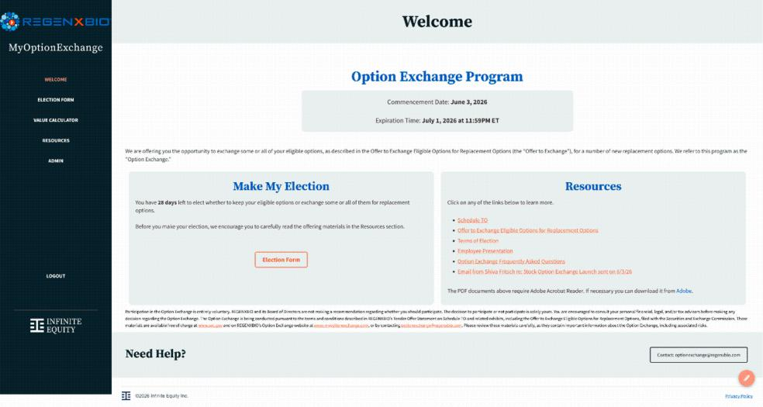

Election Form:
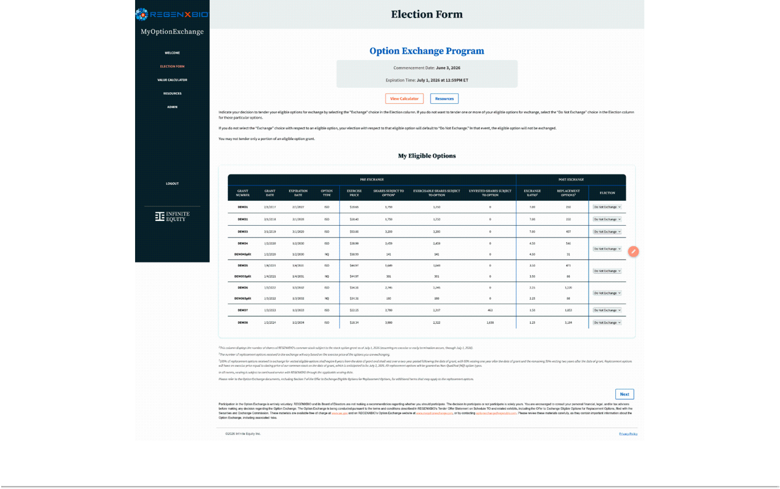

Confirm Election:
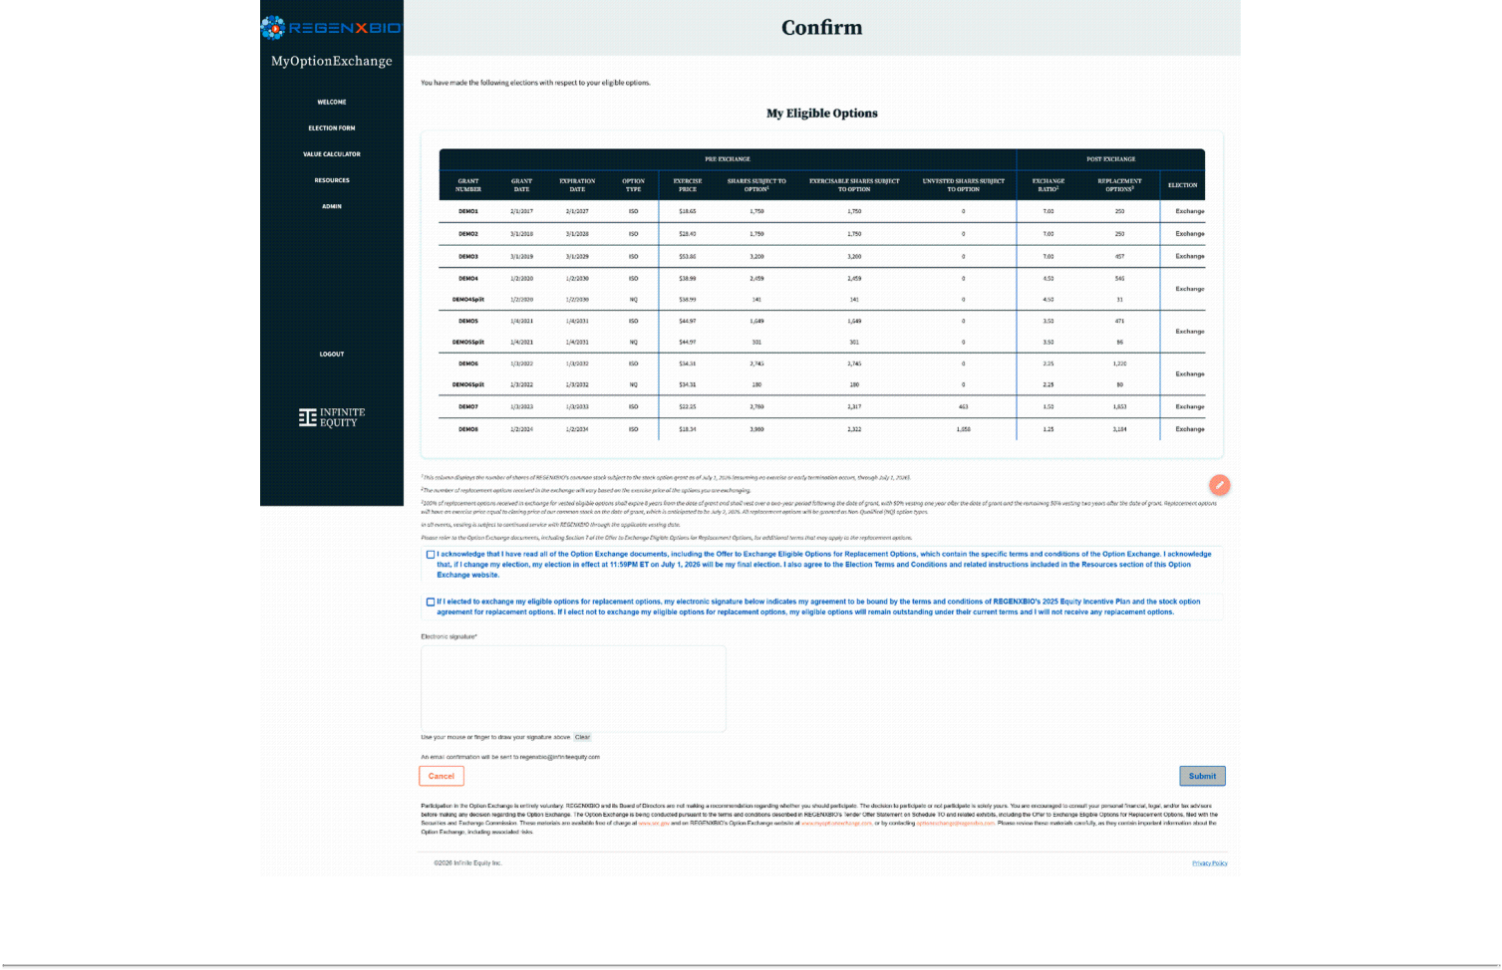

Confirmed Election:
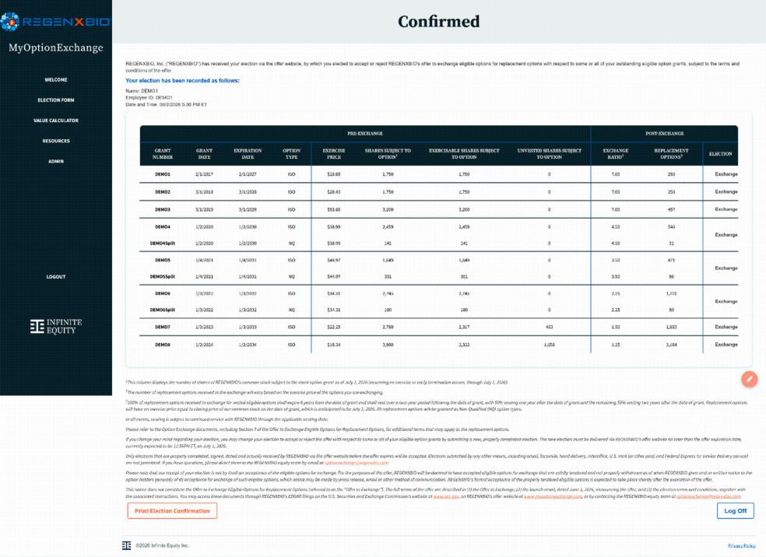

Election Confirmation:
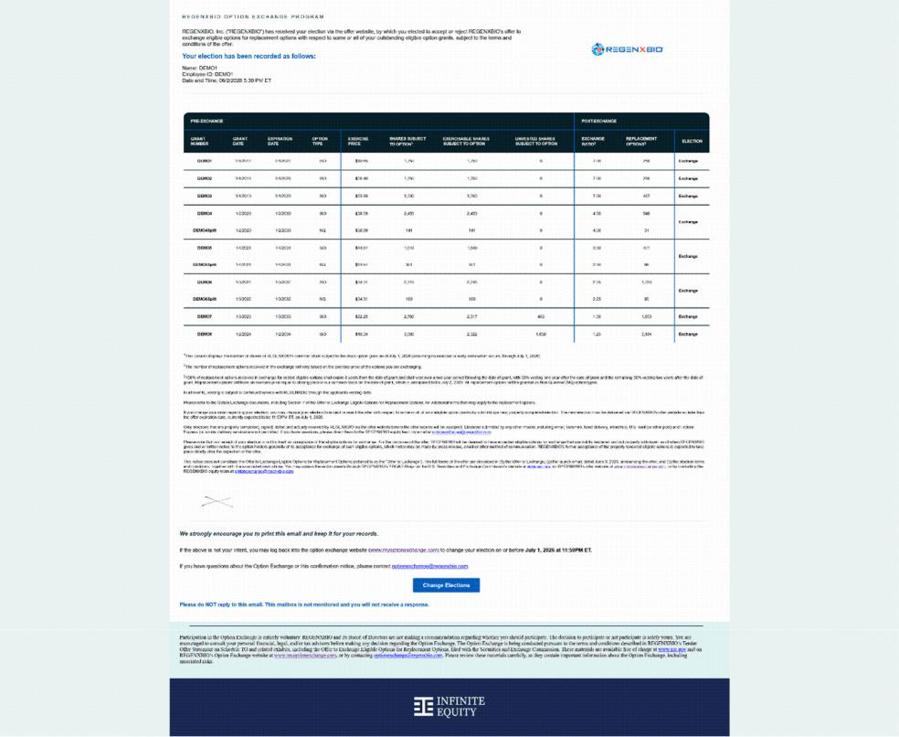

Resources:
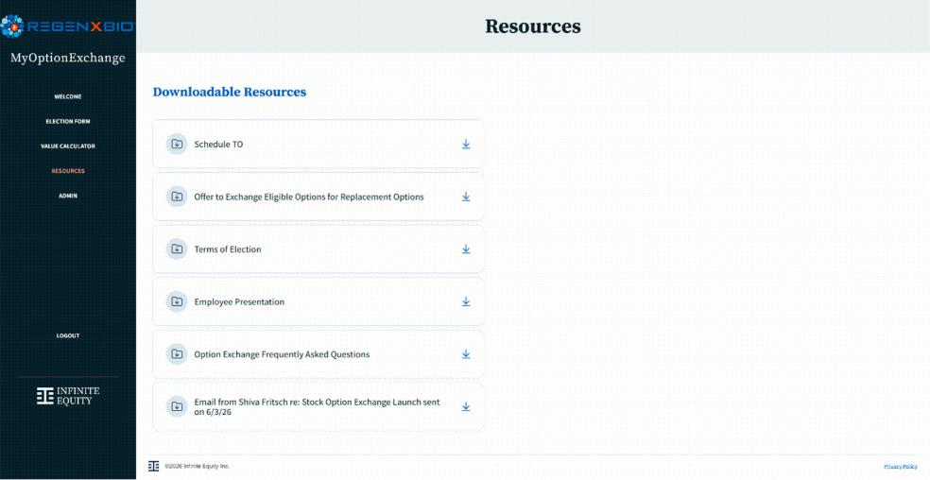

Value Calculator:
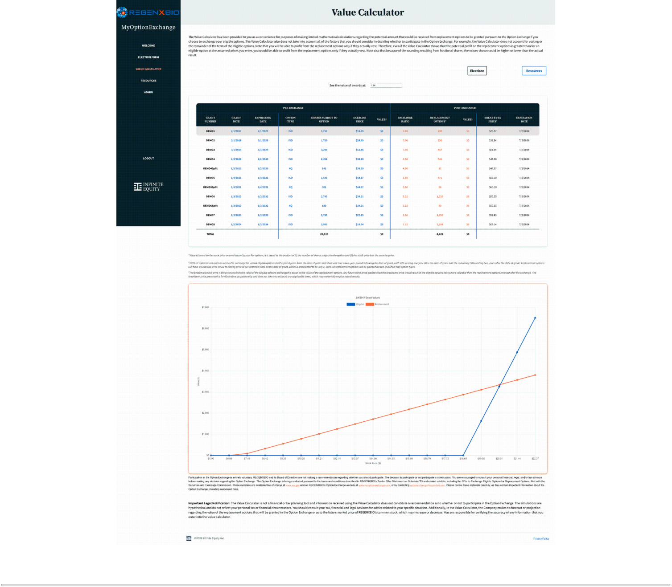

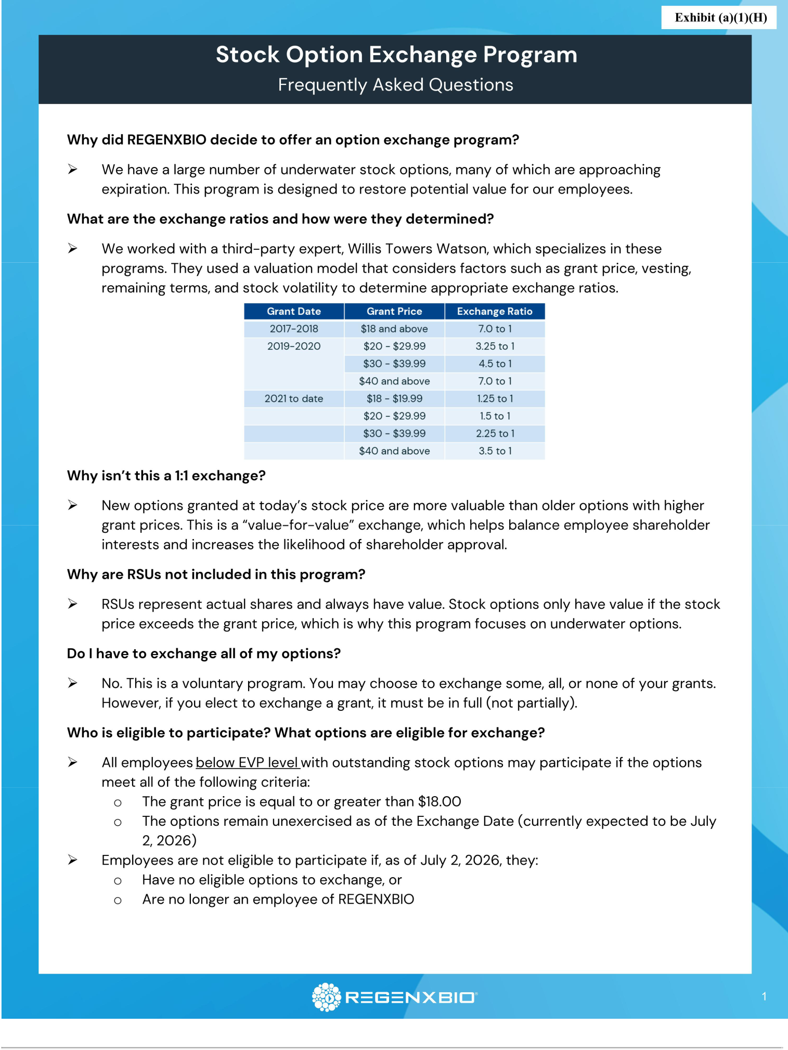

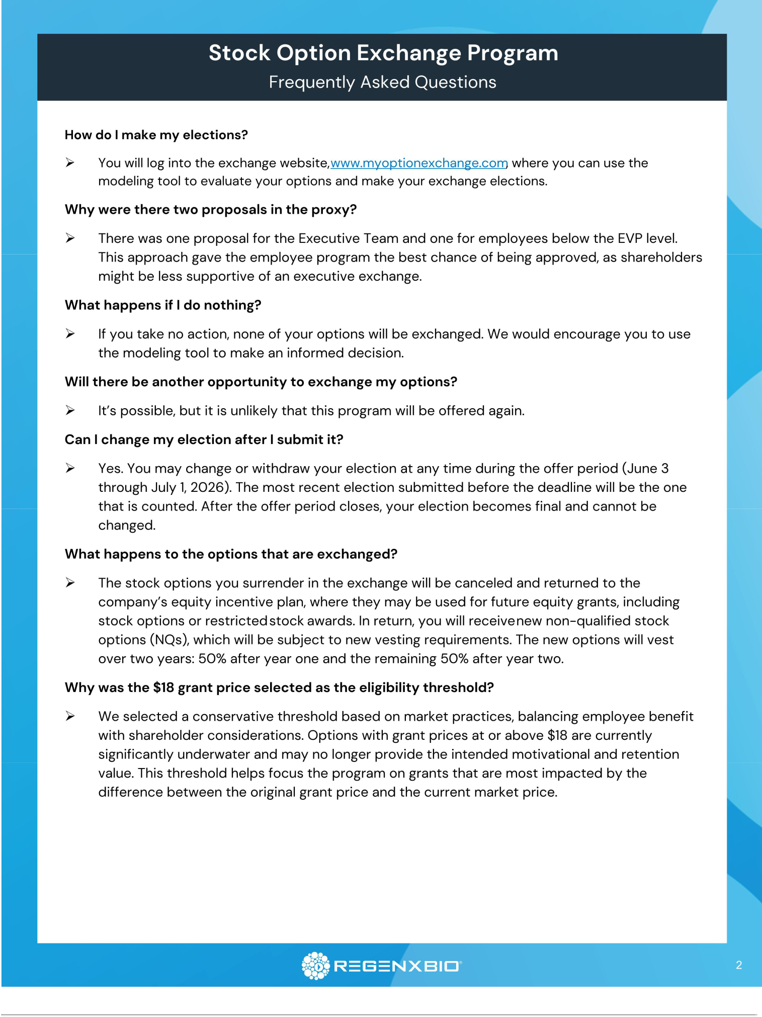

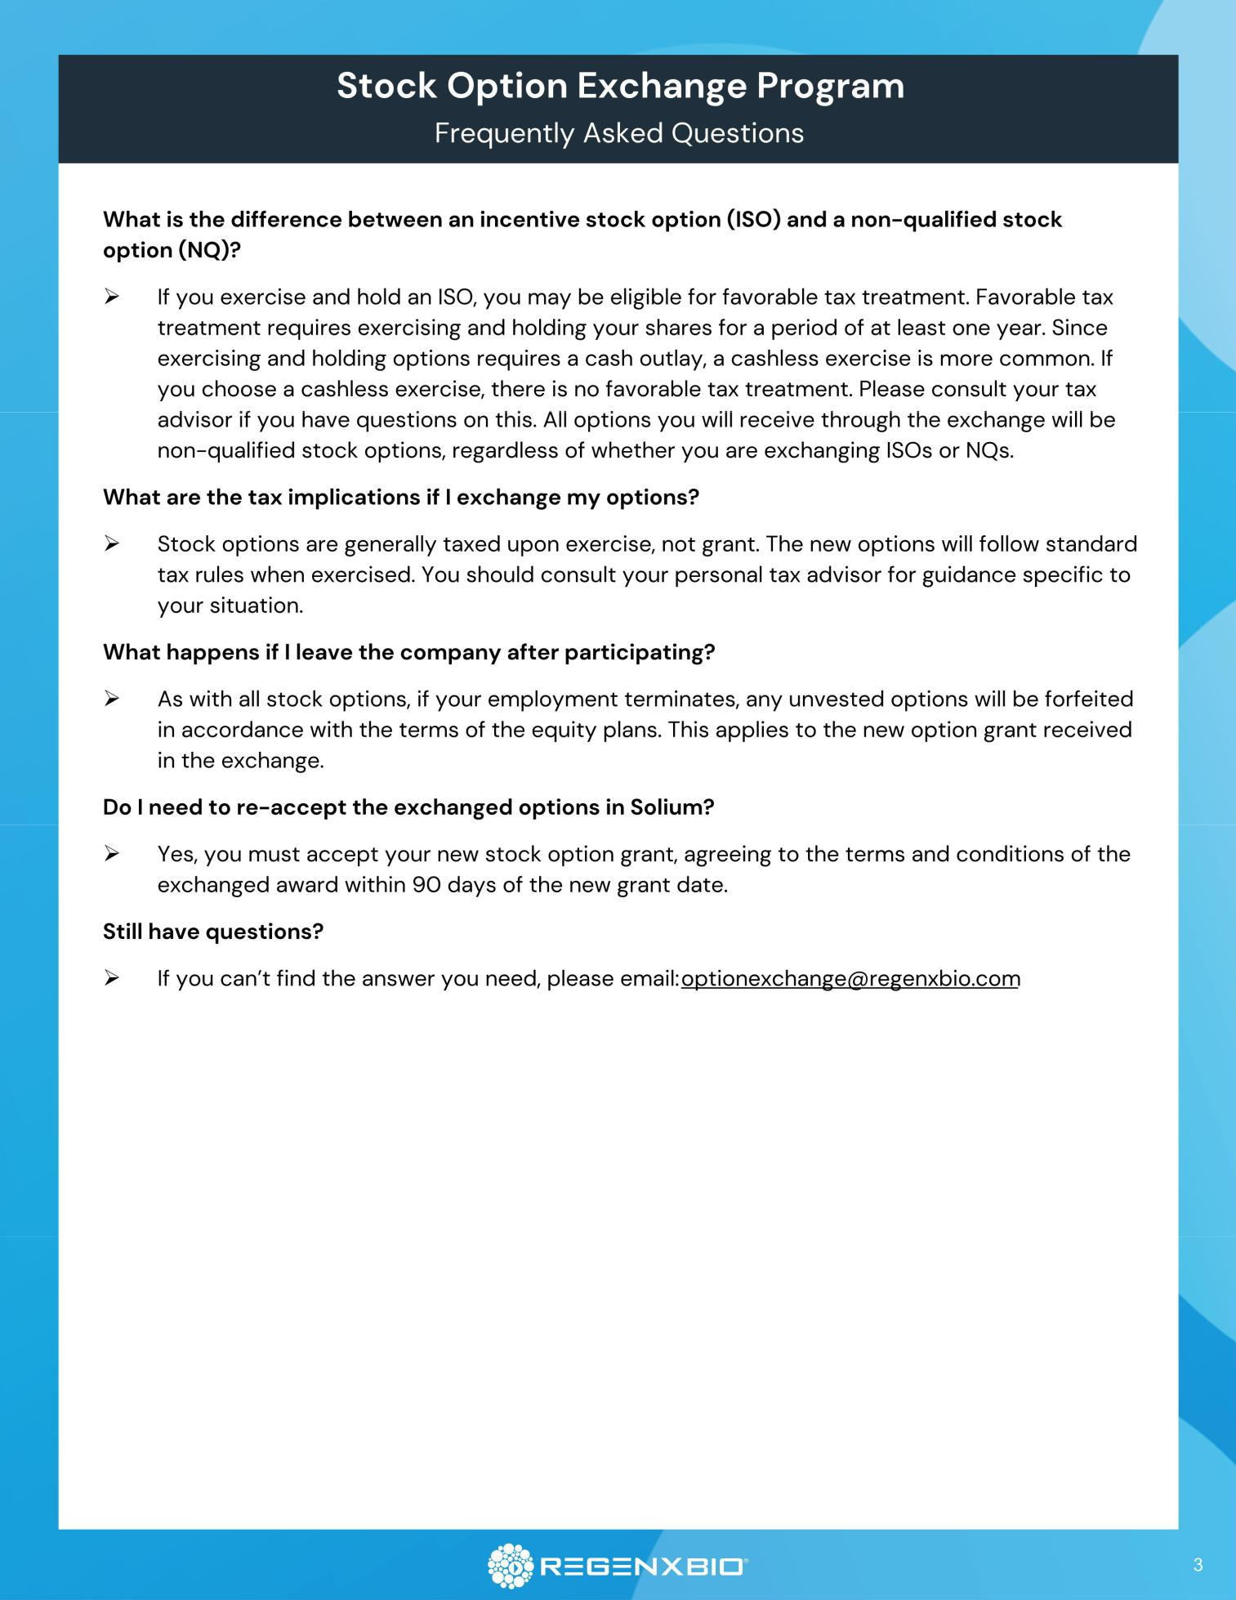

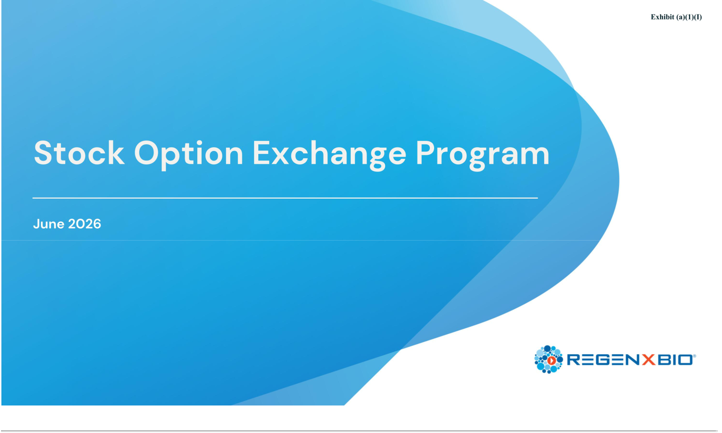

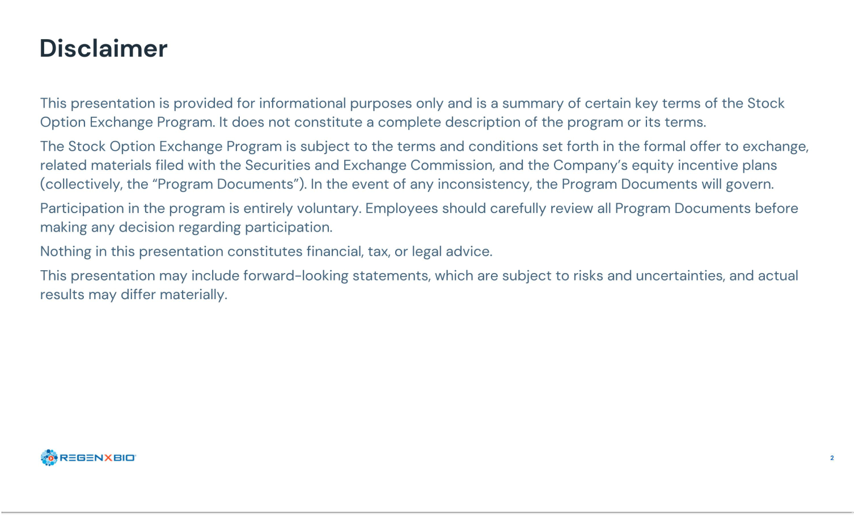

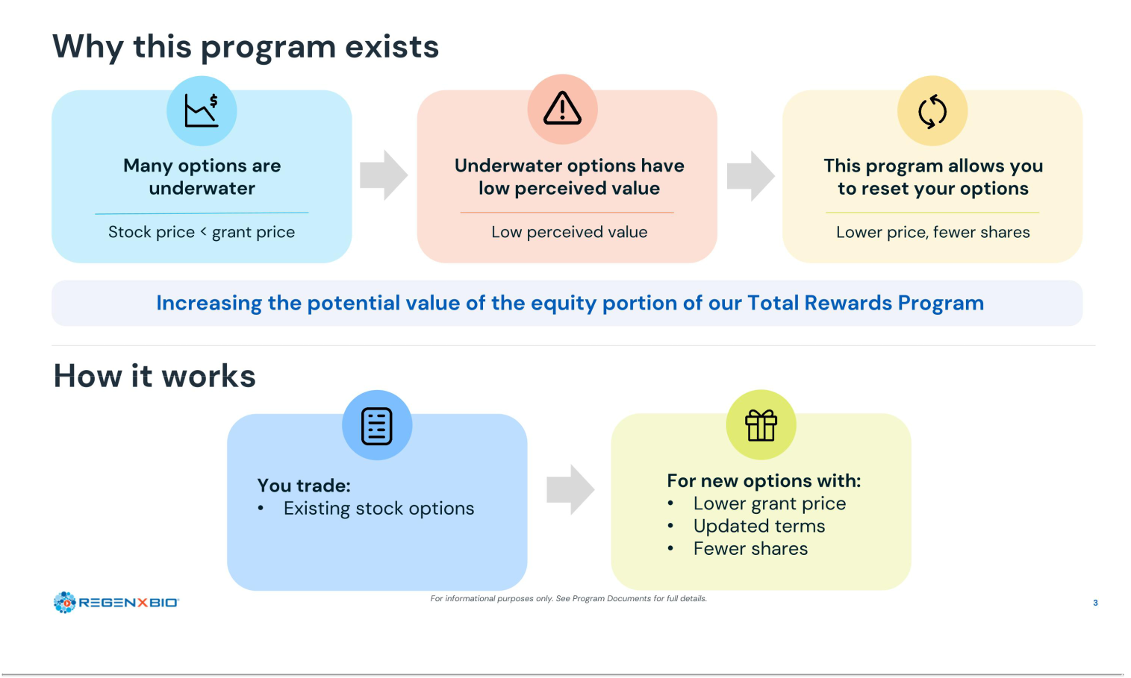

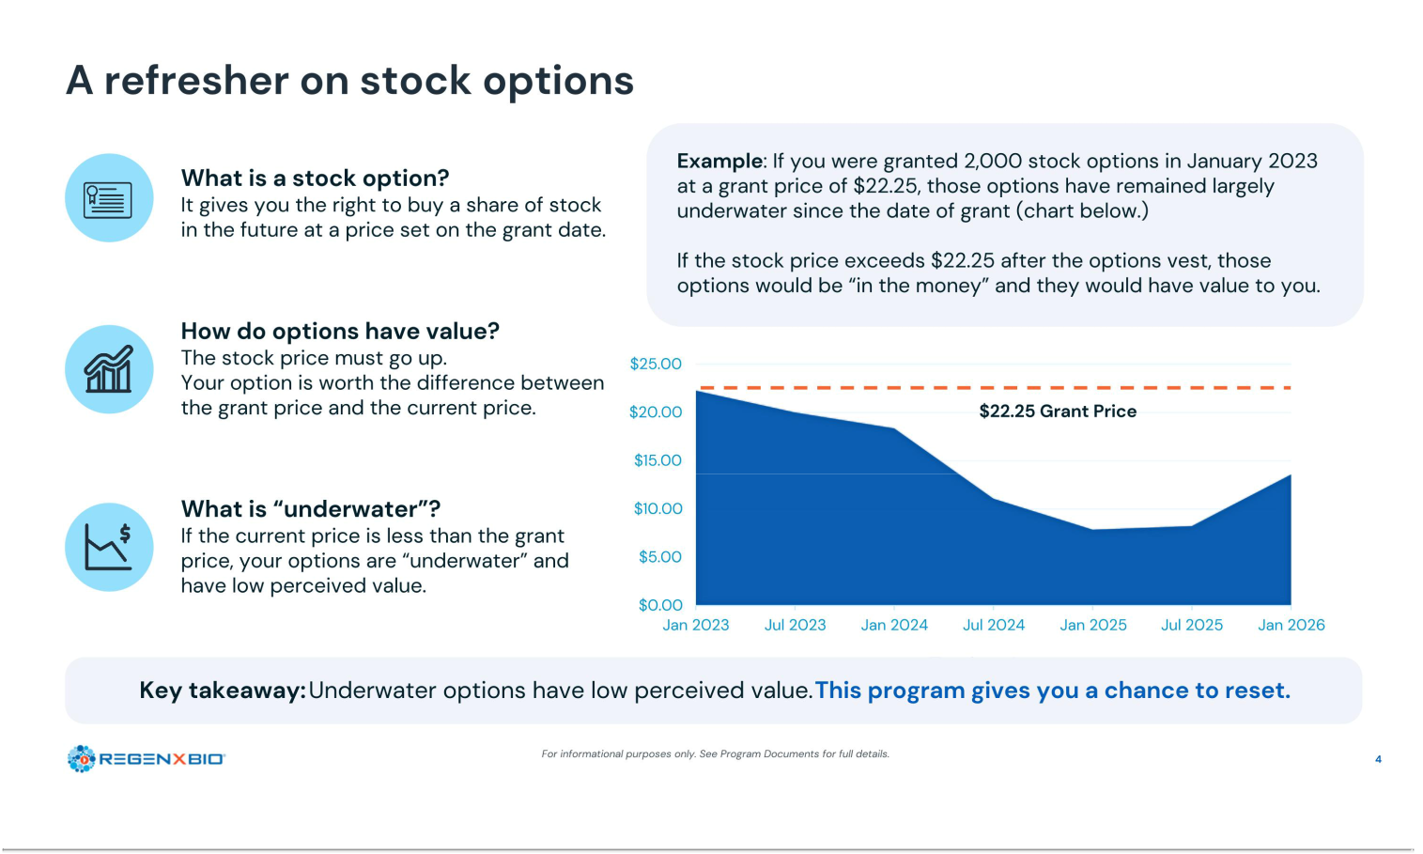

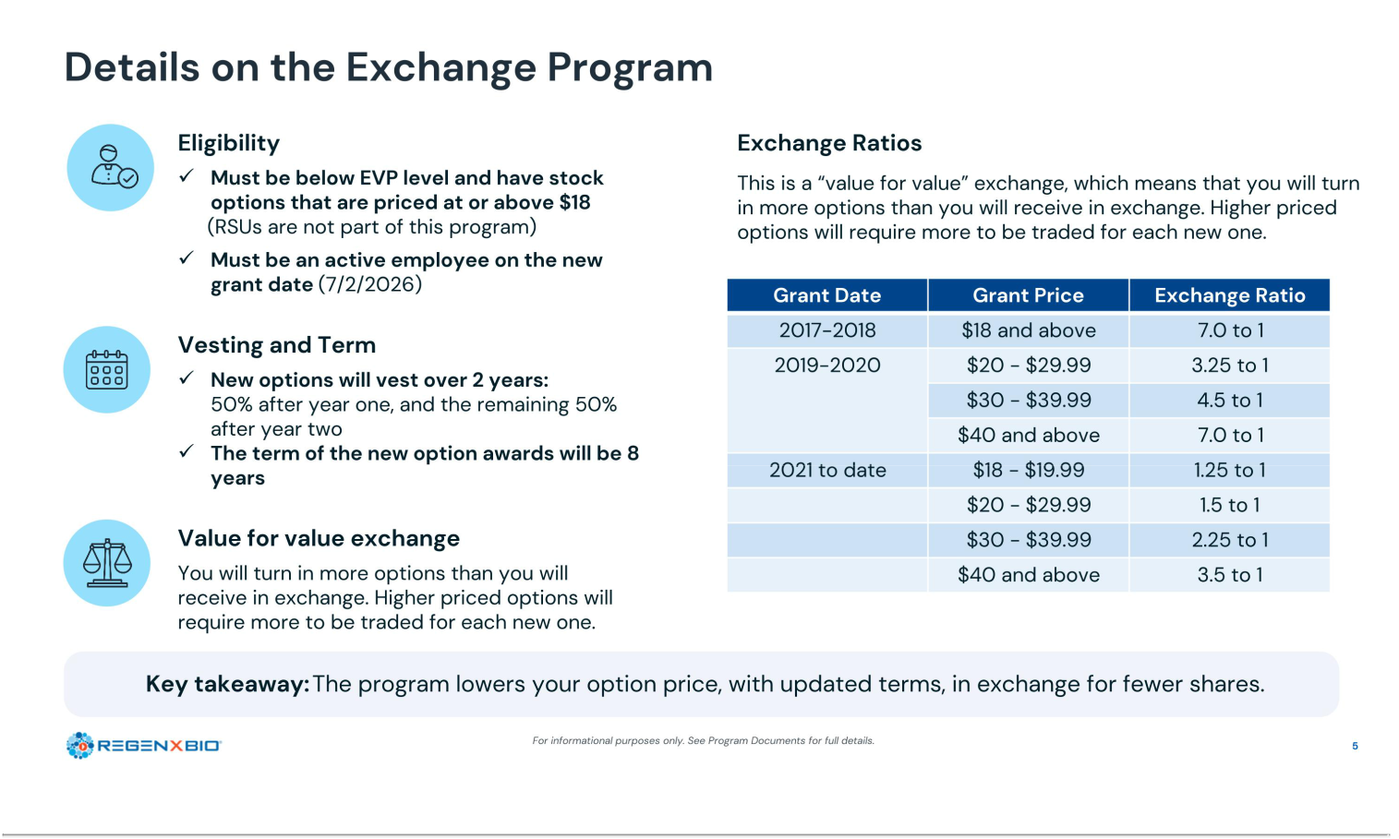

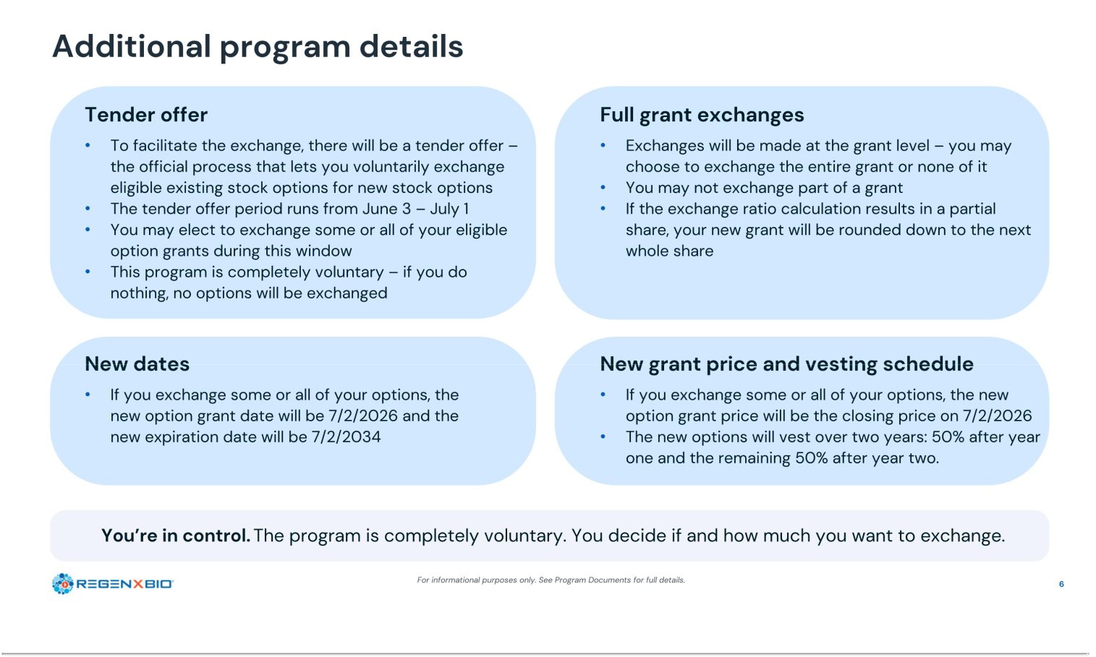

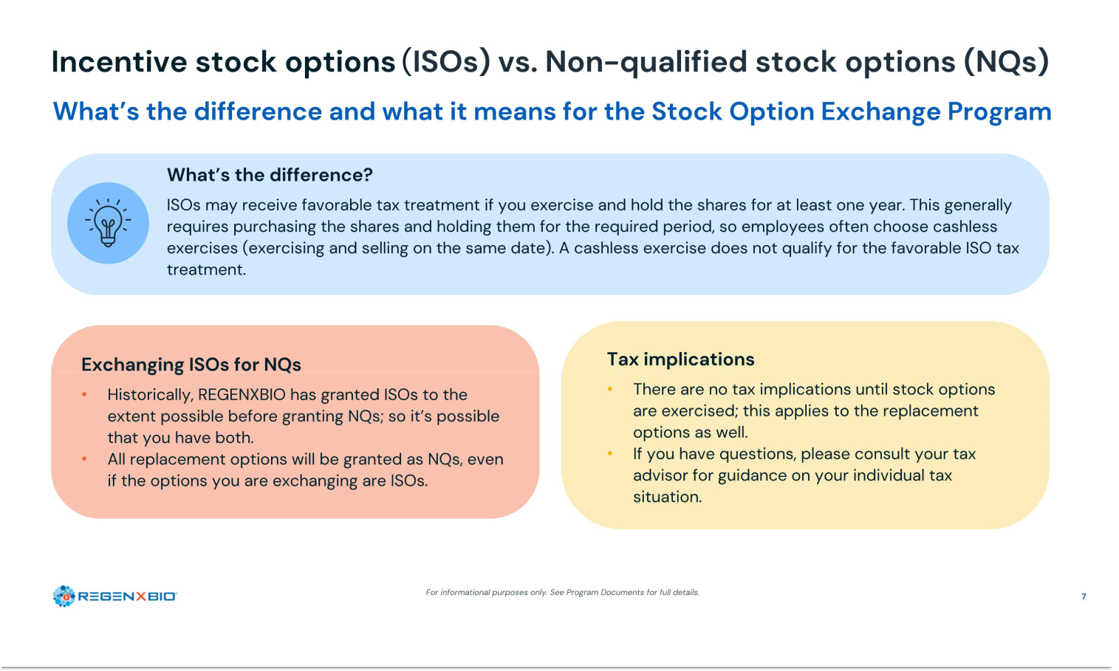

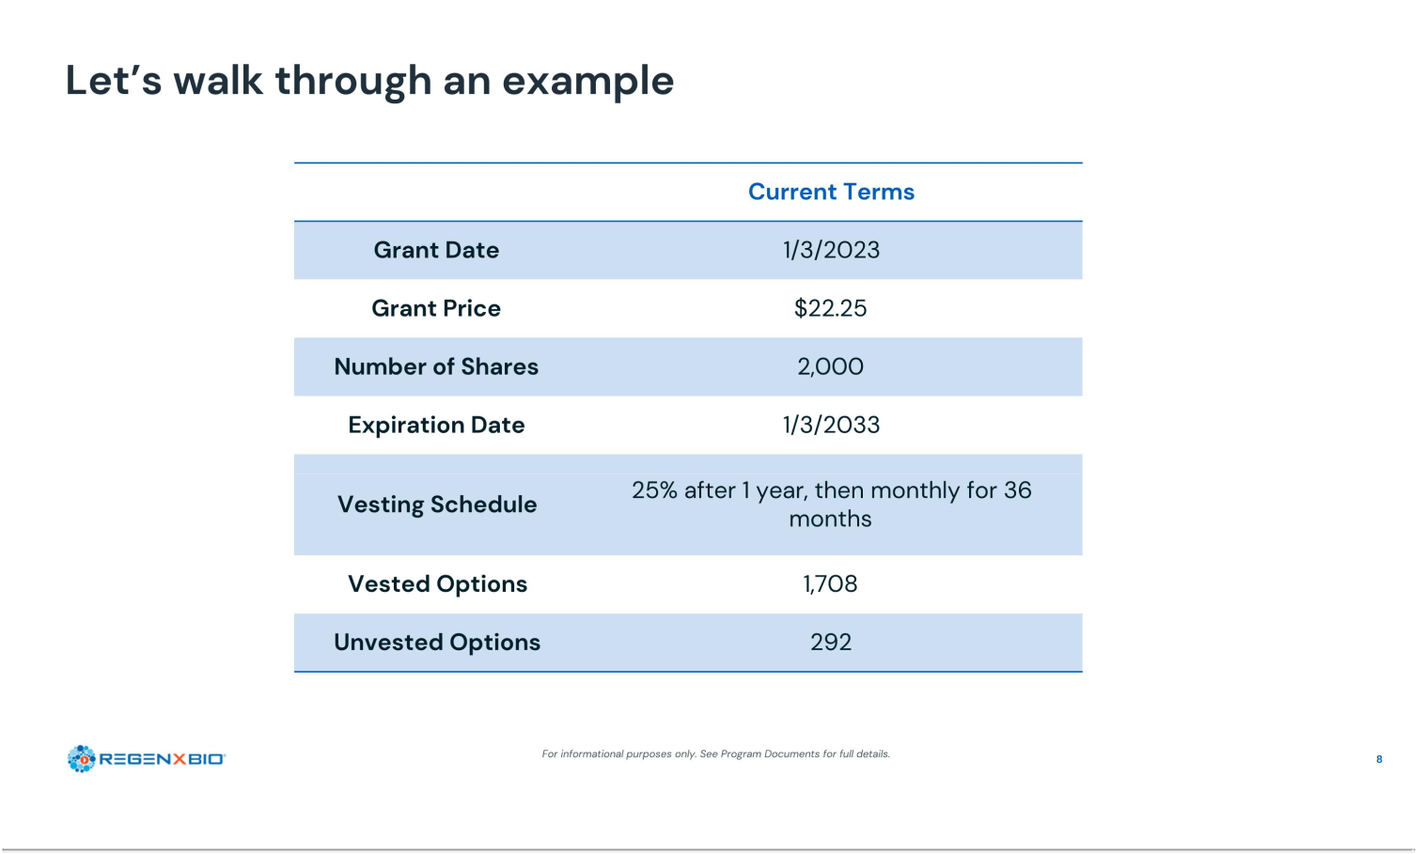

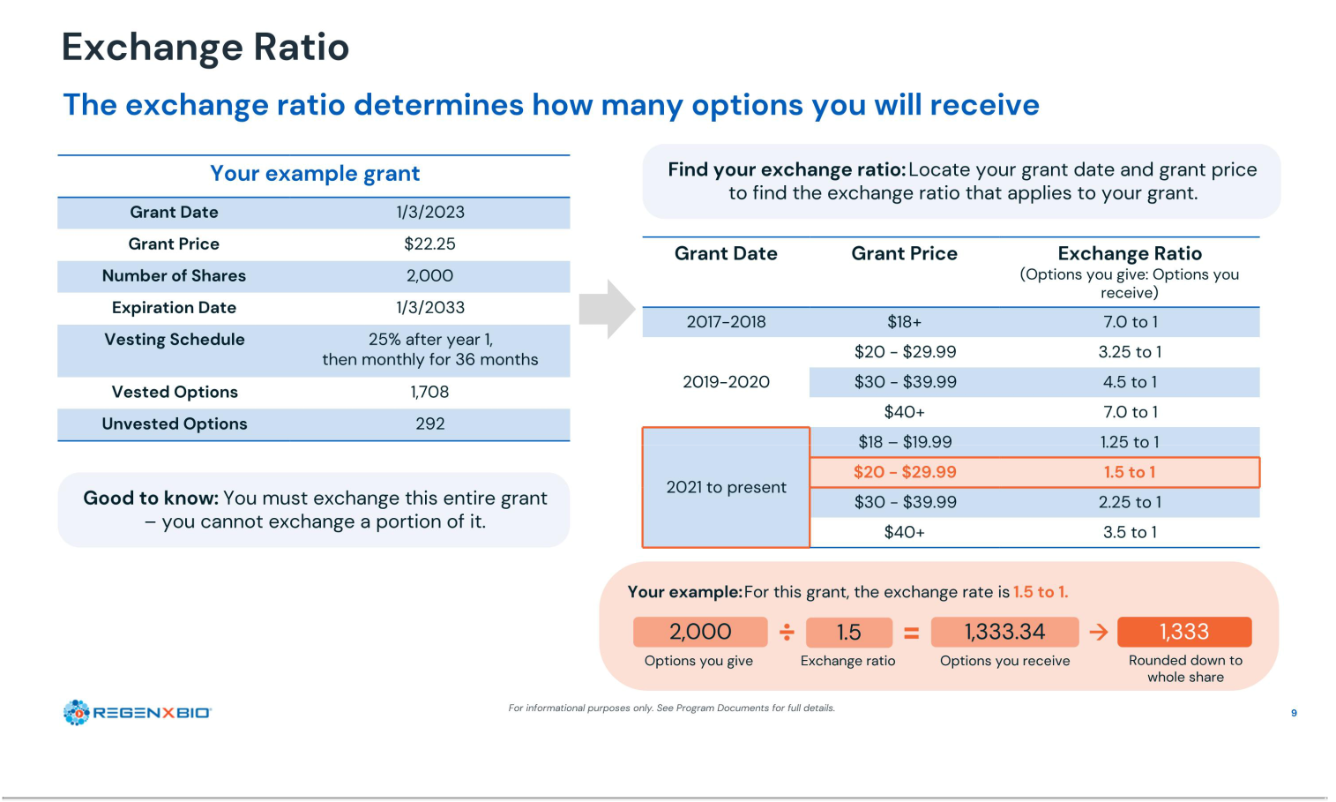

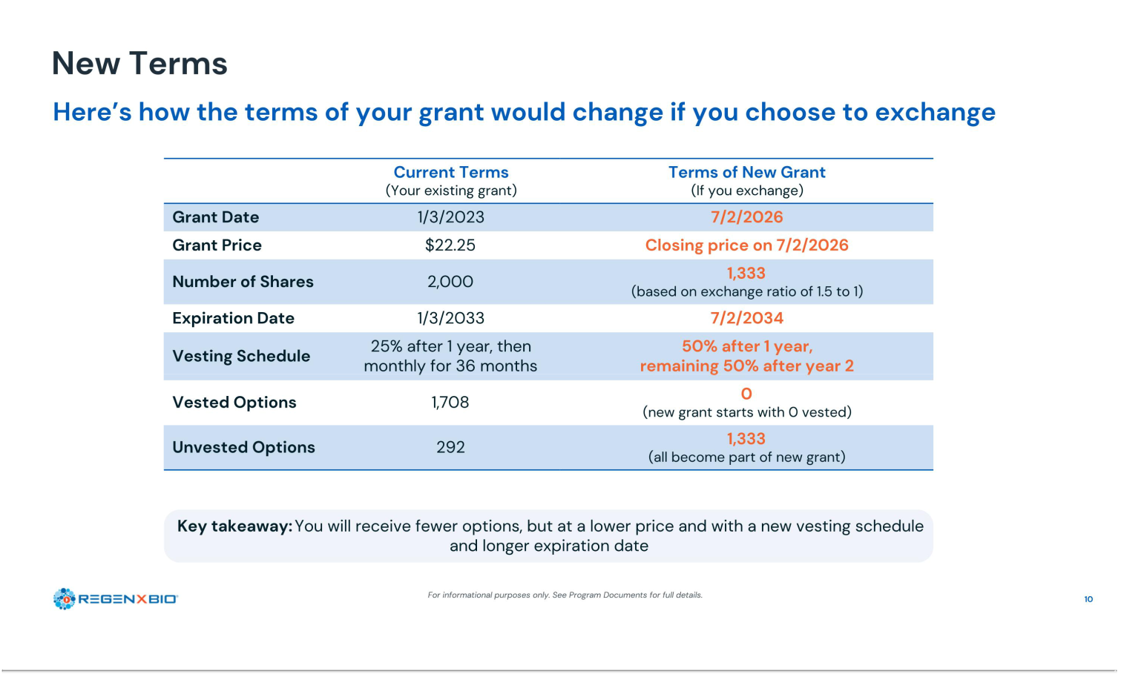

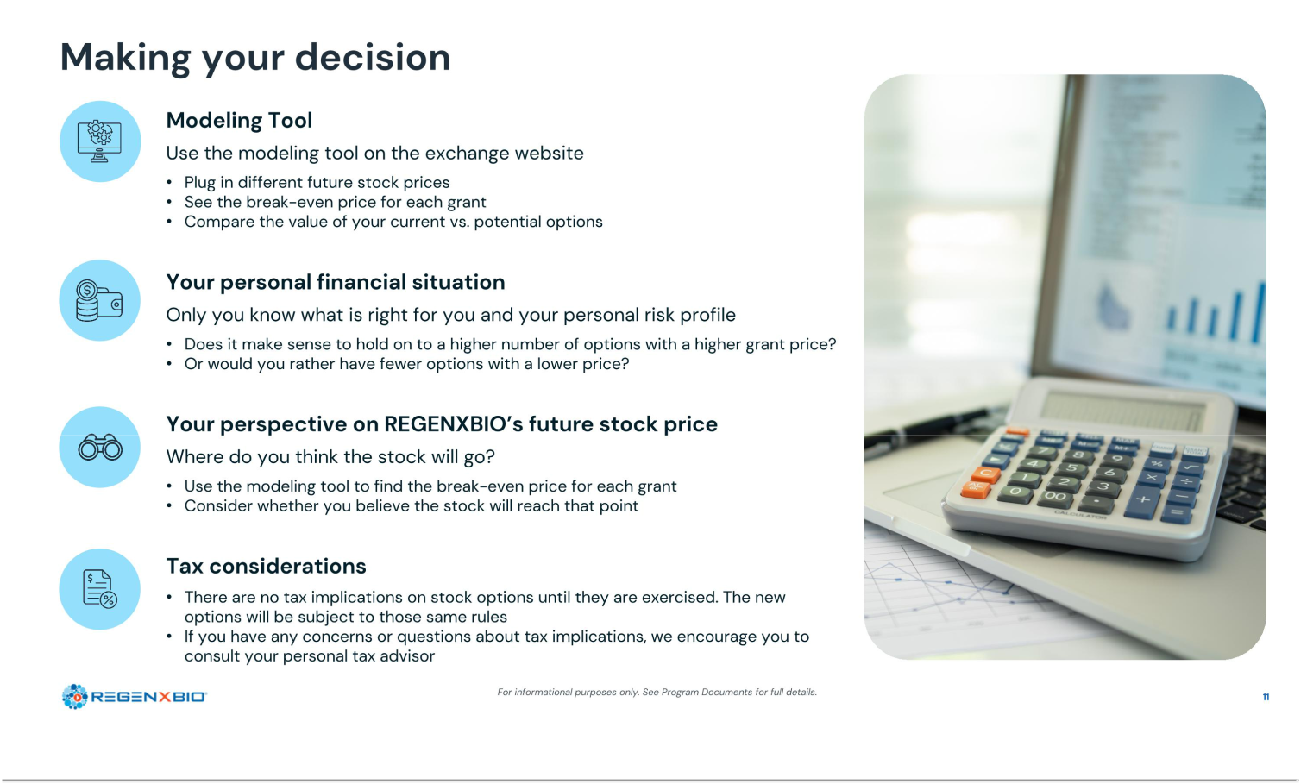

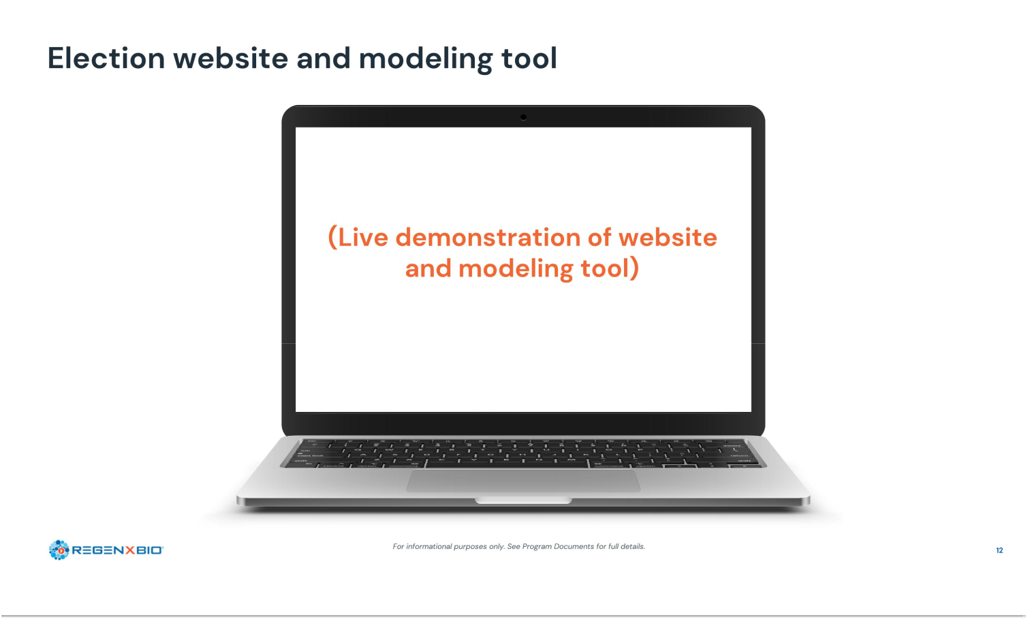

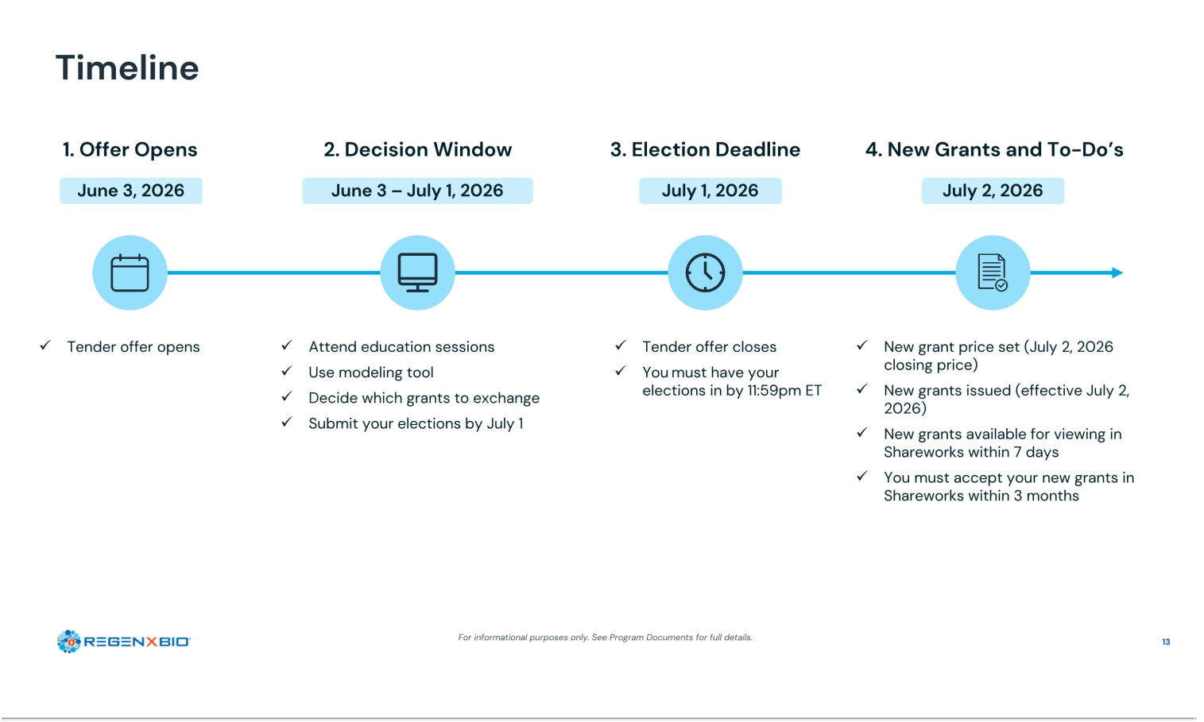

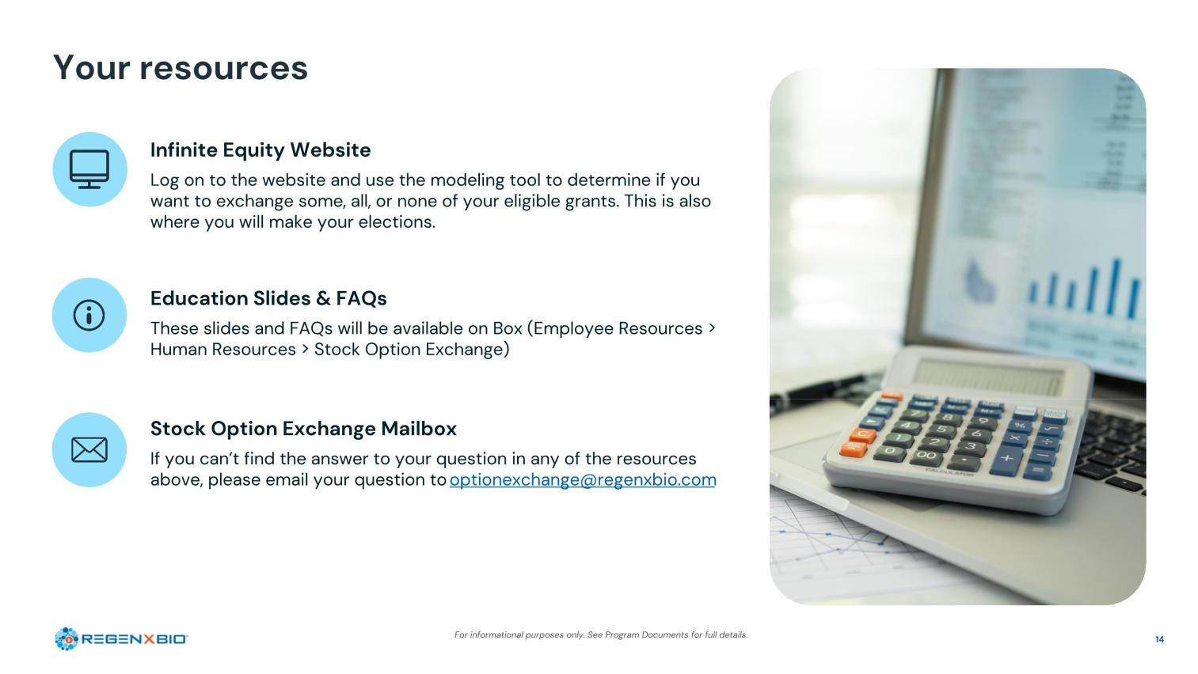

Exhibit 107

Calculation of Filing Fee Tables

SCHEDULE TO

(Form Type)

REGENXBIO Inc.

(Exact Name of Registrant as Specified in its Charter)

Table 1 - Transaction Valuation

 | Transaction | Fee | Amount of
 | Valuation | Rate | Filing Fee
Fees to Be Paid | $19,114,019.48⁽¹⁾ | 0.00013810 | $2,639.65⁽²⁾
Fees Previously Paid | — |  | —
Total Transaction Valuation | $19,114,019.48
Total Fees Due for Filing |  |  | $2,639.65
Total Fees Previously Paid |  |  | —
Total Fee Offsets |  |  | —
Net Fee Due |  |  | $2,639.65

- Calculated solely for purposes of determining the filing fee pursuant to Rule 0-11 of the Securities Exchange Act of 1934, as amended. The calculation of the Transaction Valuation assumes that all outstanding stock options to purchase shares of the Registrant’s common stock that may be eligible for exchange in the offer will be exchanged pursuant to the offer and is based on the product of (i) $6.55, the average of the high and low prices per share of the Registrant’s Common Stock on May 27, 2026, as reported on the Nasdaq Global Select Market and (ii) 2,915,945, the maximum number of shares of common stock underlying stock options to be exchanged in the transaction.

- The amount of the filing fee, calculated in accordance with Rule 0-11(b) of the Securities Exchange Act of 1934, as amended, equals $138.10 per $1,000,000 of the aggregate amount of the Transaction Valuation (or 0.01381% of the aggregate Transaction Valuation). The Transaction Valuation set forth above was calculated for the sole purpose of determining the filing fee and should not be used for any other purpose.

